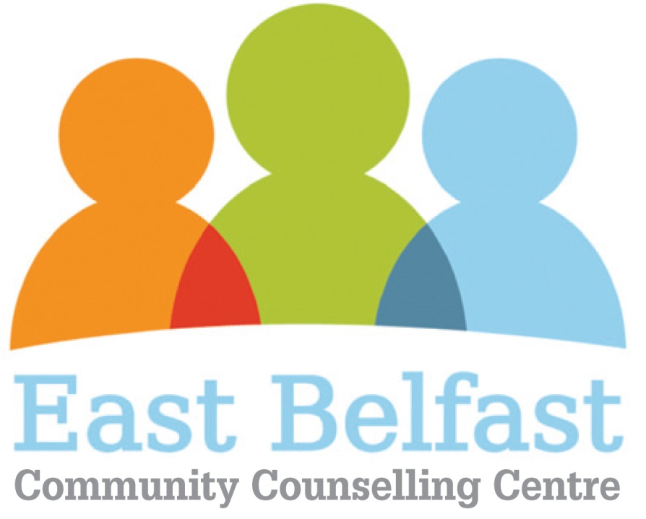

**Personality Disorder COURSE BOOKING FORM**

Please complete this form and return it with payment to:

Roberta Richmond, East Belfast Community Counselling Centre, East Belfast Network Centre, 55 Templemore Avenue, Belfast, BT5 4FP

|  |  |  |  |  |  |  |  |
| --- | --- | --- | --- | --- | --- | --- | --- |
| **First Name** |  | | | **Surname** |  | | |
| **Address** |  | | | | | | |
|  | | | | **Postcode** | |  |
| **Email Address** (correspondence mainly via email) |  | | | | | | |
| **Telephone no.** |  | | | | | | |
| **Special Requirements** (inc dietry) | **The course fee does not include lunch, however tea, coffee and biscuits will be available each day** | | | | | | |
|  |  | | | | | | |
|  |  | | | | | | |
| **COURSE REQUIRED** | | **COURSE**  **DATE** | **NUMBER OF PLACES REQUIIRED** | | | **NAMES OF ATTENDEES** | |
| **Personality Disorder Training – 3 days**  **Park Avenue Hotel – registration 9 30 – 10 00am each day** | | **12th, 18th & 25th October 2017** |  | | |  | |
|  | |  |  | | |  | |
|  | |  |  | | |  | |
| **Total fee** (East Belfast Community Counselling Centre’) | **£265 - £100 deposit, will secure your place, with the balance payable by 30th September 2017.** | | | | | | |

**Booking**To book, complete the booking form attached. Send a hard copy in the post with payment. Please make cheques payable to ‘East Belfast Community Counselling Centre”. Also, please return your form to this email address roberta@eastbelfastcounselling.org as an attachment (this will provisionally book you a place and help ensure a successful booking process. Places are limited and will be allocated on a first come, first served basis. Course requires a minimum of 12 to run. Deposits refunded if numbers are too low.   
**Location**

Park Avenue Hotel, Holywood Road, Belfast.

**Terms and Conditions**

By making a postal or an online booking you are acknowledging that you have read and agree to the following terms and conditions:

Terms

1. Booking fees cover tuition, materials, refreshments(Tea and coffee), lunch is not provided.

2. Bookings are accepted by post and email. Bookings made without payment will only be held for 7 days, after which we reserve the right to offer your reservation to other applicants.

3. Only when your deposit has been made can we fully guarantee your booking.

4. The course is limited to 20 people, and requires a minimum of 12 to run.

5. All participants of the courses take part at their own discretion and are individually and wholly responsible for their own property and actions, either on or off the course premises, for the duration of each session.

6. In the unlikely event of a course being cancelled, moved or rearranged you will be offered a full refund of your payment or an alternative course. The organiser will not be held responsible for any extra costs arising out of the cancellation of a course.

7. EBCCC cannot refund your course fee if you cancel your booking less than a week in advance of your course.

8. Places are limited and will be allocated on a ‘first come, first served’ basis. Return this form by email for a provisional booking – places will be confirmed on receipt of payment.