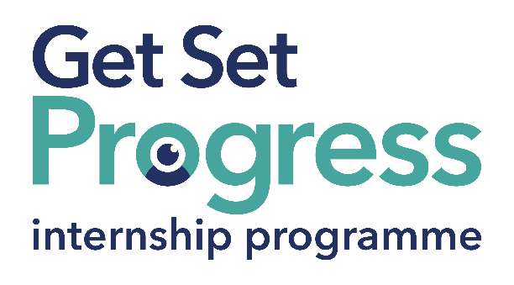

# Communications and Marketing Coordinator Internship

## Join us at Angel Eyes NI

Thomas Pocklington Trust (TPT) and RNIB are collaborating with organisations from both the sight loss and wider charity sector as well as corporate organisations to create new opportunities for blind and partially sighted people to find employment through the Get Set Progress (GSP) Internship programme. Angel Eyes NI is delighted to be offering an internship as part of the Get Set Progress scheme.

Angel Eyes NI is the leading organisation in Northern Ireland supporting children and young people who are blind or partially sighted, and their families. Founded in 2007 by a parent of two visually impaired children, we remain parent-led and driven by the belief that every child should have equal access to the support they need to flourish.  
  
Our vision is for a fully inclusive society where blind and partially sighted children can achieve their full potential.

**Our Values**

**Advocate**

We work to identify and draw attention to the barriers of accessibility and inclusion, and campaign for the rights of children and young people who are blind and partially sighted.

**Educate**

We aim to enable families by providing information and access to training, to raise aspirations, and to make informed choices for their child.

**Navigate**

We aim to empower families to navigate the complicated support system, to be able to secure the support they want to fit their needs, and that of their children, by maximising the lived experience in our team which is at the heart of all the support we deliver.

**Innovate**

We are passionate about creating innovative solutions to make a positive impact, and to overcome barriers for children who are blind or partially sighted.

Blue and Teal coloured Works for Me logo featuring a graphic of an eye within the O in 'works'. with employment programme written in smaller letters underneath in dark blue. 


## What are the benefits of a Get Set Progress internship for me?

As part of your 9-month internship, you will be part of a large cohort of fellow interns and gain the following:

* Obtain valuable work experience within the charity sector
* Technology support (Including Microsoft Office) and upskilling opportunities
* Online and in-person Training and development opportunities
* Opportunity to present and network with Senior leaders within the Sight Loss Sector
* Opportunities to build relationships with fellow interns
* A personal mentor offering support, advice and guidance throughout your internship
* Help deliver positive changes for people with sight loss

As part of the GSP Internship programme, you will also be enrolled on the TPT **Works For Me** Employment Programme, where you will gain bespoke employment support, guidance and advice from the TPT Employment Team, some of the skills that you will receive support and guidance around include:

* CV writing
* Job searching
* Cover letter and speculative letter writing
* Application form writing
* Interview techniques

## Job Description

Role: Communications and Marketing Coordinator Internship

Department: Marketing and Communications

Reporting to: Senior Management Team

Location: Belfast

Salary: £13.78/hour (based on the [Real Living Wage](https://livingwage.org.uk/))

Contract type: Fixed Term, 9 month contract, 32 hours per week

## Job Specification Information

To support and enhance the communications and marketing efforts of Angel Eyes NI and Empatheyes. This internship is designed specifically for a visually impaired person, offering the chance to build professional experience in a supported and inclusive environment.

## Key Areas of Responsibility:

* Create accessible, engaging content for social media, website, and campaigns
* Support brand consistency and public engagement activities
* Assist with internal communications and strategy development
* Work collaboratively with staff to ensure messaging reflects lived experience

## Person Specification - Essential criteria:

This post has a Genuine Occupational Requirement that the successful applicant be a person who is blind or partially sighted, in line with The Equality Act 2010.

* Lived experience of visual impairment
* Either a qualification in Marketing/Communications or at least 3 years of relevant experience

## Desirable Skills and Attributes:

* Strong written and verbal communication
* Knowledge of accessibility relating to web content and social media
* Creativity in digital content creation and storytelling
* Ability to tailor messaging to diverse audiences
* Basic knowledge of social media platforms (e.g., Instagram, X, LinkedIn, Facebook)
* Good organisation and time management
* Ability to work both independently and as part of a team
* A strong commitment to accessibility, inclusion, and the power of lived experience
* Willingness to learn, contribute, and take initiative
* Willingness to travel to the TPT Hub in London for intern development events throughout the course of the internship programme (costs covered by TPT).
* Having **not** previously undertaken the Get Set Progress internship programme.

## What to do next

Please send your CV and covering letter to [sara@angeleyesni.org](mailto:sara@angeleyesni.org)

## Closing Date: Monday 21 July

## About Angel Eyes NI

Angel Eyes NI is a parent-led charity dedicated to supporting families of children with vision impairment across Northern Ireland. We also run Empatheyes, a social enterprise delivering immersive Virtual Reality experiences that help others understand the world through the eyes of someone with vision impairment. As our reach and impact grow, so does our need for a strong, unified communications voice that represents the diversity and lived experiences at the heart of our mission.

## About the Role

This internship is a new and essential role, created specifically for a visually impaired person, designed to strengthen and unify the voice of both Angel Eyes NI and Empatheyes. It offers the opportunity to gain meaningful professional experience while making a real contribution to our communications, public engagement, and advocacy efforts.

You will play a key part in ensuring our digital content is creative, inclusive, and accessible, helping us engage families, professionals, funders, and the wider public with authenticity and impact. You’ll also have a say in shaping how we talk about our work, who we reach, and how we grow.

## Key Responsibilities

* Create and publish accessible, engaging content for social media, websites, newsletters, and campaigns
* Support brand consistency across Angel Eyes NI and Empatheyes materials
* Help plan and deliver communications for events, awareness campaigns, and fundraising
* Work with the Senior Management Team and Service Managers to reflect lived experience in all messaging
* Assist in developing internal communication processes and contributing to a wider communications strategy
* Participate in community engagement and storytelling to raise the profile of the charity and its mission
* Monitor engagement metrics and provide insights to improve communications impact