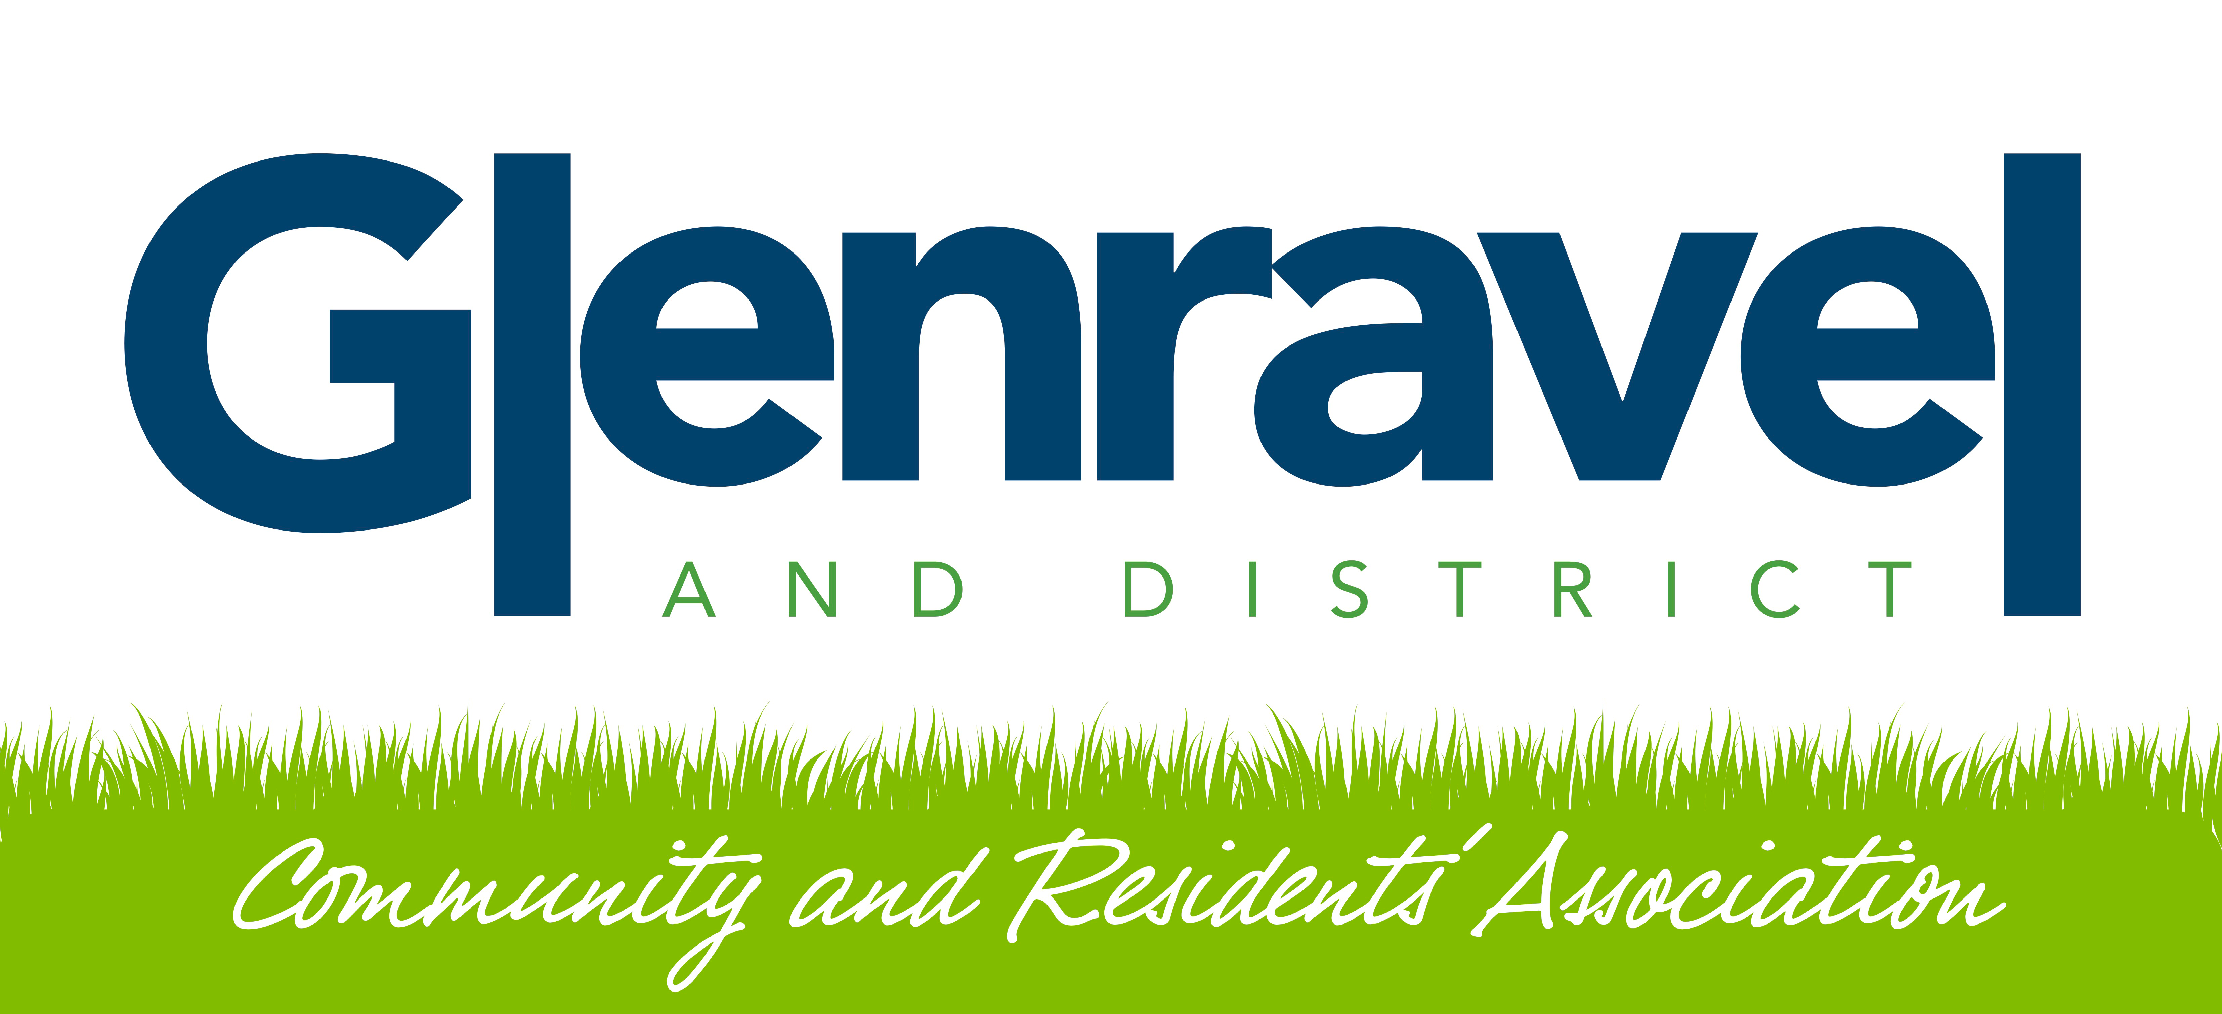

**Invitation to Tender**

**SPECIFICATION**

**GOOD RELATIONS MANAGER**

**GLENRAVEL GOOD RELATIONS PROJECT**

FROM 01 SEPTEMBER 25 – 31 MARCH 2026 (6 MONTHS CONTRACT)

*(This programme is subject to external funding from The Executive Office)*

**FOR**

**For all queries please contact:**

**Cormac Duffin, for GDCRA**

[**gdcraglenravel@gmail.com**](mailto:gdcraglenravel@gmail.com)

**07799416866**

**Closing Date**

**8TH August 2025 at 4pm**

1. **Introduction**

Tenders are invited for the appointment of a **GOOD RELATIONS MANAGER FOR GLENRAVEL GOOD RELATIONS PROJECT 2025-2026**

1. **Background**

Glenravel and District Community and Residents Association (GDCRA) was formed in 2010 and is based in Glenravel community hub.

The objectives of Glenravel & District Community and Residents Association are –

* Reduced social isolation, improvement of the quality of life for those in need, reduced levels of stress and anxiety and increased mental health among those in need.
* Increased volunteer opportunities, increased community pride, reduction of Anti-social behaviour among the local community and an increase in safe areas for the local community.
* Improved employability for residents, creation of new or enhanced skills, increased self-confidence.
* Reduced fear of crime, reduced isolation and the reduction of racial/cultural tensions. These benefits are evidenced through feedback from the local community.

1. **Scope of the Contract**

GDCRA is currently seeking submissions for a suitability qualified and competent supplier or individual to deliver the TEO CGRF funded Glenravel Good Relations Project in the Glenravel and district area.

*Demographics* - Glenravel is a mixed area with rural interfaces between 4 villages (Clough/Martinstown/Cargan/Newtowncrommelin)

NISRA Census 2021 clearly shows the disparity within the Data Zones which make up the Braid A1, A2, A3, B1 and C1 where the demography is made up of majority CNR community in 3 zones and almost equal mixed CNR and PUL in 2 zones. On average 60.48% belong to or were brought up in the Catholic religion and 36.66% belong to or were brought up in a 'Protestant and Other Christian (including Christian related)' religion. There is also a median of 3% other nationalities who hold passports from other countries outside UK and Ireland. Local people experience deprivation where NIHE recognise the high social housing need (NIHE Housing Market Analysis) and there is high percentages of economically inactive (35%-41%) which may be accounted for older people, children and young people as well as unemployed and disabilities. Glenravel experiences social isolation and poor access to services as well as 33% low educational attainment (NISRA Area Profile Report 2022).

The relations between the villages are further impacted by segregation of churches, schools and community venues. GDCRA works to improve relations and through experiential work realises the need for attitudinal change and work to improve mutual understanding.

**Detailed Requirements**

**POST: GOOD RELATIONS MANAGER (35 HOURS)**

***TENDER VALUE: - £33,000***

***(£22,000 for the GR Manager and £11,000 for programme costs)***

**POST DURATION:** 01 SEPTEMBER 2025 – 31 MARCH 2026

**OUTPUTS:** The GOOD RELATIONS MANAGER will organise, participate and facilitate:

20 x History and Culture talks* including local culture and hidden histories to increase sense of community belonging (widen contribution beyond community background) and cultural diversity is celebrated

20 x Good Relations workshops* on e.g.: Flags, Emblems and banners /ethnicities in the villages / Ulster Scots Culture / plantation of Ulster and the Big Houses / history and industry / bog and bog art to increase sense of community belonging (widen contribution beyond community background) and cultural diversity is celebrated.

10 study visits* to different institutions including: GAA, AOH, LOL, Churches, and local community hub.

1 x Cultural Celebration event in March 2026* inviting all participants, institutions and agencies involved, funders and GDCRA Committee members to highlight the success of the project, the learning etc. to showcase the increased sense of community belonging (widen contribution beyond community background) and cultural diversity is celebrated.

*Sessions required for participants to introduce at start GR Project and end of GR project to facilitate completion of baseline questionnaire and exit questionnaire OR facilitate completion of one-off event questionnaire.

Minimum of 50 participants each attending 2 talks, 1 study visit and 5 workshops.

100 participants at Celebration event.

55% CNR / 40% PUL and 5% Other.

Age range 18 years to 80+ years (schools element tbc)

Records to be kept of attendance, case studies, participant feedback (quotes etc) and photos etc showcasing events and workshops.

This Good Relations Project (as outlined in GDCRA application to TEO Central Good Relations Fund and the Letter of Offer from TEO) will engage adults, older people, ethnic communities and the whole community to understand diverse cultural and religious backgrounds and increase peoples’ sense of belonging to the area. The GOOD RELATIONS MANAGER will engage local cultural institutions, local historians, ethnic community and public bodies in talks and tours to aid understanding of different cultures and religions to dispel myths and enhance understanding of the diversity in our community. The GOOD RELATIONS MANAGER will ensure learning by local people regarding flags, emblems, banners, sports, churches, loyal orders etc and through education and engagement the GOOD RELATIONS MANAGER will actively encourage interaction with others, increase mutual understanding, assist with attitudinal change and increase co-operation between villages and within the community.

**MAIN PURPOSE OF POST:**

To deliver and facilitate GLENRAVEL GOOD RELATIONS PROJECT to targeted communities (4 villages Clough/Martinstown/Cargan/Newtown Crommelin) to increase sense of community belonging (widens contribution beyond community background) and celebrate cultural diversity for mutual understanding of T:BUC Priority 4 Cultural expression.

**MAIN DUTIES AND RESPONSIBILITIES:**

* To deliver the Glenravel wide Good Relations Programme which supports positive social and attitudinal change within each village community;
* To engage with each village community and give voice to the local cultures and help build a united community with mutual understanding and intercultural understanding;
* To engage with all the community in a facilitation/training role to increase knowledge of diverse cultural outlooks, ensuring maximum levels of participation and capacity building;
* To network and work in partnership with institutions, community, statutory and voluntary sectors, ensuring a complementary and co-ordinated response to programme delivery;
* To engage village representatives in study visits to learn from good relations and good practice projects within other village communities;
* To organise and deliver the Glenravel GR programme to bring people together to learn and engage in different cultural settings with cultural organisations in

Sport, Arts, Heritage, Social activities;

* To prepare monthly progress reports to the GDCRA committee detailing progress in relation to the programme;
* To undertake monitoring and evaluation of every aspect of the project for all programme delivery which highlights the journey for individuals from start to finish and be responsible for project reports reporting to funders and to GDCRA Management;
* To undertake monitoring of financial spend to vouch and process claims and monitoring as required by TEO;
* To engage in public relations activity to promote the programme widely through social media and other communications using TEO PR Guidelines and logos and GDCRA logo;
* To work evenings and weekends as and when necessary to ensure effective delivery of services;
* To undertake any other duties deemed appropriate by the Board of Directors.

**PERSONNEL SPECIFICATION:**

***Essential criteria:***

* Minimum of 2 years paid experience in a good relations/ peace and reconciliation role within a community development setting **OR** 3rd level qualification in a relevant discipline i.e. community development, social policy, youth and community work ;
* Demonstrable experience of Good Relations project engagement with political/cultural institutions;
* Demonstrable experience of implementing good relations, community relations and reconciliation projects;
* Demonstrable experience in a training and facilitation role/s;
* Practical experience of monitoring and evaluation including financial and project returns to funders;
* Experience of working with and establishing links and networks with institutions and statutory, community and voluntary sectors;
* Good organisational and interpersonal skills;
* Experience of working on own initiative and as part of a team;
* Good communication skills both oral and written;
* Computer literate and a working knowledge of Microsoft Office;
* Have access to a form of transport necessary to carry out the duties of the post;
* Willingness to work unsocial hours including evenings and weekends

***Desirable criteria***

* Demonstrable experience of organising community events and programmes in Northern Ireland
* Knowledge of villages in Glenravel (Clough, Martinstown, Cargan and Newtowncrommelin)
* Knowledge of cultural institutions and ethnic communities

The Shortlisting Panel reserves the right to enhance the shortlisting criteria in order to effect a more manageable shortlist.

**All successful candidates will be required to carry out a full Access NI disclosure.**

**How to Apply:**

**Shortlisting will be based on meeting essential / desirable criteria and fulfilling the proposal bid outlined below:**

**Proposal Bid to include:**

Cover letter, and work plan outlining the delivery of this Good Relations Project structured under the following headings;

* + Understanding of brief - proposed methodology and general approach to assignment
  + Expertise – composition of proposed project team/individual to include CV for all personnel, relevant qualifications and any other relevant information.
  + Experience – evidence, including 2 referees and track record of similar type projects in recent years.
  + Timescales – ability to start and commence project within the timescales outlined.

**Please note:**  
Only applicants who, based on the information provided, clearly demonstrate they meet the required skills, experience, and abilities will be shortlisted for interview.

**Closing date Friday 8th August 2025 at 6pm**

**Interviews to be held week starting : Monday 18h August 2025**

**Email bids to:** [**gdrcaglenravel@gmail.com**](mailto:gdrcaglenravel@gmail.com)