

Job Description & Personnel Specification

Furniture Shop Manager
Belfast Ormeau Road

£24,790 - £25,992 pa : £13.62 - £14.28 ph

Permanent

35 hours per week
(5 out of 6 days Monday-Saturday)

Employees of Action Cancer must support its Mission, Values and Behaviours:



Values and Behaviours:

Our strengths are that we are a Values driven charity with people being at the very centre of everything we do. Our services are proven to make a difference, we are a Northern Ireland charity run and controlled by local people, raising money, spending money, and supporting people only here in Northern Ireland.
We have three stated Values which are supported by seven expected behaviours.

Value 1: Putting People First - People are at the centre of everything we do.

Value 2: Making a Difference - Having a positive impact on everything we do.

Value 3: Having Integrity – Operating with full transparency, honesty and fairness in everything we do.

Our Values are supported by seven Behaviours. We Will…
1. Treat people with respect, care, dignity and consideration.
2. Listen, hear and respond positively to what people say.
3. Work together, supporting, adding value, learning from and sharing with others.
4. Embrace and develop new ideas, and ways of working.
5. Nurture, support, develop and equip our people to reach their full potential
6. Learn from the past, build upon and celebrate our success
7. Welcome scrutiny, taking ownership and responsibility for our actions.

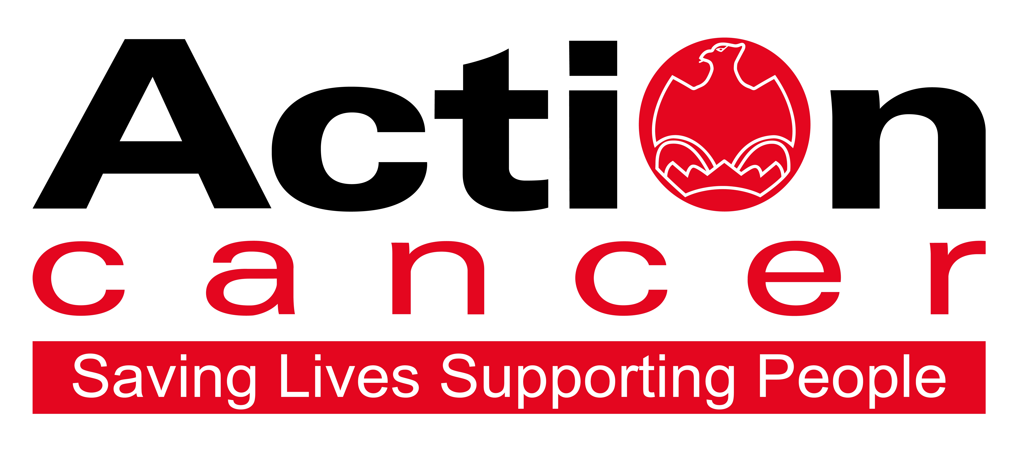

We offer:
- 20 days leave increasing to 25 days + 11 Public Holidays
- 1 extra leave day at Christmas
- Christmas closure
- Enhanced sickness, maternity, paternity, and adoption leave and pay
- 6% contributory pension scheme
- NHS Top-Up Cash Plan
- Death in Service Plan
- Staff care and support services, including access to Action Cancer services
- Training and development

In addition to a competitive salary, Action Cancer offer a Total Reward Package – see Appendix - which focuses on what our staff value, and includes a flexible mix of rewards designed to meet staff needs, their lifestyle, and their stage in life, including a time-off-in-lieu accrual system, training, flexible family-friendly working arrangements, pension contributions, and excellent professional development opportunities.

Action Cancer is a local Northern Ireland charity - all our money is raised to provide services for local communities. Our dedicated team of staff and volunteers work across the whole of Northern Ireland helping to save lives and support people affected by cancer. To operate our services we must raise circa £4 million every year. We provide early detection and health promotion services, and counselling and support services for cancer patients and their families, thereby making a real difference to people who are affected by or living with cancer.

Action Cancer staff - a mix of highly skilled professionals - are the most valuable asset to our charity. We offer a wide variety of training and development opportunities, and family friendly initiatives to enhance work-life balance, and to value and support individuals and family life. In recognition of this we were awarded Best Learning and Development Organisation in Ireland - Not for Profit Sector, and were winners of The Irish News ‘Best Place to Work’ Award, Employers For Childcare “Childcare Works Award”, Employers For Childcare Family Friendly Employer Award - Social Enterprise/Charity of the Year, and Employer of the Year Award by UTV Business Eye Awards.

We are also very proud to have achieved Investors in People Gold Champion status, Investors in People Health & Wellbeing Good Practice accreditation, and Investors in Volunteers accreditation. These awards are testament to our continued commitment to “have highly valued, trained, enthusiastic, focused and committed people who work together and engage with others to make a positive impact on our community”.

Action Cancer Furniture Shop

Action Cancer have furniture, clothing and specialist stores across Northern Ireland, manned by a dedicated team of staff and volunteers, who raise money from donations of pre-loved items to help fund our breast screening, counselling, complementary therapy and health promotion services, thereby helping to save lives and support people affected by cancer in our local communities.

Our furniture stores in Belfast, Bangor and Lisburn offer an exceptional shopping experience for shoppers looking for great prices for home furnishings and accessories.

Furniture Shop Manager Job Description

Overall Responsibility

While taking responsibility as a Store Manager you will be accountable for your store’s performance, maximising sales through physical and digital channels, and achieving store targets by leading an inclusive and diverse team that consistently demonstrate Action Cancer values.

Main Areas of Responsibility:

Sales

- To meet set shop targets by increasing shop sales.

- To sort and select appropriate items for sale from donated goods and maintain correct level, quality and rotation of stock.

- To ensure a high standard of presentation, display and pricing of stock according to Action Cancer’s retail standards.

- To monitor and check the security of stock on the shop floor and stock room, and to report any irregularities to the Retail Operations Manager.

- To ensure adequate stock levels by proactively sourcing stock in local area and on digital platforms.

- Manage the collection and delivery of stock through our partnership with third parties using our booking system ensuring efficient communication with all parties.

- To ensure that the shop, stock room, and other facilities are clean, tidy and safe at all times.

Gift Aid

- Promote donor sign-ups for Gift Aid and input all Gift Aid donors’ personal details to ensure data protection and accuracy.

- Process Gift Aid items with correct individual donor details and price accordingly

Financial Administration

- To implement and maintain financial procedures as set by the Retail Operations Manager.

- To take full responsibility for the shop’s administration and accounting procedure, including till operations, daily banking and weekly accounts.

3. To address and report any financial irregularities that may arise in the shop.

Volunteers

- To take full responsibility for the recruitment, management, and training of sufficient volunteers to enable the shop to run efficiently.

- To implement an effective rota system to ensure that the shop is covered and trading in the manager’s absence.

- To arrange regular meetings with volunteers to pass on information.

Information Service

- To provide, maintain and update the information service, as established by Action
Cancer.

- To instruct volunteers in the provision and maintenance of the information service.

Health and Safety

- To ensure that the workplace for which the post-holder is responsible is maintained appropriately and in accordance with Action Cancer’s Health and Safety Policy and relevant Health and Safety Legislation.

- To ensure that all volunteers are trained in all aspects of Health and Safety.

- To complete relevant Health and Safety checklists as instructed by the Retail Operations Manager.

Other Requirements

- To observe equality of opportunity in all areas of the day-to-day work for which the post-holder has responsibility.

- To compulsorily attend monthly shop management meetings and to undertake training as agreed with the Retail Operations Manager.

- To actively participate in the implementation of the Annual Performance Review System and any assessments.

- To provide cover for other Action Cancer shops as requested by the Retail Operations Manager.

- To undertake any other duties which may from time to time be requested by the Retail Operations Manager, which are commensurate with the duties and responsibilities of the post.

This job description will be subject to review in the light of changing circumstances and is not intended to be rigid and definitive, but should be regarded as providing guidelines within which the individual works. Other duties of a similar nature and appropriate to the grade may be assigned from time to time. It is important to note that the responsibilities of the post may change to meet the evolving needs of the services that the charity provides.

General Responsibilities

Members of staff are expected at all times to provide the appropriate service and to treat those with whom they come into contact with in a courteous and respectful manner.

All staff must comply with Action Cancer’s No Smoking Policy on Action Cancer Premises and also while on duty for the charity.

All duties are carried out in compliance with Action Cancer’s Health and Safety Policy and Statutory requirements.

Action Cancer is an Equal Opportunities Employer. You are required to adhere to Action Cancer’s Equal Opportunities Policy throughout the course of employment.

All staff must comply with Action Cancer GDPR Policy and Procedures.

To ensure the ongoing confidence of the public in the staff of Action Cancer, staff must ensure they maintain the high standards of personal accountability.

Terms and Conditions of Employment

- 2 satisfactory written references are required direct from a current / previous employer covering the preceding two years of employment.
- Successful applicants must evidence their right to work in the UK (under the Asylum and Immigration Act). This will be evidenced in the first instance by a passport or other forms of ID that will be outlined if no passport is available.
- 6 months probationary period
- Evidence of relevant qualifications
- Evidence of appropriate vehicle documentation
- All potential employees may be asked to attend a pre-employment medical

Action Cancer is an Equal Opportunities employer

PERSONNEL SPECIFICATION

Essential Requirements

- Relevant management experience in a furniture retail sales environment.

- Experience of working within and achieving income and expenditure budgets.

- Strong and positive leadership skills including the ability to motivate and to delegate.

- Excellent organisational skills including the ability to prioritise and manage workload, multi-task and work to deadlines.

- Excellent communication and interpersonal skills

- Ability to work under pressure using own initiative as required

- Positive and flexible approach.

- Be able to undertake manual lifting and handling duties.

- Must be prepared to work 5 out of 6 days including Saturday (excluding Sunday).

- Have access to the use of a car or some other appropriate form of transport to carry out the duties of the post including travelling for training purposes and meetings when required (a full, current driving licence with business insurance is required when using own car for business purposes).

Desirable Requirements

- Retail Gift Aid experience

- Six month’s relevant management experience in a retail sales environment.

- Relevant management experience in a fashion or clothing retail sales environment.

- Experience of working with volunteers in a retail environment.

- Computer literate with a working knowledge of MS Office (Word, Excel, Outlook, Internet)

Appendix 1: Action Cancer Total Reward Statement
Training and Development
- Organisation Wide Training Budget
- Paid Tailored Training and Development Support
- Comprehensive In-House Training Courses and External Development Opportunities linked to Role, Strategic Plan, Individual Requests, and Competencies
- Comprehensive Induction Program
- Continued Professional Development Support
- Structured Interim and Annual Performance Reviews
- All Staff and Department Teambuilding Away Days and Events
- Cross Departmental Working Opportunities/ Workplace Shadowing
- Overseas Challenge Opportunities

Work Life Balance
- Standard 35 hour working week
- Flexible Working - hybrid working, compressed hours, staggered start times
- Enhanced paid annual leave - 11 annual statutory days, up to 25 days annual leave (depending on role), Additional Day Paid Leave at Christmas
- Fixed Christmas closure throughout the entire organisation
- Christmas staff and family events
- Time Off In Lieu in compensation of additional hours worked
- Sabbatical, Discretionary and Dependant care leave
- People and Family Friendly Policies
- Enhanced maternity, paternity and adoption leave and pay subject to eligibility.

Social, Physical and Mental Health and Wellbeing
- WPA - NHS Cash Back Plan and Employee Assistance Program.
- Health and Menopause Support Policies and Return to Work programs
- Therapeutic supports – counselling, complementary therapies, acupuncture
- External care and support services – Staffcare & DAS confidential counselling helpline services
- AIG Smart Health - digital GPs, health checks, nutrition consultation, mental health support, myStrength app, 24/7 mental health helpline, legal and financial support.
- External Occupational Health Service, health checks, screening, and vaccinations
- Regular Staff Health and Wellbeing and Awareness and Opinion Surveys, and Staff Wellness Week
- Mediation services
- Staff kitchen facilities, free tea and coffee, and shower facilities
- Christmas family party and subsidised Christmas departmental celebrations
- Staff pool car
- Clear Policies and Procedures
- CSER Team representing staff opinion and arranging events throughout the year.

Financial Reward and Recognition
- Sector competitive salaries
- Action Cancer 6% pension contribution + 3.2% employee contribution + tax relief = 10% contribution to pension pot
- Salary Sacrifice for Annual Leave, Pension, and Bike to Work Schemes
- Work related professional membership fees paid
- Mileage Allowance at the Prevailing HMRC Rate
- Additional Day Paid Leave at 10,15,and 20 Years’ service for staff on NJC payscales
- Free staff uniforms
- Free car parking
- Death-in-service benefit of £50,000 lump sum payable to nominee.

Where such references are unavailable, and in respect of employee(s) joining directly from school or government sponsored youth training schemes, character references will be required.
Manager, Assistant Manager, Deputy Manager, Acting Manager, Department/Concession Manager, Supervisor.

