CRAIGAVON TRAVELLERS SUPPORT COMMITTEE
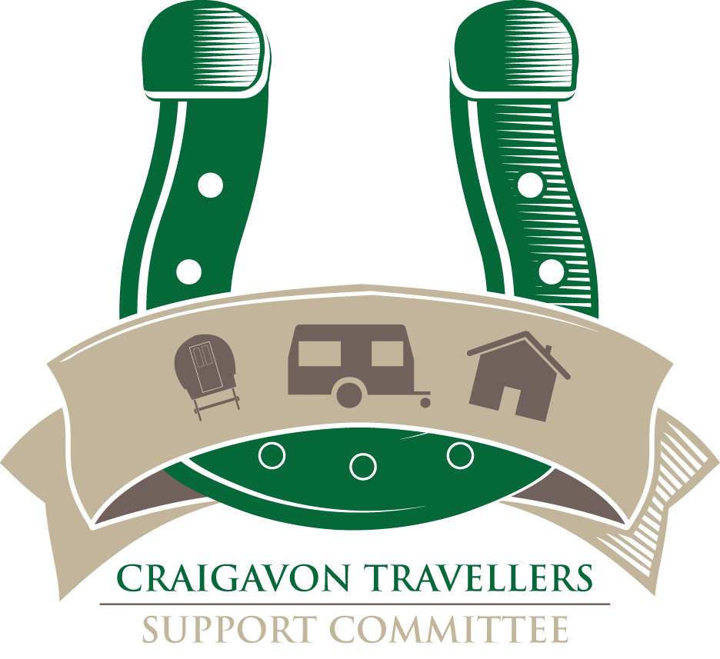
JOB DESCRIPTION

Job Title Youth Development Worker
Salary £28163 pro rata (£20117 per annum)
Hours 25 hrs per week. This post will include at least one evening session per week.
Annual Leave 25 Days and Statutory Days pro rata
Location Based in Craigavon, with some location work within the Southern Trust locality
Responsible to Project Manager

Fixed term until 31st of November 2026. There is the possibility of future funding which may extend the duration of the project.

Background

CTSC is a voluntary organisation and is registered as a charity in Northern Ireland. It is managed by a board constituted from individuals and representatives of local community groups based in the greater Craigavon and Banbridge areas.

Over the last 30 years CTSC has successfully implemented a substantial range of projects for public bodies including the Health and Social Services Trust, the Public Health Agency, the Executive Office, the European Union through Peace I, II, III, IV funded programmes and other voluntary funded projects such as the National Lottery, Joseph Rowntree Charitable Trust and Children in Need.

Although located in Craigavon CTSC works in Banbridge also, this project will extend to Newry to complete an assessment of need of Traveller children and young people in that area also. Alongside our core community development activities, we also contribute to the high-level policy and strategy development within the Human Rights Framework.

Purpose of the Posts

CTSC is seeking a proactive Youth Development Worker to drive the the delivery of our youth programme - promoting empowerment and resilience of young people aged 0- 18 years. This programme will be supported by a Youth Worker.
These posts are funded by Children in Need to work directly with children and young people to develop their social education by providing programmes of activities. The post holder will be line managed by the Project Manager providing strategic leadership and operational guidance. The post will involve the development of youth activities across a range of settings.

Main Purpose

The Youth Development Worker will facilitate the development and coordination of the children and young people’s programmes for Traveller families, ensuring parents are encouraged and supported to be involved at all levels in their child/ren’s development.

To work directly with other youth providers to encourage and support Traveller children and young people to access mainstream services, by supporting external services to be culturally sensitive and accessible to Traveller young people.

Key Tasks

- Establish contact with, listen to, befriend, support and advocate for the children and young people who use our services.
- To identify, prioritise and deliver programme of inclusive youth activities based on the identified needs of the children and young people.
- Ensure that the children and young people play an active role in the project and work towards a model of youth participation

- Promote positive self-talk, positive behaviours and an inclusive, supportive environment within all youth group settings.

- Promote a person-centred approach to the social development of young people, engaging and encouraging them to set their own goals and supporting them to work effectively towards reaching those goals.

- Encourage and support young people to take on new challenges and promote active participation in local community events.

- Develop and maintain relationships with the wider community and external agencies.

- Monitoring and evaluation of all activities as part of the project to be shared with Project Manager.

- Provide relevant written reports to the Project Manager.

- To provide support for volunteers within the project.

- Adhere to agreed policies, protocols and mechanisms identified by the Project Manager

- Delivery of youth work programmes underpinned by National Occupation standards for Youth work.

- Any other work that is reasonable and appropriate to the project.

Personnel Specification

OCN Level 3 in Youth Work or equivalent

5 GCSE’s or equivalent (English & Maths essential)

And

2 years relevant experience working in the community and voluntary sector with experience working with children and young people who have experienced barriers to social inclusion, education and training.

Or alternatively

5 GCSE’s or equivalent (English & Maths essential)

And

Five years’ relevant experience working in the community and voluntary sector with experience working with children and young people who have experienced barriers to social inclusion, education and training.

Experience Required

- Developing and implementing youth intervention programmes/projects.
- Research/consultation and action plan development in relation to youth intervention.
- A working knowledge and understanding of the concepts and approaches of OCN accredited training programmes.
- Conflict resolution/mediation skills.
- Assessment of training needs and organisation of relevant training programmes.
- Making presentations to a variety of groups and audiences.
- General administration, using MS Office
- Hold a valid driver’s licence and have access to a car, this can be waived in the case of an applicant whose disability prohibits driving and who is able to organise suitable, alternative arrangements which enable them to meet the duties of the post.

Skills

- An effective communicator, both oral and written with good creative, analytical and presentation skills including computer literacy.
- Proven ability to work on own initiative and also as part of a team including working to deadlines under pressure.
- Ability to communicate effectively and at all levels within the organisation and outside agencies including statutory and voluntary.
- Experience of co-facilitating, coordinating and delivering inclusive youth activities
- To practice in a non-judgmental manner and respect the rights, responsibilities and opinions of others.
- To be aware of the importance of maintaining professional boundaries and confidentiality within the working environment.

Further Information

- The post holder must be prepared to work flexible hours including evenings and weekends and be able to travel throughout Northern Ireland at times demanded by the job.
- Due to nature of the work all candidates will be vetted through an Enhanced Access NI check.

