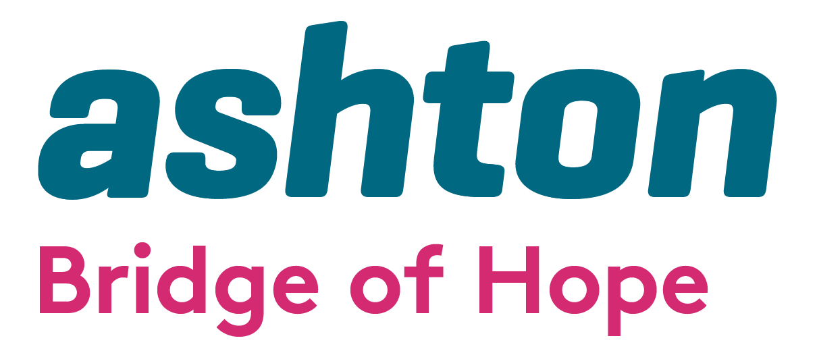

Personal Development & Stress Management Training 2025/2026

Bridge of Hope, part of Ashton’s Health and Wellbeing Department, invites applications from qualified facilitators to deliver Personal Development and Stress Management training in 2025/2026. We seek trauma-informed professionals who can offer impactful, high-quality sessions to individuals affected by conflict and mental health challenges.

Bridge of Hope is a holistic health and wellbeing service supporting those impacted by conflict and emotional trauma.
Mission: To empower and promote positive change for victims and survivors through quality health and wellbeing services.
We are BACP-accredited (No. 211323) and adhere to person-centred, ethical practices.

Services include:
- Counselling & psychological support
- Complementary therapies
- Personal development & life coaching
- Accredited training (VTCT)
- Trauma & PTSD support
- Community outreach
- Support with Troubles Permanent Disablement Pension Scheme
- Health & Wellbeing Casework Support
Learn more:
www.ashtoncentre.com | www.bridgeofhope.support

Types of Training We Offer
We welcome training proposals in areas such as:
- Resilience building
- Stress reduction techniques
- Art therapy
- Confidence building
- Mindfulness & meditation
- Creative expression
- Personal growth & self-discovery

Innovative, trauma-sensitive workshops that promote holistic wellbeing are encouraged.

Facilitator Responsibilities
- To deliver group sessions to victims and survivors of the conflict
- To engage with participants affected by trauma
- To travel to outreach locations
- To work collaboratively with Bridge of Hope staff
- To follow risk management and safeguarding protocols
- To maintain timely and accurate paperwork
- To promote other Bridge of Hope services
- To offer a flexible, client-centred approach in order to meet client need.

Application Information

Section 1: Personal Details

Full Name:

Address:

Email:
Phone:

Do you work: ☐ Independently ☐ With a business/organisation
Organisation/Business Name:

Section 2: Experience & Interests
Please describe your experience of delivering training:

Which courses would you like to deliver? (Include brief programme outline, length & cost) detailed programme content can be attached separately
Please describe your training approach:
Relevant qualifications or certifications:

☐ I’ve attached a CV or summary of experience

Section 3: Training Standards
How do you ensure your content is accurate, up to date and evidence-based?

Do you adapt content to suit different needs (age, background, ability)? ☐ Yes ☐ No
If yes, how?

Section 4: Safe & Inclusive Environment

How do you create a safe, respectful learning environment?

Have you ever completed training on safeguarding, boundaries or sensitive topics?
☐ Yes ☐ No
If yes, please provide details and dates:

Do you know how to refer participants to support services? ☐ Yes ☐ No
How do you manage your own wellbeing while delivering training?

Section 5: Additional Information
Anything else you’d like to share about your experience, approach, or motivation?

Declaration

I confirm that the information provided is accurate and complete. I understand this application does not guarantee a training contract and agree to be contacted regarding this opportunity.

Signature: Date:

Supporting Documents Checklist
☐ CV
☐ Copies of qualifications/certificates
☐ Sample training outline/session plan/cost
☐ References or testimonials (optional)

Copies of Applications with all supporting documentation should be emailed to be clearly marked “Social Support Training” to:

Lindsay Whitten
Operations Manager
Bridge of Hope
Ashton Community Trust

Lindsay.whitten@ashtoncentre.com

Application deadline 12.00 pm on 4th July 2025 No late applications will be accepted.

Please note any successful applications will only be valid for a period up to the 31st March 2026.

Ashton’s Bridge of Hope operates in line with the General Data Protection Regulations 2018. This means we will treat the information you provide to us with strict confidentiality. At times we may need to share some of your information with other staff, funders and other stakeholders.

Contact Details: If you require further information, wish to clarify any points or have a difficulty relating to the application please contact Mary Stanton, Training Coordinator.

Email: mary@ashtoncentre.com Tel: 028 9074 2255

This project is supported by VSS & PEACEPLUS, a programme managed by the Special EU Programmes Body (SEUPB).



