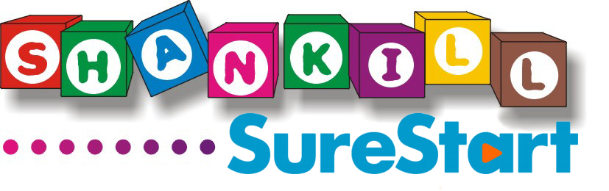

JOB DESCRIPTION

Sure Start Developmental Programme for 2 – 3-Year-Olds (Pf2Y)

Job Title: CHILDCARE WORKER

Salary: £10,500 per annum

Hours: 20 hours’/week, term-time contract

Accountable to: Programme Supervisor

Location: May be located at any of the Tiny Steps settings

Role:
Tiny Steps is a developmental programme for 2 – 3-year-olds and is currently delivered by Shankill Sure Start at four settings: the Hannah Centre, Alessie Centre Ballysillan and Blackmountain Primary Schools. The programme aims to provide children with a range of new experiences and learning opportunities which will help enhance their speech and language development, communication and social skills and which should help ensure they are better prepared for starting nursery school. The programme also seeks to encourage parental involvement and participation through attendance at Stay and Play sessions. The successful candidate will be responsible for assisting in the delivery of the Sure Start Developmental Programme for 2 – 3-Year-Olds at any of the settings listed above.

Key Responsibilities:

- To provide a safe, stimulating and varied programme of play and learning opportunities for children attending Tiny Steps.

- To promote the social, emotional, physical, creative and intellectual development of children and to work in the interest of children at all times, while ensuring the maintenance and improvement of a welcoming child centred environment.

- To contribute to development of programmes and activities for children specific to their needs and to seek advice about changes in a child’s wellbeing.

- To develop supportive relationships with parents/carers and encourage parental involvement in the Tiny Steps programme

- To ensure preparation and maintenance of all facilities required, such as rooms, materials and equipment and ensure all facilities and resources are left clean and tidy after sessions.

- To accompany the Programme Supervisor on initial home visits prior to children starting the programme. To carry out other home visits throughout the year to discuss child’s progress with parents.

- To carry out regular observations of children in your care and use them to plan appropriate activities to meet each child’s individual needs.

- To record child observations in line with current practices within Tiny Steps, including updating photographs and children’s files.

- To screen children using the Wellcomm (or similar tool), at the beginning and end of the year, to help identify those children at risk of developing delayed language skills.

- To ensure a good standard of hygiene and safety and observe all relevant health and safety rules and guidelines.

- To prepare snacks ensuring compliance with current food hygiene legislation.

- To keep a register and attendance record of children and parents attending Pf2Y programmes, as required.

- To ensure confidentiality of information relating to children and families and ensure that child protection guidelines are followed at all times.

- To comply with Sure Start policies and procedures and be aware of and work in accordance with relevant legislation at all times.

- To submit reports as required.

- To attend relevant training courses and meetings as appropriate. Participation in and completion of the regional training for the Developmental Programme For 2 – 3-Year-Olds is a requirement of this post.

- To undertake any other relevant duties as considered appropriate by the Childcare Supervisor and/or Early Learning Coordinator.

Please note that Shankill Sure Start operates a ‘No Smoking Policy’ and all employees must comply with this.

Shankill Sure Start is an Equal Opportunities employer and all staff are expected to adhere to the Equal Opportunities Policy throughout the duration of their employment.

The duties and responsibilities outlined in this job description are not meant to be definitive nor restricted and may be modified to meet changing needs. It should be noted therefore that duties, designation and location of the post might be subject to change in the future to meet the changing requirements of the service.

SURE START DEVELOPMENTAL PROGRAMME FOR 2 - 3-YEAR-OLDS

PERSON SPECIFICATION

Job Title: CHILDCARE WORKER

Salary Scale: £10,500 per annum

Hours: 20 hours’/week term-time

Reports to: Programme Supervisor

Role:
Tiny Steps is a developmental programme for 2 – 3-year-olds and is currently delivered by Shankill Sure Start at the Hannah Centre, Alessie Centre, Ballysillan and Blackmountain Primary Schools. The programme aims to provide children with a range of new experiences and learning opportunities which will help enhance their speech and language development, communication and social skills and which should help ensure they are better prepared for starting nursery school. The programme will also seek to encourage parental involvement and participation. The successful candidate will be responsible for assisting in the delivery of the Sure Start Developmental Programme for 2 - 3-Year-Olds at one of the settings listed above.

Essential Criteria

Qualifications:
- NVQ Level II in Early Years Care and Education or equivalent

Experience:
- Experience of working with young children in an early year setting.
- Knowledge and understanding of the importance of observation and planning
- An understanding of child protection issues

Abilities:
- An ability to work as part of a team and on own initiative
- Good interpersonal skills
- A good standard of written and verbal communication skills

- Hold a current UK Driving Licence and have access to a car

Desirable Criteria:
- Minimum NVQ Level III in Early Years Care and Education or equivalent
- 1 years’ experience of working within an early year setting.
- Experience of working with children with additional needs
- Experience of working with parents

