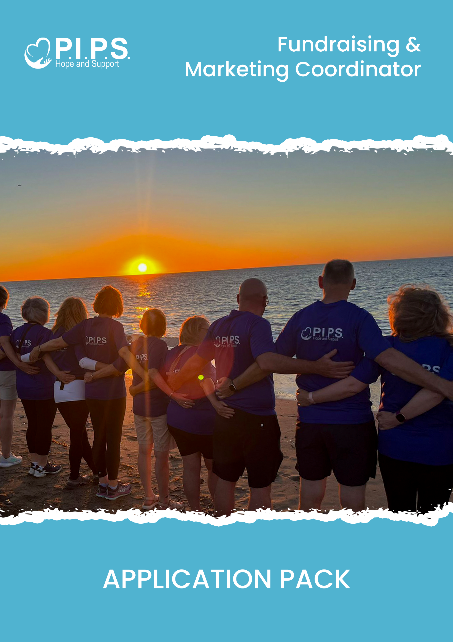

Dear Applicant,

Thank you for your interest in joining the team at **PIPS Hope & Support.**

We are delighted that you are considering applying for this exciting opportunity and look forward to receiving your application for the role of **Fundraising and Marketing Coordinator.**

This application pack includes the following documents:

* Job Description and Person Specification
* Application Form
* Equal Opportunities Monitoring Form

**Important Information – Please Read Carefully**

1. Review the Pack Thoroughly

This pack contains essential details about PIPS Hope & Support, the advertised vacancy, and the ideal candidate. Please ensure you read all documents carefully to confirm the role aligns with your skills and expectations.

1. Completing Your Application

* Please complete the Application Form and Application Checklist in full.
* If you need more space to answer a question, you may continue a separate sheet.
* It is your responsibility to ensure that your application clearly demonstrates how you meet the criteria outlined in the Person Specification.

1. CVs and Supporting Documents

* Applications will only be accepted on the official application form. This ensures consistency and fairness in the recruitment process.
* CVs will not be accepted, either in place of or alongside the application form.
* Additional sheets will only be considered if used as continuation pages for sections where space is limited.

1. Submission Deadline

Completed application forms and the Equal Opportunities Monitoring Form (submitted in a separate envelope marked Monitoring Officer) must be returned by:

**Friday 4th July at 5:00pm**. Late submissions will not be considered.

Please return your application to:

FAO: HR Admin

PIPS Hope & Support

Mill Street

Newry

Co. Down

BT34 1AG

Or by email: [Edel@pipshopeandsupport.org](mailto:Edel@pipshopeandsupport.org)

1. Verification of Identity

In accordance with the Asylum and Immigration Act 1996, all successful applicants will be required to provide valid documentation confirming their identity and right to work in the UK.

1. This role is classified as a regulated position under Article 33 of the Protection of Children and Vulnerable Adults (NI) Order 2003.

* Appointment will be subject to an Access NI enhanced disclosure check.
* A criminal record will not necessarily exclude you from employment. Each case will be assessed on its own merits, considering the nature of the role and the relevance of any convictions.
* Further information is provided by Access NI who have produced a Code of Conduct which can be downloaded from the website [www.nidirect.gov.uk/accessni](http://www.nidirect.gov.uk/accessni)

All personal data provided as part of this application process will be stored securely, processed lawfully, and only used for the purposes of recruitment in line with UK GDPR and the Data Protection Act 2018. Unsuccessful applications will be deleted or securely disposed of within 1 month after the recruitment process concludes.

Applications emailed or hard copy should be returned no later than

Friday 30th May @ noon

**Application forms received after this time and date will not be accepted.**

**RETURN TO:**

FAO, HR Admin

PIPS Hope & Support | 50 Mill Street | Newry | Co Down | BT34 1AG.

Or [Edel@pipshopeandsupport.org](mailto:Edel@pipshopeandsupport.org)

We appreciate your interest in working with PIPS Hope & Support and wish you the best of luck with your application.

# JOB DESCRIPTION

Job Role: **Fundraising and Marketing Coordinator**

Place of work: PIPS Hope and Support, Newry (with travel across the region required)

Reports to: Chief Executive Officer

Salary: £30,000 - £32,000

Hours: 37.5 hours per week (Flexibility required – occasional evening and weekend work)

Annual Leave: 24 days, plus public holidays.

**BENEFITS:** Auto Enrolment, National Employment Savings Trust (NEST)  
Pension Scheme  
Access to Company Westfield Health Care package   
Organisation Sick Pay scheme   
Investors in People awardTOIL (time off in lieu) accrual system (monthly)

**JOB PURPOSE:**

The Fundraising and Marketing Coordinator will play a key role in developing, coordinating, and delivering effective fundraising initiatives and marketing campaigns that generate income, increase public awareness, and promote the mission and services of PIPS Hope and Support.

This role will support the strategic aims of the organisation by building strong community relationships, managing donor engagement, and creating compelling content across multiple platforms to enhance the charity’s visibility and impact.

The postholder will work closely with internal teams and external stakeholders to ensure the continued growth and sustainability of the organisation’s fundraising and communications efforts.

**KEY RESPONSIBILITIES:**

**FUNDRAISING**

* Develop, implement and monitor a strategic fundraising plan aligned with the charity’s objectives.
* Identify and secure funding from multiple sources, including corporate sponsorships, events, and community fundraising.
* Build and maintain strong relationships with funders, donors and supporters.
* Plan, deliver and evaluate fundraising events and campaigns to meet income targets.
* Work with relevant staff and other relevant external and partner organisations to maximise all opportunities for fundraising activities.
* Develop donor care processes, ensuring supporters feel valued and engaged.
* Grow individual giving and supporter engagement through innovative campaigns and stewardship.
* Review and manage an ongoing programme of activity to secure, maintain and develop new and existing corporate support: including gift aid, Enthuse, Just Giving, Easy Fundraising etc.

**MARKETING AND COMMUNICATIONS**

* Lead the development and delivery of the charity’s marketing and communications strategy.
* Promote the charity’s services, campaigns and achievements through digital and traditional media.
* Drive and co-ordinate marketing campaigns and activities that generate income, owning their implementation from idea to execution.
* Create and manage engaging content across multiple platforms (e.g., website, social media, newsletters, press).
* Build and maintain relationships with local and regional media outlets.
* Oversee the design and production of marketing materials and promotional content.
* Monitor and evaluate communications impact, adapting strategies where needed.

**BRAND AND PUBLIC RELATIONS**

* Ensure consistency of branding across all internal and external communications.
* Represent PIPS Hope and Support at events and forums to raise the organisation’s profile.
* Champion the charity’s values, safeguarding its reputation and ensuring appropriate messaging.

**MANAGEMENT AND ADMINISTRATION**

* Maintain accurate records and ensure GDPR compliance in all communications and donor management.
* Prepare reports, updates and data analysis for the CEO and Board of Trustees.
* Contribute to the wider organisational development and participate in staff meetings and training.

**PERSON SPECIFICATION:**

|  |  |
| --- | --- |
| Essential requirements: | Essential |
| 1. Minimum 2 years’ experience in a fundraising, marketing or communications role (preferably in the charity/voluntary sector). | √ |
| 1. Demonstrated success in achieving income targets through varied fundraising methods. | **√** |
| 1. Strong written and verbal communication skills, adaptable to multiple audiences. | **√** |
| 1. Proficiency in digital communications, including social media, website management and e-newsletters. | **√** |
| 1. Strong organisational and time management skills with the ability to prioritise. | **√** |
| 1. Ability to work independently, show initiative, and collaborate with a team. | **√** |
| 1. Flexible and willing to work evenings and weekends as required. | **√** |
| 1. Full UK driving licence and access to suitable transport, or can you meet the travel requirements of the role with reasonable adjustments, if required due to a disability? | **√** |

|  |  |
| --- | --- |
| Desirable requirements: | Desirable |
| 1. Event planning and delivery experience. | √ |
| 1. Skills in graphic design, photography or video editing (e.g., Canva, Adobe Suite). | **√** |
| 1. Experience using donor management systems or CRM databases. | **√** |
| 1. Knowledge of suicide prevention, mental health, and third sector services. | **√** |
| 1. Experience managing PR/media relations and liaising with press. | **√** |
| 1. Understanding of ethical fundraising standards and the Fundraising Regulator Code. | **√** |
| 1. Experience managing e-marketing tools such as Mailchimp or equivalent. | **√** |
| 1. Familiarity with safeguarding policies and procedures. | **√** |

**TERMS AND CONDITIONS OF EMPLOYMENT:**

* Appointment is subject to the receipt of two satisfactory references.
* In accordance with the Asylum and Immigration Act, successful applicants must provide evidence of their right to work in the United Kingdom. This is typically demonstrated through a valid passport; alternative forms of identification will be outlined if a passport is not available.
* Appointment to this post is subject to a satisfactory Access NI enhanced disclosure check.

***This job description is not intended to be exhaustive or restrictive.***

***The duties and responsibilities outlined may be subject to reasonable change in line with the needs and development of the organisation and the services it provides.***

**PIPS HOPE & SUPPORT JOB APPLICATION FORM**

|  |
| --- |
| **Job Ref: FMC-2025** |
| **Application No:** |

* **Please write clearly (type or block capitals)**
* **All information will be treated in confidence and will be used by PIPS Hope & Support to assess your suitability for the job.**
* **Candidates will be short listed based on information contained in this application.**

**THE VACANCY**

Job Applied For: **Fundraising and Marketing Coordinator**

Family Name: ________________________________________

Forename (s): ________________________________________

Address: ________________________________________

________________________________________

________________________________________

Postcode: ________________________________________

Home Tel. No. ________________________________________

Mobile No. _______________________________________

Email Address: ________________________________________

National Insurance No. _______________________________________

**REFERENCES**

All offers of employment are subject to receipt of satisfactory written references. Please provide the names, telephone numbers, addresses and email addresses of two referees, one of whom should be your present or most recent employer/line manager, and one who knows/has known you in a work capacity and can comment on your suitability for this post.

|  |  |
| --- | --- |
| **FIRST REFEREE** | **SECOND REFEREE** |
| NAME: | NAME: |
| ADDRESS: | ADDRESS: |
| TEL: | TEL: |
| EMAIL: | EMAIL: |
| OCCUPATION: | OCCUPATION: |
| RELATIONSHIP TO YOU: | RELATIONSHIP TO YOU: |

**We will only contact referees after a conditional offer.**

Have you ever been convicted of a criminal offence? Yes / No

[Exclude convictions which are spent under the

Rehabilitation of Offenders (NI Order 1978)]

Have you ever been excluded / barred from working with Yes / No

children and/or young people?

**YOUR QUALIFICATIONS**

|  |  |  |
| --- | --- | --- |
| Type of Exam (GCSE, NVQ, A Level, Degree etc) | Subject | Grade |
|  |  |  |

Are you currently employed? Yes / No

Current Salary: ______________________

Notice Required: ______________________  
  
  
**PREVIOUS JOBS** *(Start with present or most recent job)*

|  |  |  |  |
| --- | --- | --- | --- |
| **Name & Address of Employer** | **Dates employed & salary** | **Type of Job (give brief description of duties**) | **Reason for Leaving** |
|  |  |  |  |
|  |  |  |  |
|  |  |  |  |
|  |  |  |  |

*[Please attach additional sheet if required]*

**ESSENTIAL CRITERIA**

Referring to the Person specification above ***(Essential criteria)*** Please ensure that you complete the following checklist ensuring you meet the essential criteria on points numbered 1 – 6 to assist us in the processing of your application.

Shortlisting will be based on evidence that you meet the requirements for this post.

**Criteria – Essential**

|  |
| --- |
| 1. Do you have at least 2 years’ experience in a fundraising, marketing or communications role (preferably in the charity/voluntary sector)? ***Please describe your experience, including organisation names, roles, and dates.*** |
|  |
| 1. Can you demonstrate success in achieving income targets through varied fundraising methods? ***Give examples of campaigns, grants or initiatives you've led or contributed to.*** |
|  |
| 1. Do you have strong written and verbal communication skills, adaptable to different audiences? ***Provide examples of content you’ve developed, or presentations given.*** |
|  |
| 1. Are you proficient in digital communications, including managing social media, websites, and e-newsletters? ***List tools you’ve used (e.g., WordPress, Mailchimp etc.) and describe your role in managing them.*** |
|  |
| 1. Do you have strong organisational and time-management skills, with the ability to prioritise? ***Give an example of how you managed competing deadlines or multiple projects.*** |
|  |
| 1. Can you work independently, show initiative, and work as part of a team? ***Describe a time you took the lead or collaborated successfully.*** |
|  |
| 1. Are you flexible and willing to work evenings and weekends when required? ***Briefly comment on your availability and approach to flexible working.*** |
|  |
| 1. Full UK driving licence and access to suitable transport, or can you meet the travel requirements of the role with reasonable adjustments, if required due to a disability? |
|  |

**Criteria – DESIRABLE**

(You are not required to meet all of these to apply, but please complete any that apply to you.)

|  |
| --- |
| 1. Do you have experience in planning and delivering events? ***Provide details of events organised and your responsibilities.*** |
|  |
| 1. Do you have skills in graphic design, photography, or video editing (e.g., Canva, Adobe Suite)? ***List relevant tools and projects.*** |
|  |
| 1. Do you have experience using donor management systems or CRM databases? ***Specify systems and how you used them.*** |
|  |
| 1. Do you have knowledge of suicide prevention, mental health, or third-sector services? ***Describe your understanding or any relevant experience.*** |
|  |
| 1. Have you worked with press/media or managed PR relationships? ***Provide examples of coverage gained or media engagement.*** |
|  |
| 1. Do you understand ethical fundraising standards and the Fundraising Regulator Code? ***Briefly outline your awareness or training.*** |
|  |
| 1. Have you used e-marketing platforms such as Mailchimp or similar tools? ***Provide details of your role in managing campaigns.*** |
|  |

**OTHER INFORMATION**

|  |
| --- |
| Please tell us about you, your interests and indicate why you are interested in this position. |
|  |

|  |
| --- |
| Please include any other information which you feel may be of interest in considering your application. |
|  |

By submitting this application, I consent to my personal data being used for the purposes of recruitment in accordance with UK GDPR and the Data Protection Act 2018. I understand that if unsuccessful, my data will be securely deleted within one month of the recruitment process concluding.

**DECLARATION**

I declare that the information I have given is correct.

Signed: ________________________________

Date: ________________________________

**MONITORING FORM Ref: PIPSWBC2025**

PIPS Hope & Support is committed to promoting equality, diversity, and inclusion in all aspects of its work. We aim to create a supportive environment that respects and values individual differences and ensures equal opportunities for all.

To help us monitor how well we are meeting our equality and diversity objectives, we ask all applicants to complete this form. The information you provide will be treated with the strictest confidence, stored securely, and used solely for monitoring purposes in accordance with the UK General Data Protection Regulation (UK GDPR) and the Data Protection Act 2018.

This form is separate from your application and will not be used in the selection process.

Please provide information below about yourself that would assist this process.

|  |
| --- |
| **Please indicate the community background to which you belong or are perceived to belong (required for monitoring under the Fair Employment and Treatment (NI) Order 1998):**  I am a member of the Protestant community.  I am a member of the Roman Catholic community.  I am a member of neither the Protestant nor Roman Catholic community.  Prefer not to say. |

|  |
| --- |
| **Please indicate your gender by ticking the appropriate box below:**  Female  Male  Non-binary  Prefer to self-describe: ____________________  Prefer not to say.  **Is your gender identity the same as the sex you were assigned at birth?**  Yes  No  Prefer not to say. |

|  |  |  |
| --- | --- | --- |
| **Sexual Orientation.** | | |
| Heterosexual / Straight  Asexual  Other (please specify): | Gay or Lesbian  Pansexual | Bisexual  Prefer not to say |

|  |
| --- |
| **Do you consider yourself to have a disability as defined under the Equality Act 2010, defined as a physical or mental impairment, which has a substantial and long-term adverse effect on a person’s ability to conduct normal day to day activities?**  Yes  No  Prefer not to say.  If yes, please state the nature of your disability (optional): |

|  |  |  |
| --- | --- | --- |
| **Age Group** | | |
| Under 18  35–44  65+ | 18-24  45–54  Prefer not to say | 25–34  55–64 |

|  |  |  |
| --- | --- | --- |
| **Please tick the option that best describes your ethnic group.** | | |
| Bangladeshi  Black other  Irish Traveller  Other Ethnic Group:  (Please state) | Black Africa  Chinese  Pakistani | Black Caribbean  Indian  White |

|  |  |  |
| --- | --- | --- |
| **Please tick the option that best describes your Religious Belief.** | | |
| Roman Catholic   Methodist  Hindu  Sikh | Presbyterian  Baptist  Jewish  Prefer not to say | Church of Ireland  Muslim  Buddhist  Other, please specify: |

|  |  |  |
| --- | --- | --- |
| **Caring Responsibilities** | | |
| None  Primary carer of a disabled adult (18+)  Prefer not to say. | Primary carer of a child or children (under 18)  Primary carer of an older person (65+) | Primary carer of a disabled child  Secondary carer (e.g., assists a primary carer) |

Please return this form in a sealed envelope marked **Private & Confidential – Monitoring** to:

**Monitoring Officer**  
PIPS Hope & Support  
50 Mill Street  
Newry  
Co. Down  
BT34 1AG