

**Candidate Information Pack**

**For the Position of**

**Floating Support Worker**

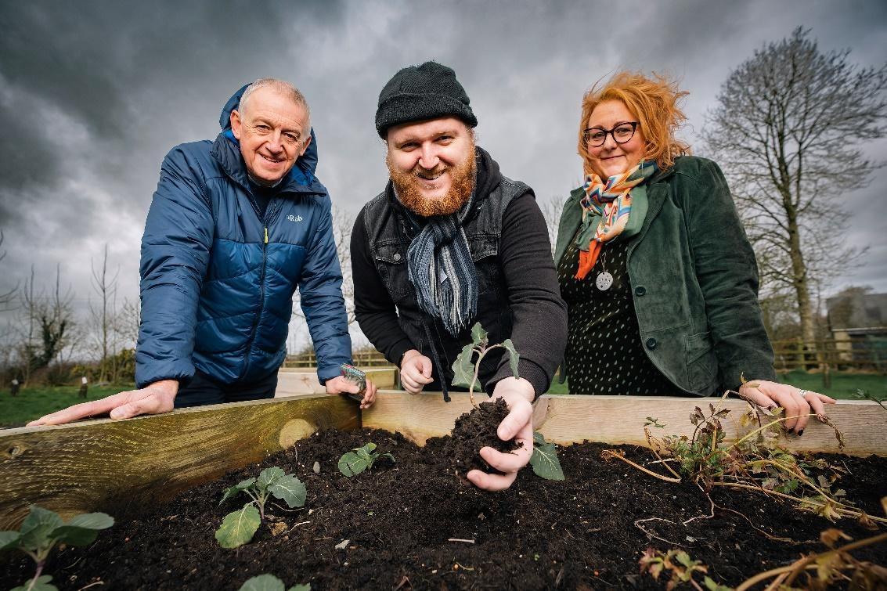

**

**June 2025**

Dear Applicant,

Thank you for expressing your interest in the post of **Floating Support Worker**.

This is an exciting opportunity for the successful candidate to make their mark and help drive innovation within a well-respected organisation, recognised as a model of best practice. We value experience and attitude over qualifications so if you think you are the right person for the job we want to hear from you.

Please find enclosed relevant information relating to CAN and the role.

Please send us your **CV and** include a **covering letter** telling us:

1. Why you are attracted to this position: and
2. What you will bring in terms of previous experience?

PLEASE clearly demonstrate HOW you meet the Essential and Desirable Criterion in the covering letter as failure to do so may eliminate you from the process. If you would like any further information, please do not hesitate to contact us on 028 275 23053 or email info@compasspeople.org.

Applications must be sent to us (as above) by **Friday 19th July 2025** at 4pm.

Thank you for your interest in Compass Advocacy Network.

**Yours sincerely,**

**Janet**

**Janet Schofield,**

**Chief Executive Officer**

**___________________________________________________________________________________**

Charity No. **NIC100988** Registered Company No. NI32676

Head Office Address: 32 Lislagan Road, Ballymoney, BT53 7DD.  Tel  028 275 23053. [www.compasspeople.org](http://www.compasspeople.org/)

**Background to the Organisation**

**CAN (Compass Advocacy Network)** is an award-winning organisation based in Northern Ireland, recognised for its leadership in sustainability and its transformative impact on health and social care. With over 25 years of experience, CAN delivers creative, cost-effective solutions that place individuals at the centre of everything it does.

An independent, user-led organisation, CAN ensures the voices of its core service users are heard and valued through its active Board and dedicated People’s Forum. Each year, CAN supports over 575 individuals, families, and carers through holistic programmes designed to meet diverse needs. In addition to its core services, CAN has developed several successful social enterprises that generate income while offering meaningful training and employment opportunities for people with disabilities and mental health challenges.

Despite the pressures of COVID-19, political instability, and a cost-of-living crisis, CAN has remained resilient—maximising income and streamlining operations to sustain and grow its services. Its long-term vision is to create a society where people with disabilities and mental health needs can fully realise their potential.

By 2028, CAN aims to generate at least 50% of its income through social enterprise activities, increasing its financial independence and sustainability. A key milestone in this journey was the 2021 acquisition of **Lislagan Farm**, an 11-acre site that will serve as a flagship facility, offering a unique blend of therapeutic, social, and training opportunities.

Refurbishment is about to begin on the farm’s **Old Stone Cottage**, which will soon offer bookable accommodation and overnight respite care. This marks the first step in the development of CAN’s ambitious **Respite Village**—a welcoming, inclusive environment designed to meet the evolving needs of children and adults with learning disabilities, autism, and neurodiversity, as well as their families and carers.

Lislagan Farm is a vibrant, multi-use space where individuals can connect with nature and community through meaningful activities all year round.

It stands as a beacon of CAN’s commitment to inclusion, innovation, and sustainable impact.

This role will be critical in maximizing the benefits of the site.

**Job Description**

**Job Title: Floating Support Worker**

**Reporting to:** Director of Services

**Hours of Work:** 37 hours

**Location:** This role is based at any location of CAN’s projects (currently Ballymoney, Ballymena & Coleraine). This post may require travel across NI and occasionally outside NI. Reasonable Hybrid/Off-Site working enabled where appropriate.

**Culture:** Flexible, life and family-friendly, happy to discuss working patterns to suit you.

**Salary:** £25108.20 per annum - £13.05 per hour

**Pension:** 8% Employer contribution of salary

**Holiday Entitlement:** 25 Days plus 10 Statutory Days (Pro-Rata) increasing with long service

**About You:**

We want someone to join us who embodies our core values of ambition, passion, and integrity, dedicated to fostering positive social change and enhancing the lives of individuals in Northern Ireland. Your approach will reflect our ethos of active listening, non-judgment, and collaboration, both internally and externally.

You'll possess the skills and qualities necessary to cultivate strong and meaningful relationships, coupled with a commitment to collaborative work alongside the Services team and our broader staff community.

Our organisational culture encourages an ego-free environment, fostering a relaxed and supportive atmosphere where authenticity is celebrated and encouraged in your role.

**Purpose of the Role**

The Floating Support Worker will be available to support our members across all CAN’s projects (Services & Enterprise), and will involve carrying out a wide range of tasks to ensure that we are offering meaningful day activities which promote independence and empowerment. The role is diverse and could involve covering our BASE service which offers day opportunities to 17 people per day or it could be providing one to one support on the farm through our LIFE programme.

They will be a key member of the Service provision team, working closely with colleagues to ensure programme delivery aligns with CAN’s mission, delivers high social impact, and is sustainable. This role requires a dynamic, person who understands our member’s needs, believes passionately in social change, and can bring people with them.

#### Key Responsibilities

#### Operational Delivery:

* To provide ongoing active support to our service users in the implementation of their daily activities;
* To offer practical support across the organisation;
* To ensure service users receive appropriate assessment, training and encouragement to develop both their skills and attitudes;
* Ensure the service users are assisted to participate and integrate fully into local communities.
* Ensure a safe and clean environment is maintained at all times within the project through adherence to and in accordance with legislative requirement
* To provide administration support to the services department and maintaining accurate records;
* To carry out the role in a professional manner, working within the aims, values and ethos of CAN;

#### Support Duties:

* Provide support to the service users by supporting them in their daily activities which could be situated at a Base, Lislagan Farm or retail social enterprise;
* Daily supervision of adults with learning disabilities;
* To ensure that service users are fully aware of their rights and responsibilities;
* To advocate on behalf of the service user as appropriate;
* To promote and facilitate service user participation across the services department;
* To prepare and assist in the preparation and design of training materials, guidelines and other materials relevant to the project and the delivery of same to the service users;
* Report any safeguarding concerns to the ASC for referral as appropriate;
* To assist with any additional staff cover where required to cover absence periods

#### Health & Safety:

* To risk assess activities within organisational guidelines;
* To be responsible for safe and tidy work practices within the office and externally;
* Notify the Director of Services of any incidents or accidents and ensure appropriate records are kept;
* To undertake mandatory training to fulfil the duties of the post.

#### Administration:

* General office duties including answering the telephone and dealing with enquiries relating to a project;
* Responsibility for appropriate record keeping and reporting relating to the project;
* Maintain administrative records with regards to the safe handling of petty cash;
* Attendance at CAN staff meetings as necessary;
* To take part in promotional events, press interviews, seminars and training days as appropriate; Maintain project attendance and financial records;
* To be responsible for all aspects of office administration and to implement new centralised office procedures;
* To act as first point of contact for enquiries regarding information, correspondence or services including co-ordination with Day Opportunities Co-Ordinators and CAN staff;
* To report to the Director of Services on individual/project progress through verbal communication and monthly written reports including through Evide Social Impact Tracker and RAG (Red, Amber & Green) reports.

#### Other:

All staff are required to:

* Carry out their work in accordance with the organisational culture, values and behaviours;
* Be aware of, understand and comply with all the CAN’s policies and procedures;
* Participate in any staff review/performance management processes involving the identifying and meeting of training needs for self and others;
* Always maintain the confidentiality of information received;
* Carry out such other appropriate tasks and work as requested;
* Attend and participate in staff meetings, team meetings and relevant training;
* Attend some of CAN’s events each year;
* Identify improvements and efficiencies – we have a lean approach to our operations and are always trying to improve;
* CAN is an Equal Opportunities Employer.

**Personnel Specification**

To be considered for this role, you need:

**Personal Qualities and Skills:**

* **Highly flexible and adaptable:** Willing to work across multiple locations and adapt to changing service needs.
* **Keenness to learn:** Enthusiastic about personal and professional development, and eager to participate in ongoing training and learning opportunities.
* **Ambitious:** Motivated to take on new challenges and advance within the organisation, with a proactive approach to continuous improvement.
* **Strong team player:** Able to work collaboratively, take initiative, and support colleagues.
* **Open to innovation:** Willing to contribute new ideas and help improve service delivery.

**Essential Criteria:**

* 2 years in the last 5 years’ experience of working with vulnerable people within a community based environment (or part time equivalent);
* Secondary level education
* Demonstrable and relevant voluntary sector project delivery experience;
* Excellent interpersonal skills (both written and verbal) with the ability to interact effectively with young people, members, colleagues and families and to build relationships with external organisations
* Competent IT Skills (Word, Outlook, Excel, Publisher)
* Able to analyse Risk Assessments and prepare Support Plans for individual service users as required.
* Good time management and organisational skills and an ability to prioritise workload in a crisis.
* Ability to work independently as well as in a team in the delivery of a holistic service to project participants;
* Hold a clean, valid driver’s licence and have access to a car (this can be waived in the case of an applicant whose disability prohibits driving, but who is able to organise suitable alternative arrangements which enable them to meet the duties of the post)

**Desirable Criteria:**

* A qualification in youth work, counselling or a relevant professional qualification in a health or social work-related field;
* Recent experience of working with people with learning disabilities and their families;
* Experience in the management of challenging behaviour and/or complex needs.
* Experience of/and or understanding of advocacy services;

**Other Requirements:**

* Demonstrate a commitment to CAN's vision, mission, and core values: Ambition, Passion, and Integrity, along with the behaviours of Active Listening, Non-judgmental attitude, and Collaboration.
* Show dedication to Diversity, Equity, and Inclusion, willing to engage with a broad spectrum of individuals.
* Be available to attend both daytime and evening events across Northern Ireland, the UK, and Ireland.

**N.B. This Job Description is not intended to comprehensively list the responsibilities of the post, but to indicate the main areas which at this stage appear to be the essential requirements of the post.**

**Equal Opportunities**

Compass Advocacy Network is an Equal Opportunities Employer and all applications for employment are considered strictly on the basis of merit.

CAN is committed to ensuring equal opportunities, fairness of treatment, dignity, work-life balance and the elimination of all forms of discrimination in the workplace for all staff and job applicants. CAN aims to create a working environment in which all individuals are able to make best use of their skills, free from discrimination or harassment, and in which all decisions are based on merit.

**Access NI (Criminal Convictions Check)**

Please note, all successful post-holders are required to complete an Enhanced Disclosure through Access NI. In addition, this individual will also be required to handle cash, cheque and other transactions, necessitating total trustworthiness and reliability.

**Disability**

In accordance with the Disability Discrimination Act a person is disabled if they have, or have had, “a physical or mental impairment which has, or has had, a substantial and long term adverse effect on your ability to carry out normal day to day activities”. If you consider yourself to have a disability relevant to the position for which you are applying please contact Danielle McKee so that we can process your application fairly, make any specific arrangements for your interview, and make any necessary reasonable adjustments or adaptations, or provide any aids to assist you in completing the duties of the post.

**References**

Applicants are required to provide details of two referees. Referees will not be contacted until after the interview process. You should not provide anyone who is related to you as a referee.

**Application Deadline**

**The deadline for completed applications is Friday 19th July at 4pm.**

**To apply, please send your CV along with a Covering Letter (see above).**