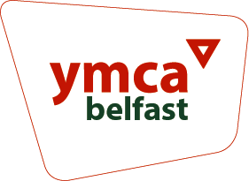Fundraising and Communication Manager

**Supplementary Questions – Please include examples in your responses**

| Tell us about your relevant third level qualification or equivalent (150 words max) |
| --- |
|  |
| Tell us about your 3 years or more experience of working within a fundraising and communication role (300 words max) |
|  |
| Tell us about your track record of delivering fundraising campaigns (300 words max) |
|  |
| Describe how you would develop a fundraising and communication strategy for Belfast YMCA (300 words max) |
|  |
| Describe your experience of developing relationships with key stakeholders, partners and funders (200 words max) |
|  |
| Describe your excellent organisational skills (150 words max) |
|  |
| **Desirable Criteria**  (In the event of a high number of applications we may apply the desirable criterion as part of the selection) |
| Tell us about your experience of leading on significant fundraising campaigns - generating income in excess of £200k per year (200 words max) |
|  |
| Tell us about your experience in using design tools and social media platforms in a professional role (200 words max) |
|  |

**Please complete and return along with your CV (max 3 sides) and Equal Opportunities Monitoring Form to** [**jobs@belfast-ymca.org**](mailto:jobs@belfast-ymca.org) **by noon Monday 9th June 2025**