Fundraising and Communications Manager  
Information Pack

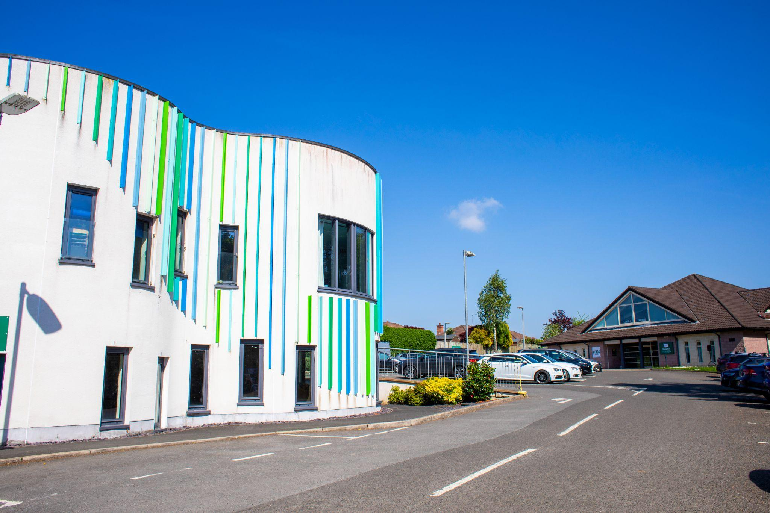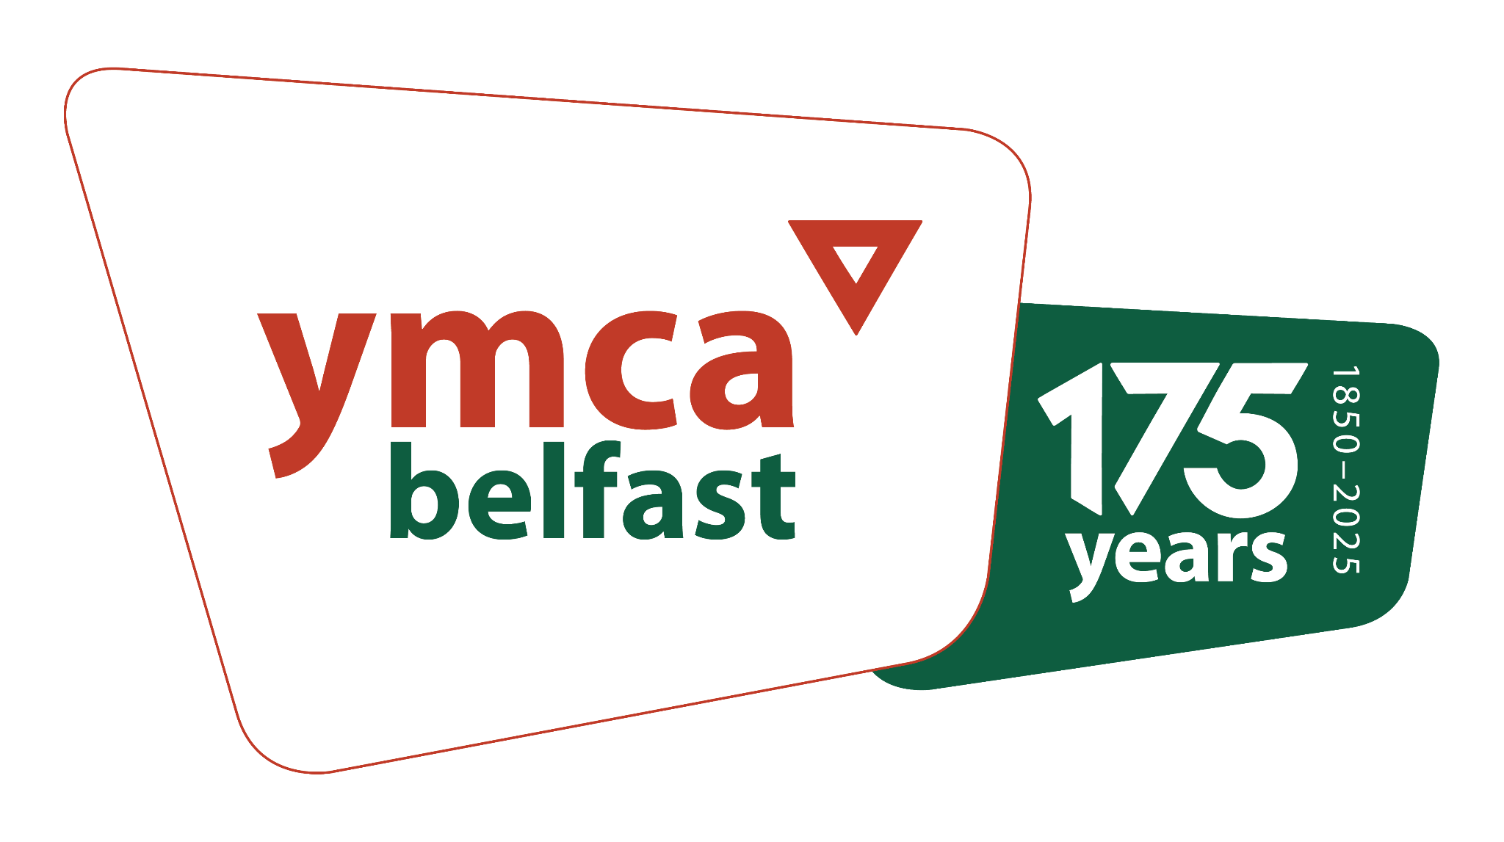

Contents

**Introduction 3**

**What we do 4**

**Vision, Mission and Values 6**

**Strategic Plan and Priorities 7**

**Job Description 8**

**Job Details 9**

**Person Specification 11**

**How to apply 13**



# 

## 

## 

## Introduction

**Dear Candidate**

We have been serving people and communities across Belfast for 175 years and we have a rich legacy of supporting children, young people and communities throughout that time. Peacebuilding has been at the core of our work for over 40 years and this will continue to be the golden thread through all we do.

A registered charity and company limited by guarantee in our own right, we are also part of a global family of YMCAs which helps keep us openminded and outward-looking for ever better ways to realise our mission.

In an exciting time of growth for the organisation, we are seeking to recruit a Fundraising and Communications Manager who shares our vision. As a skilled communicator, you will bring your experience and skills as well as your knowledge of how to both develop and deliver on a fundraising and communications strategy. Experience in securing trusts and grants is a key requirement for anyone in this role.   
  
The role will be based on our site in Stranmillis, bordering the Lagan Meadows, where we have purpose built nursery facilities, offices, sports hall and pitches with an abundance of outdoor space.

We think this is a great place to work and we care about making it an organisation where our staff, volunteers and young people all have the opportunity to thrive.

If you are passionate about fundraising and communication and making life better together then we would very much welcome your application.

**Chris Cupples**CEO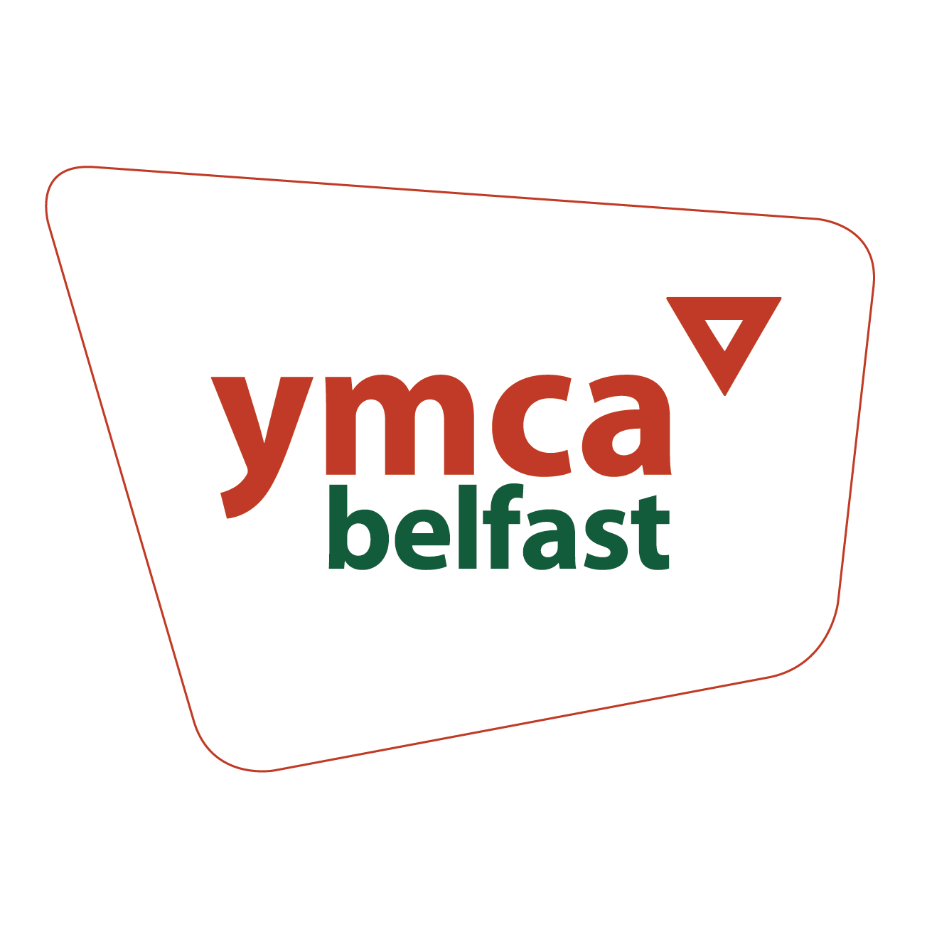

## 

## 

### What we do

**Nursery, Afterschool and holiday clubs**

We provide care for over 200 children each week with a team of over 38 staff working across our childcare and after schools groups.

In our Stranmillis nursery, we have dedicated rooms for babies, toddlers and three nursery aged rooms. We also have a range of indoor and outdoor play areas available for each of the rooms to use.

Our after school programme at Stranmillis provides two separate classrooms for P1- P3 children and P4-P7 children as well as ample outdoor space for play.

Our newest After School club is based in St Jude’s Parish Hall on the Ravenhill Road, opposite Cherryvale Park. Where we have a large and bright upstairs hall, garden space and we regularly use Cherryvale Park for outdoor play and activities.

Our nursery and after school facilities are inspirational spaces for opportunities and experiences for all age groups that stimulate physical, social, intellectual and emotional development.

We offer great outdoor spaces where children can enjoy free play and a healthy environment.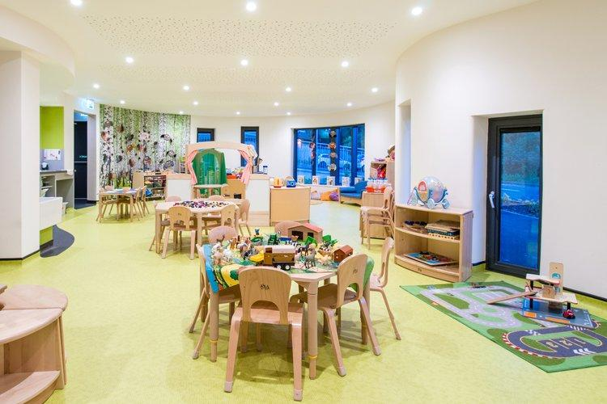

### 

During school holidays we also run clubs for school aged children between 9am-6pm with a programme of play, craft, sport, trips and various outdoor activities.

**Youth and Good Relations Programmes**

Since 2013 our youth team have been delivering our projects in schools throughout East Belfast. Over the course of the academic year we work with over 500 young people in schools across a number of the programmes we offer. The youth team facilitates sessions with pupils in their class groups, usually weekly throughout a term. Our largest programmes focus on good relations.

Ubuntu, our good relations schools programme uses dialogue and interactive learning to increase awareness of stereotyping, sectarianism and migration.

Our youth team also run a number of other programmes including; Youth in Government, Youth Club and summer programmes.

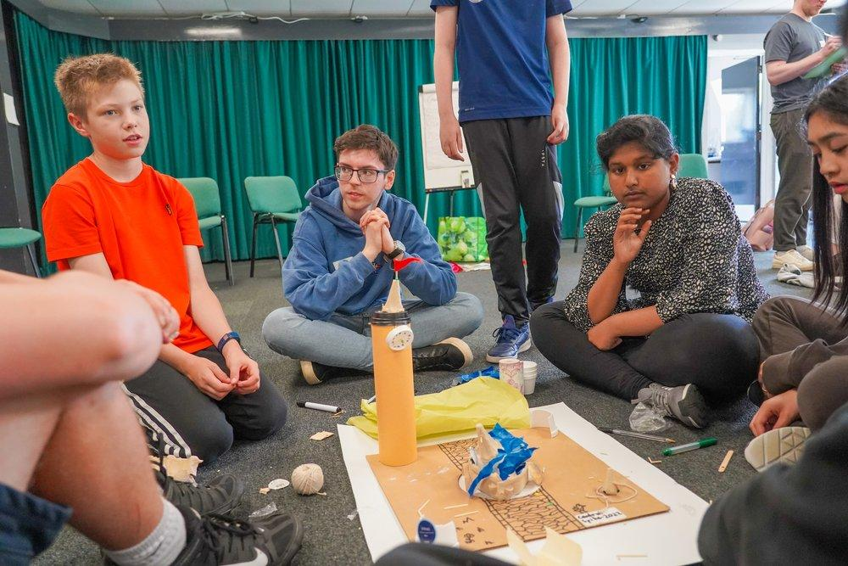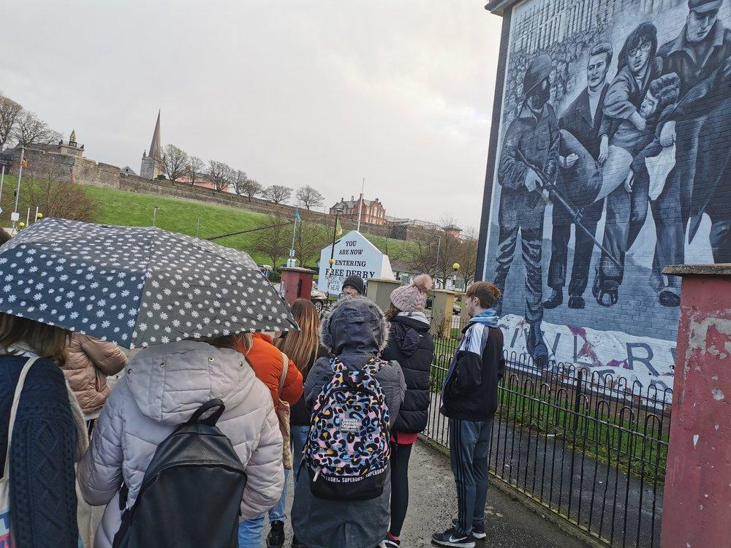

**Community**

We value community and bringing people together. That’s why we work in partnership with other community organisations:

* **CFC South** - Every Sunday we host the local Church, CFC South. We work in partnership to host community events and other initiatives.
* **Dad Camp** - Each August, we team up with Crown Jesus Ministries to run Dad Camp, a special experience for fathers and their children.
* **Alpha** - We work with Alpha to offer chances for people to explore and deepen their Christian faith.
* **Ethos Training**: Ethos Training, our anchor tenant, operates a gym within our Stranmillis Hub, promoting health and fitness.
* **Aquinas Football Club**: Our sports pitches are home to Aquinas FC, providing football training and matches for local boys and girls.
* **Sólás**: Through the SONA project, we host Sólás who provide care for young adults with autism and additional needs.
* **Stranmillis Primary School:** We share our playing fields with Stranmillis Primary School, enhancing outdoor activities for 470 pupils.
* **Community Garden**: We have a newly established community garden thanks to our growing volunteer team.
* **Forest School**: We are in the process of establishing a Forest School on site
* J**unior Parkrun**: Since January 2024, we've been running a volunteer-led Junior Parkrun, a weekly 2k run for children aged 4-14.

Throughout the year we also run a number of community events and fun days for the whole community.

## Vision, Mission and Values

## Our Purpose

**Vision**Our vision is a city where life is better for children, young people and our communities

**Mission**  
Our mission is to:

1. Empower children and young people to learn, grow and thrive
2. Support our community towards a lasting peace
3. Create opportunity through accessible activities, places and partnerships

**Values**

Welcome - Our welcome is unconditional  
Care - We care passionately about our people   
Excellence - We pursue excellence in all we do  
Relevance - We are relevant to the changing needs of Belfast

**Our charitable objectives are to:**

* Promote the Christian faith
* Provide educational opportunities for all people (particularly young people)
* Promote healthy living (including mental, emotional and spiritual wellbeing)
* Promote community engagement and citizenship
* Assist in the relief of hardship or distress

## Job Description

**Job Title:** Fundraising and communications Manager

**Reporting to:** Head of Operations

**Location:** Belfast YMCA, 56-58 Knightsbridge Park, Belfast, BT9 5EH

**Salary Scale:** £30,000 - £35,000

**Other Benefits:** 5% employer pension contribution  
 Employer sick pay scheme   
 Holidays - 31 days per year rising to 37 days per year   
 (Inclusive of stat days)  
 Death in service life insurance  
 Long service awards  
 Staff discount on childcare   
 Flexible and home working

**Hours:**  37.5 hours per week Monday to Friday between

9.00am-5.00pm with occasional evening and weekend work. (Flexible working arrangements, including part-time hours, may be considered for the ideal candidate.)

**Contract:**  Full Time Permanent

**Probation Period:** Six Months

**Main purpose of the Job:**

You will be responsible for leading one of our strategic priorities: to diversify and increase our income with overall leadership of our fundraising and communications strategy for the organisation.

This will be a varied and exciting role, with the opportunity to bring your own skills and flair in how we achieve this. It will require a significant focus on securing annual and multi-year trusts and grants to enable the delivery of our youth, family and community programmes.

Over the next 3 years there will also be the opportunity to lead on a capital funding programme as we seek to redevelop our facilities and expand our reach across Belfast.

## Job Details

1. **Fundraising** 
   1. To carry overall responsibility for leading our fundraising and communications strategy for the organisation with the overall aim of diversifying and increasing our income year on year
   2. When needed, to work with external consultants / agencies to provide specialist expertise (video, design, PR etc)
   3. To appropriately plan, allocate and evaluate your work related to the strategy and ensure an operational plan is put in place each year
   4. To work closely with the Head of Operations, CEO and colleagues across the organisation to identify appropriate funding needs and opportunities
   5. Develop and deliver fundraising campaigns to increase income including: one off gifts, regular giving, capital donations, legacy income, high value donors and corporate partners
   6. To increase income from trusts and foundations by building relationships, identifying opportunities, completing applications, and providing quality reports
   7. Develop and deliver donor development plans, creating clear journeys for support for our new and existing donors
   8. Supporting applications and reports to institutional donors, as and when required
   9. To lead on partnerships with Corporate partners to grow our influence, collaboration and funding
2. **Communications** 
   1. Working with the Head of Operations, CEO and colleagues to maintain and improve communication across the organisation around our impact and outcomes
   2. To lead on regular social media content and output across linkedin, instagram and facebook - liaising with other teams and departments to enable stories, photos and help tell the impact of our work
   3. To work with external consultants to better promote our digital presence across both websites and social
   4. To enable the organisation to tell our story better - upskilling staff and the wider organisation to do this in their communications
   5. To build upon and ensure an effective engagement strategy, creating links with new and existing stakeholders and potential supporters
   6. To establish positive feedback loops with donors, funders and partners
   7. To produce reports and material that can be used for communicating to a wide range of audiences
   8. To work closely with external partners and colleagues to ensure good quality digital content is planned and delivered across various channels
3. **Customer Relationship Management System**
   1. To be responsible for working with the Head of Operations and colleagues in updating and using our CRM system and donations platform
   2. To ensure that data is handled effectively and efficiently and in a way which complies with legal and best practice guidelines
   3. To produce management reports and donor contact lists to communicate with donors through various channels
   4. Support the input and amendment of records on the CRM, as and when required
4. **Financial Management** 
   1. To be responsible for the fundraising and communications budget
   2. To work closely with the operations and finance team to effectively record income and expenditure in line with the strategy and operational plan
   3. To ensure compliance with financial policies and procedures
   4. To ensure compliance and reporting to funders for both restricted and unrestricted income
5. **Other responsibilities** 
   1. To identify new opportunities for the organisation to partner and collaborate with other organisations within the community and voluntary sector
   2. To play a key part in the organisation’s senior team, working closely with the Head of Operations and colleagues

**NOTE:** This is not an exhaustive summary of the responsibilities. The post holder will be expected to undertake any other duties of a similar nature from time to time.

## 

## 

## Person Specification

|  | **Essential** | **Desirable** |
| --- | --- | --- |
| **Qualifications** | A relevant third level qualification or equivalent | Further professional qualifications in a relevant discipline (Fundraising or communications) |
| **Experience** | 3 years or more experience working within a fundraising and/or communications role  A track record of delivering fundraising campaigns  Experience in developing relationships with stakeholders or partners  Experience of writing successful applications to funders and grant making Trusts  Experience of generating income in excess of £100k per year  Experience of developing and delivering a fundraising and communications strategy  An understanding of the local and national fundraising sector | Experience of leading on significant fundraising campaigns - generating income in excess of £200k per year  Experience of representing an organisation to a wide range of stakeholders  Knowledge of issues relevant to the third sector in Northern Ireland |
| **Skills** | Excellent written and verbal communication skills  Excellent organisational and interpersonal skills  High digital literacy including use of digital systems  Ability to work on own initiative  Understanding of setting and managing a budget | Experience in using design tools and social media platforms in a professional role  Experience in using google workplace software  Experience of having previously implemented a CRM system |
| **Personal / Character** | Supportive of Belfast YMCA’s Christian ethos, values and aims  A passionate and motivational fundraiser |  |
| **Other** |  | A clean driving licence and have access to a car for work purposes |

**Disability**

In accordance with the Disability Discrimination Act a person is disabled if they have, or have had, “a physical or mental impairment which has, or has had, a substantial and long term adverse effect on your ability to carry out normal day to day activities”.

If you consider yourself to have a disability relevant to the position for which you are applying, please contact us so that we can process your application fairly, make any specific arrangements for your interview, and make any necessary reasonable adjustments or adaptations, or provide any aids to assist you in completing the duties of the post if appointed.

**Equal Opportunities**

Belfast YMCA is an equal opportunities employer and will not unlawfully discriminate in its recruitment and selection procedures. In accordance with Article 70 of the Fair Employment & Treatment (NI) Order 1998.

## 

## 

## How to apply

Please forward a CV, maximum three A4 sides, together with a completed Supplementary Questions and Monitoring Form available from [jobs@belfast-ymca.org](mailto:jobs@belfast-ymca.org) or downloadable on our [website](https://www.belfastymca.org/). Please ensure you have included mobile and home telephone numbers.

The **deadline is 10am on Monday 9th June 2025**. Applications should be made by email to: [jobs@belfast-ymca.org](mailto:jobs@belfast-ymca.org). Receipt of your application will be confirmed by email.

Provisional Interview dates are included in the timeline below.

Contact [jobs@belfast-ymca.org](mailto:jobs@belfast-ymca.org)or call Aly Orr on 02890684663 (Monday to Thursday) if you have any queries about the role or the application process.

**Timeline**

| **CV, supplementary questions and monitoring form to be submitted by email** | Closing date: 10am on Monday 9th June |
| --- | --- |
| **First Round Interviews**  In person at Belfast YMCA | Wednesday 25th June |
| **Second Round Interviews** In person at Belfast YMCA | If needed |

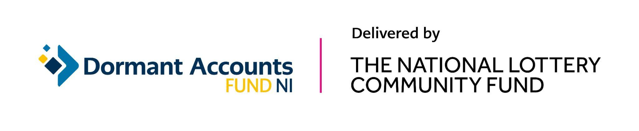

**Belfast YMCA**

56-58 Knightsbridge Park, Stranmillis, Belfast BT9 5EH

[Google Maps](https://www.google.com/maps/place/Belfast+YMCA+Limited/@54.5676966,-5.944552,14.58z/data=!4m5!3m4!1s0x486108c14b5e56b9:0x2f3daa1415b1c634!8m2!3d54.5659184!4d-5.9377789)

Tel: 02890684660

Email: jobs@belfast-ymca.org