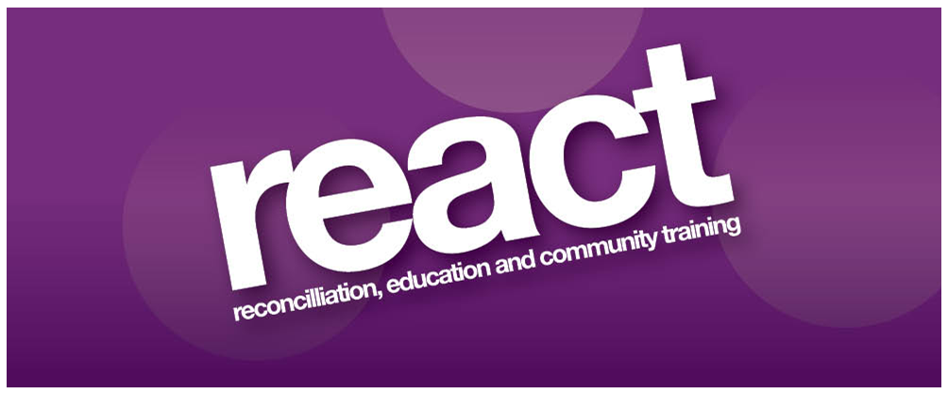

**Invitation to Tender**

**Sessional Yoga and Pilates**

**Instructors**

**May 2025**

Tender Closing Date: 3pm on Thursday 29th May 2025

**Introduction**

REACT is seeking to recruit reputable, experienced and qualified sessional Yoga and Pilates instructors to deliver Yoga and Pilates classes to members of the REACT Victims and Survivors Project.

**Background**

REACT Victims and Survivors Project offers health and well being and social support services to individuals directly affected by the NI Conflict, their families, and carers in the Armagh area.

**Programme delivery will include:**

* Yoga, Pilates and Relaxation classes for individuals with a history of trauma and associated ailments.
* Yoga, Pilates and Relaxation courses for individuals with reduced mobility and a range of physical conditions.
* Yoga, Pilates and Relaxation courses for individuals between the ages of 60 and 90 years old.

**Eligibility Criteria**

All applicants will be required to meet theEligibility Criteria stated. Candidates’ that meet the Eligibility Criteria will then be assessed and scored against the Tender Evaluation Criteria as outlined in this document.

1. A recognised qualification in Yoga, Pilates or relevant area of work (Minimum Diploma Level)
2. 3 years experience working as an instructor
3. Valid Personal Indemnity and Professional Indemnity Insurance.
4. Member of a relevant recognised professional body

**Tender Evaluation Criteria**

Tenders will be evaluated and scored to ascertain the most economical and advantageous proposal using the tender evaluation criteria.

|  |  |
| --- | --- |
| **Tender Evaluation Criteria** | **Marks Available** |
| 1.Experience of working with individuals between the ages of 60 and 90 years old | 25% |
| 2.Experience of working with individuals who have a history of trauma and associated ailments | 25% |
| 3.Experience of working with individuals with a range of physical health needs and reduced mobility | 25% |
| 4.Availability/Flexibility (Evening work compulsory) | 25% |

**Duration of contract**

The contract expires on the 31st March 2026 with the option to extend for a further two one year periods dependent on receipt of funding.

**Pricing**

£60 per hour inclusive of VAT. Prices are not subject to increase during the term of the contract.

**Format of Tenders**

Tenders must strictly adhere to the format and requirements stipulated in this document and include a copy of a CV, all relevant qualifications, current professional insurance and current membership of relevant professional bodies. Tenders must clearly reference and demonstrate how they meet the eligibility criteria and tender evaluation criteria. Failure to comply will render the tender proposal invalid.

**Proposals**

The tender proposal and relevant documents should be submitted by email to:

[info@reactni.org](mailto:info@reactni.org) To arrive no later than 3pm on Thursday 29th May 2025. Proposals that are received late will not be considered.

**Termination of Contract**

REACT reserves the right to terminate the contract at any time following one month’s notice to do so. However, any breaches of contract may result in immediate termination. The contract may be cancelled by the successful tenderer provided one months’ notice in writing has been given.

**Contractually binding information**

All information supplied by tenderers will be treated as contractually binding. However, REACT reserves the right to seek clarification or verification of any such information.

**Conflicts of Interest**

Any conflicts of interest involving a tenderer must be fully disclosed to REACT, particularly where there is a conflict of interest in relation to the aims of the project.

**Insurance Requirements**

Tenderers must produce all Insurance for Employers and Public Liability and Professional Indemnity and any other required insurances. The successful tenderer will be required to produce valid certificates for the duration of the contract.

**Commencement of Contract**

The successful tenderer will be required to certify that they are in a position to commence the contract within four (4) weeks from date of award.

Queries relating to this document and any of the requirements stated herein should be directed in writing or email to:

REACT

14/14a Armagh Shopping Centre

Armagh

BT617AE

Tel: 028 37526869

Email: [info@reactni.org](mailto:shirley@reactni.org)

REACT promotes equal opportunities. Registered Charity Number: XR 33610

The above project is funded under the Victims Support Programme for Groups Working with Victims and Survivors, which is administered by the Victims and Survivors Service on behalf of the Northern Ireland Executive Office.

