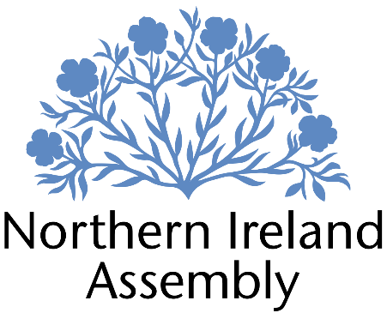

Paula Bradshaw MLA

Alliance Party Member of the Northern Ireland Assembly for South Belfast Constituency

RESEARCH OFFICER (Part-time / fixed-term)

Report to: | Paula Bradshaw MLA
Office Location: | Room 45, Parliament Buildings, Stormont
Hours: | 21 hours per week
Holidays: | As per determination
Salary: | £33,409 pro rata (£17.37 per hour)
Pension: | A central Assembly-approved pension scheme is provided. If enrolled an amount equivalent to 10% of employees salary will be paid into the pension scheme.
Duration: | Six months
Closing Date | Noon, Wednesday 28th May 2025
Interview dates: | It is anticipated that shortlisted candidates will be interviewed on Friday 30th May 2025

JOB DESCRIPTION

“Responsibility to assist Paula Bradshaw MLA with policy and research support, with particular reference to her Private Member’s Bill, committee work and preparation for Assembly business”

- Supporting the legislative process for her Private Member’s Bill
- Engaging with stakeholders relating to the work of the Executive Office Committee
- Providing rapid, accurate and detailed research on a wide range of policy issues
- Drafting speeches, questions and briefing papers
- Assisting in the development of Assembly motions and amendments
- Monitoring business of the Assembly and Committees, and providing detailed briefing
- Maintaining up to date knowledge of relevant legislation, policy and wider political and industry developments
- Ensuring efficient data and file management to comply with GDPR and data management
- Other duties as required in support of the MLA carrying out their Assembly duties.

PERSON SPECIFICATION

 | Essential Criteria | Desirable Criteria
Professional / Technical Qualifications | - Five GCSE’s / O’ Levels or Equivalent at Grade C or above including both English Language and Mathematics  - Third level qualification  - Excellent written skills (grammar, punctuation and spelling)  - Proficiency in the use of  Microsoft Outlook, Word and Excel packages | - Post-graduate qualification
Experience / Job Knowledge | - Knowledge of the workings of the Northern Ireland Assembly and its scrutiny committees  - Minimum of six months experience working in a paid or voluntary capacity in undertaking research in a political context  - Knowledge of Northern Ireland political scene | - Understanding of human rights and equality legislation  - Understanding of the work in support of victims and survivors of the Troubles, Childhood Abuse and / or Mother & Baby Institutions  - Understanding of the conflicting views on cultural expressions in public spaces
Personal Qualities /  Skills | - Good punctuality and time management  - Excellent verbal communication skills in person and on the phone  - Flexible approach to work duties  - Understanding of Alliance Party objectives | - Ability to multi task in the context of challenging deadlines.  - Experience of organising online events  - Proven ability to foster productive professional working relationships.
Circumstances | - Able to work unsupervised and as lone worker in office or at home when required | - May be required to travel to meetings

Applicants must demonstrate clearly on their application form how they meet the criteria.

