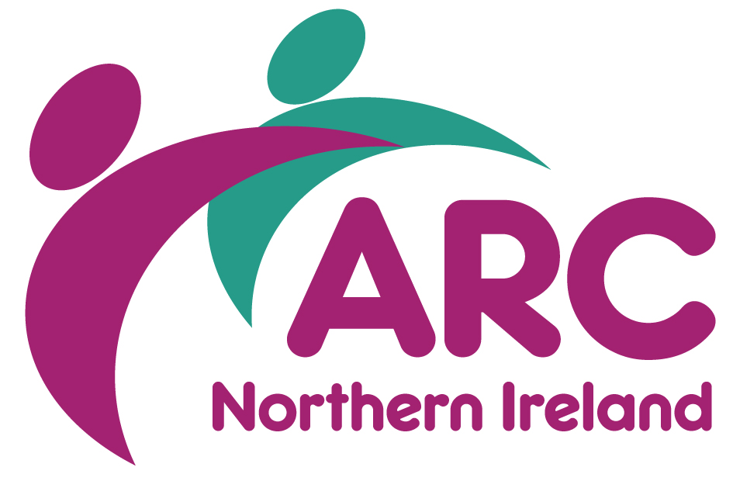

**TRAINING BOOKING FORM**

|  |  |
| --- | --- |
| **Course Title** |  |
| **Course Date** |  |
| **Start Time** |  |
| **Method of Delivery** |  |

|  |  |  |  |
| --- | --- | --- | --- |
| **Name** |  | | |
| **Job Title** |  | | |
| **Organisation** |  | | |
| **Address** |  | | |
|  |  | | |
| **Town/City** |  | **Postcode** |  |
| **Email** |  | | |
| **Telephone** |  | | |
| **Special Requirements** | | | |
| Dietary, mobility, access etc | | | |
| **Line Manager** |  | | |
| **Email** |  | | |
| ☐ I am an ARC member ☐ I am not a member of ARC  **PAYMENT**  ☐ Payment by Stripe ☐ Please invoice  *All invoices will be sent directly to your finance/accounts payable. Please ensure you have obtained a Purchase Order No (PO) from your finance/account payable before submitting form, as it will be returned if not fully completed.* | | | |
| **Finance Name** |  | | |
| **Finance Email** |  | | |
| **Your PO No** |  | | |

Please return completed booking form to Training Department, ARC (NI), McSweeney Centre, 31 Henry Place, Belfast BT15 2AY or by email to training.ni@arcuk.org.uk

**Cancellation charges will apply.** For any queries or additional information please call 028 9038 0960

If you are booking as an ARC NI member, your email address will be automatically added to our distribution list where we will keep you up to date with future training and events. At any time, you can remove yourself from this by either emailing arc.ni@arcuk.org.uk.

If you are not an ARC NI member, and/or this is a personal email address, and you would like to continue to hear of our up-and-coming training and events, please tick here:

**BOOKING ARRANGEMENTS & CANCELLATION CHARGES**

|  |  |
| --- | --- |
| **Booking arrangements** | Booking on courses can be secured by online at <https://arcni.org.uk/training/>  Booking online has not yet been set up for our Health & Social Care Trust members (Belfast, Western, South-Eastern and Northern). To book on any course, please contact the ARC NI office for a booking form, which must be completed and return to the email address below.  **Please Note: Booking forms are used for invoicing purposes and it is essential line management authorisation is provided, along with a PO Number.**  Tel: 028 9038 0960  Email: [training.ni@arcuk.org.uk](mailto:training.ni@arcuk.org.uk)  Place will be allocated on a *first come, first serve basis,* so early booking is advisable*.* |
| **Payment** | **ARC Members:** When booking online ARC members will be offered the choice to pay by immediately through [Stripe](https://stripe.com/gb/payments) or on account. If by account, on completion of the course an invoice will be issued, and payment can be made with BACS payment.  **Non-Members:** Immediate payment will be requested through the [Stripe](https://stripe.com/gb/payments) payment platform. Payment must be made to confirm your booking. |
| **Your cancellation charges** | If you are unable to attend the course you are booked on, you may substitute, **by prior arrangement and after notifying us**, someone else from your organisation.  Such transfers will be considered on case-by-case basis, and on the condition that we are informed in writing of your intentions prior to the originally booked event. Bookings can only be transferred once.  If you are unable to attend, and not in a position either to transfer your place to another person or to another event, then the following charges will apply:  **Cancellation charges - training courses**  15-11 working day before course: 50%  10-6 working days before the course: 75%  5 or less working days before the course: 100%  **Please note that full payment is required for non-attendance on a booking that has been transferred.**  **Free Courses – The charges applied to free courses for cancellation or non-attendance is as follows:**  10-6 working days before the course: no charge  5 working days or less and/or non-attendance: £45 (½ day) | £90 (full day) |
| **ARC’s cancellation** | ARC NI events and courses are periodically updated and while we endeavour to deliver the courses as advertised there may inevitably be occasions where we have to change content without prior notice or, in exceptional circumstances, to cancel an event.  In the case of a course cancellation delegates will either be offered an alternative date, or a full refund and we will also consider any reasonable request to cover non-refundable travel arrangements if a course is cancelled within 2 working days of the start day. |
| **Extension on expiring certificates** | ARC NI may grant short extensions for expiring certificates in exceptional cases, at its discretion, upon written request. |
| **Office Address** | McSweeney Centre  First Floor  31 Henry Street  BELFAST BT15 2AY |