PERSON SPECIFICATION  Job Title:  CENTRE CO-ORDINATOR | 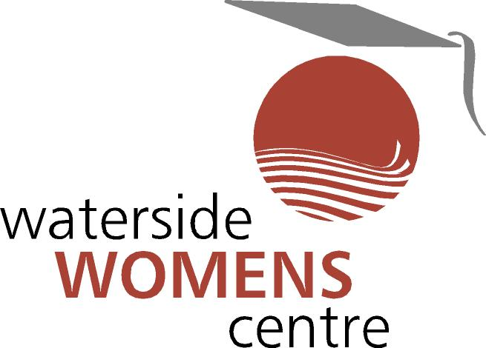

The personnel specification shows essential skills, abilities, knowledge and qualifications required to be able to carry out the duties of this post. Therefore, in completing the application form, please address each of the criteria listed in the specification, drawing upon all of your experience.

1) QUALIFICATIONS

Essential
- Degree or equivalent in a professional, management or community development discipline plus three years relevant experience of managing a project (or projects) of a similar nature. OR Five years’ experience of managing a project (or projects) of a similar nature.
- Experience of successful applications for funding, completing project monitoring and evaluation reports.
- Satisfactory Access NI disclosure certificate (successful candidate only)
- Satisfactory Early Years- Western Health and Social Care Trust Check (successful candidate only).
- Hold a full, current driving licence and have access to a car for business purposes. Where a disability may preclude someone from holding a driving licence, the ability to undertake business travel throughout Northern Ireland must be demonstrated.
- Working knowledge of IT and Internet including the use of MS Word, MS Excel, MS Powerpoint, MS Outlook (Or similar software applications) and social media platforms.

2) Desirable
- Experience and understanding the issues involved in working with women from different communities.
- Experience of staff supervision
- Experience of writing successful funding proposals.

3) EXPERIENCE:
- Experience of project management
- Ability to work on own initiative and systematically develop and organise tasks through effective planning and performance management.
- Experience in writing clear and accurate reports
- Experience of planning, budgeting and presentation of Reports.

4) SKILLS

- Excellent communication and leadership skills to work closely with management, staff, volunteers, centre users, other groups, funders, statutory agencies and media for effective communication and promotion purposes.
- Ability to communicate clearly, both orally and in writing.
- Ability to build good working relationships.
- Ability to work as part of a team.
- Ability to organise information storage and retrieval systems.

5) KNOWLEDGE

- Knowledge of relevant funders - trusts, charities, foundations etc.
- A clear understanding and empathy with the aims and ethos of Waterside Women's Centre.
- Understanding of gender equality/women's issues.
- Understanding of voluntary/community sector issues.

6) DISPOSITION

- Willingness to work within the values of Waterside Women's Centre and the wider women’s sector.
- Confidentiality and discretion.
- An approach which values the contribution and participation of women.

