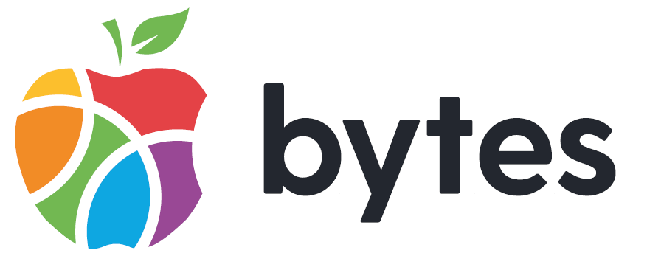
The Bytes Project
300-302 Antrim Road, Glengormley
BT36 5EG

Employment Application Form

Application forms must be returned to: applications@bytes.org
Please use email subject heading: Private and Confidential – Digital Empowerment Manager
Closing date for receipt of application form: Friday 30th May 2025 by 12pm.
Please complete this application form and return it on or before the closing date stated. Late applications will not be accepted. Only information provided on this application form will be considered by the panel.

Please complete all sections of this form using black print or typescript.

“A candidate found to have knowingly given false information or to have wilfully suppressed any material fact will be liable to disqualification, or if appointed, to dismissal.”

Post applied for: | Digital Empowerment Manager (select as many as you wish)  North-West  North-East | Application Reference:
Hours: | 37.5

Personal Details:

Surname: | Telephone Number (Mobile):
Forename(s): | Email Address:
Address and postcode:

Employment History

Please give details of jobs that you have held, starting with your present or most recent employer and work backwards, in chronological order. Include in this section any breaks in employment history for example, caring responsibilities, travelling or returning to study, registered unemployment and temporary/voluntary employment. (Please continue a separate sheet if required)

Dates From/To | Employer’s Name and Address | Post held | Reasons for leaving

If you are currently employed what is the notice period?

Relevant Qualifications and/or Professional Membership

Original proof of qualifications will be requested if recommended for appointment
(Please continue a separate sheet if necessary)

Qualifications | School/collage/university/registered body | Grade | Date Gained

Suitability for this position

Please detail below how you meet the essential criteria.

- Qualifications (150 words max)
A relevant HND/HNC, equivalent or higher qualification in IT or similar. OR
Able to demonstrate a minimum of 3 years’ experience devising creative ICT solutions. OR
3 years delivering ICT support to clients.
*Please note we will accept applications from those graduating in the Summer 2024

- Knowledge (100 words max)
Demonstrable knowledge of the following: (100 words max)
- Department of Education Child Protection regulations.

Demonstrable knowledge of the following: (100 words max)
- ICT systems, with confidence in learning any new systems or software as required.

Demonstrable working knowledge of information technology systems including Microsoft office packages. (100 words max)

- Evidence of Skills (200 words max per subheading)
Strong competence in IT, demonstrated either through a relevant qualification or substantial applied practice: (200 words max)

Skills in building and sustaining effective relationships and working collaboratively with external providers and organisations. (200 words max)

Skills to manage a project budget: (200 words max)

Skills to manage concurrent projects.: (200 words max)

Excellent presentation/verbal communication skills: (200 words max)

Ability to effectively manage and influence people to deliver outcomes: (200 words max)

Ability to work under pressure to strict deadlines: (200 words max)

- Innovation (250 words max)
Demonstrable capacity for one of the following mindsets (Further information can be found in the JD) (250 words max)

- People who can identify opportunities
- People who can ignite ideas:
- People who can investigate ideas:
- People who can invest in ideas:
- People who can implement ideas:
- People who can improve ideas:

- Desirable Criteria
Experience in using ICT in an educational/youth work context: (200 words max)

Awareness of the NI Youth Work Curriculum: (200 words max)

Experience in utilising Creative Media such as Adobe Creative Suite: (200 words max)

- Other
- Can you Commit to the aims and values of Bytes, including the principles that drive the values and behaviours of staff in Bytes as outlined on page 4 of information pack?
Yes | No

- A full current driving licence* and access to a form of transport that will enable the postholder to meet the travel requirements of the Job
*Consideration will be given to alternative travelling proposals in respect of applicants with a disability who cannot hold a licence
Yes | No

- Have you the ability to work flexible hours and to travel throughout UK, Ireland, and occasionally abroad at times demanded by the job?
Yes | No

- To be eligible for this position you must complete an Access NI Enhanced Disclosure.
Is there any reason you cannot work in Regulated Activity?
Yes | No

Having a criminal record will not necessarily be a bar to obtaining a position
A copy of the Access NI Code of Practice will be made available to all applicants upon request.
Copies of The Bytes Project’s policies on Recruitment of Ex-Offenders & Access NI Disclosure Handling Policy are also available on demand.

I confirm that the information I have given is accurate and complete, as misleading or false statements will result in the withdrawal of the offer of employment, or if employed dismissal.

Signed Date

