

Job Description & Personnel Specification

Services Administration Coordinator

Permanent 35 hours per week

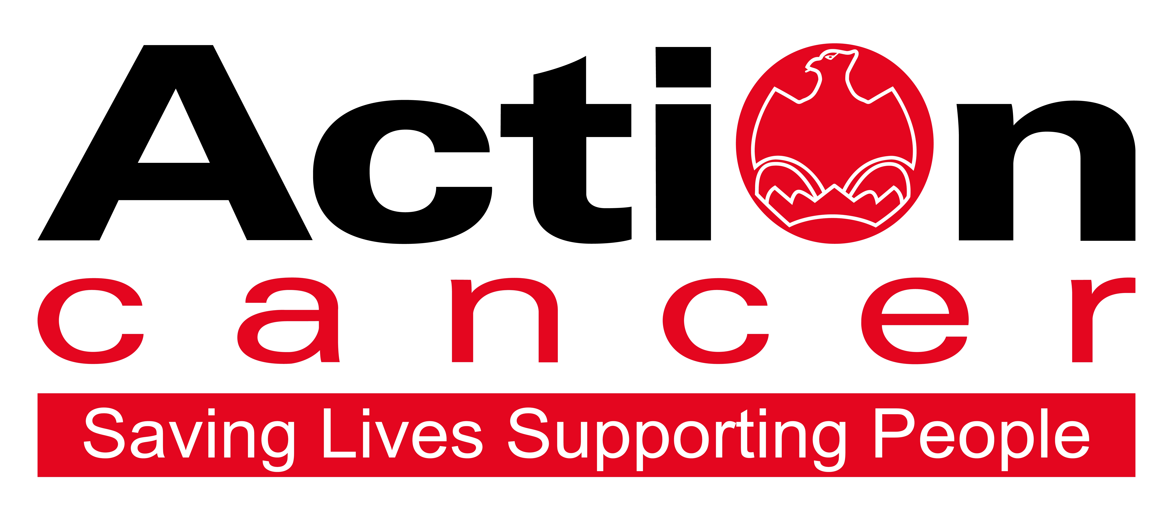

Title of Post: Services Administration Coordinator

Location: Based at Action Cancer House, 20 Windsor Avenue, Belfast, BT9
6EE.

Salary: NJC Pts 20-24: £31,586 - £34,314

We also offer:
- 20 days leave increasing to 25 days + 11 Public Holidays
- 1 extra leave day at Christmas
- Christmas closure
- Enhanced sickness, maternity, paternity, and adoption leave and pay
- 6% contributory pension scheme
- NHS Top-Up Cash Plan
- Death in Service Plan
- Staff care and support services, including access to Action Cancer services
- Training and development

In addition to a competitive salary, Action Cancer offer a Total Reward Package – see Appendix - which focuses on what our staff value, and includes a flexible mix of rewards designed to meet staff needs, their lifestyle, and their stage in life, including a time-off-in-lieu accrual system, training, flexible family-friendly working arrangements, pension contributions, and excellent professional development opportunities.

Action Cancer is a local Northern Ireland charity - all our money is raised to provide services for local communities. Our dedicated team of staff and volunteers work across the whole of Northern Ireland helping to save lives and support people affected by cancer. To operate our services we must raise circa £4 million every year. We provide early detection and health promotion services, and counselling and support services for cancer patients and their families, thereby making a real difference to people who are affected by or living with cancer.

Action Cancer staff - a mix of highly skilled professionals - are the most valuable asset to our charity. We offer a wide variety of training and development opportunities, and family friendly initiatives to enhance work-life balance, and to value and support individuals and family life. In recognition of this we were awarded Best Learning and Development Organisation in Ireland - Not for Profit Sector, and were winners of The Irish News ‘Best Place to Work’ Award, Employers For Childcare “Childcare Works Award”, Employers For Childcare Family Friendly Employer Award - Social Enterprise/Charity of the Year, and Employer of the Year Award by UTV Business Eye Awards.

We were also very proud to achieve Investors in People Gold Champion status, Investors in People Health & Wellbeing Good Practice accreditation, and Investors in Volunteers accreditation. These awards testament to our continued commitment to “have highly valued, trained, enthusiastic, focused and committed people who work together and engage with others to make a positive impact on our community”.

Employees and Volunteers of Action Cancer must support its Mission, Values and Behaviours:



Values and Behaviours:

Our strengths are that we are a Values driven charity with people being at the very centre of everything we do. Our services are proven to make a difference, we are a Northern Ireland charity run and controlled by local people, raising money, spending money, and supporting people only here in Northern Ireland.
We have three stated Values which are supported by seven expected behaviours.

Value 1: Putting People First - People are at the centre of everything we do.

Value 2: Making a Difference - Having a positive impact on everything we do.

Value 3: Having Integrity – Operating with full transparency, honesty and fairness in everything we do.

Our Values are supported by seven Behaviours. We Will…
1. Treat people with respect, care, dignity and consideration.
2. Listen, hear and respond positively to what people say.
3. Work together, supporting, adding value, learning from and sharing with others.
4. Embrace and develop new ideas, and ways of working.
5. Nurture, support, develop and equip our people to reach their full potential
6. Learn from the past, build upon and celebrate our success
7. Welcome scrutiny, taking ownership and responsibility for our actions.

Services Administration Coordinator

OVERALL RESPONSIBILITY:

The Services Administration Coordinator, as part of the Services Administration Team, is responsible for overseeing and coordinating high-quality administrative, clerical, and reception support for Action Cancer’s services at Action Cancer House and aboard the Big Bus mobile unit. This role includes coordinating services administration procedures, supervising staff and volunteers, liaising with Montgomery’s Transport for Big Bus operations, ensuring accurate data entry, and upholding data protection and client confidentiality standards.

Main Duties

1. Service Coordination and Operational Support

- Provide high-quality clerical, secretarial, administrative, and reception support for services at Action Cancer House, the Big Bus, and other venues, ensuring appropriate cover for evening and Saturday clinics.
- Liaise with service departments, including but not limited to Radiography, Therapeutic Services, Skin Cancer Detection, Health Improvement departments, and Head of Professional Services, to support the smooth delivery of all services.
- Work closely with Service Managers, and the Head of Professional Services, to ensure adherence to procedures and effective appointment management.
- Supervise and co-ordinate appointment scheduling processes to ensure accuracy in data entry and correspondence.
- Co-ordinate with the X-ray team to ensure mammography reporting and screening audit processes are carried out in line with policy.
- Co-ordinate with Montgomery’s Transport to schedule and deploy the Big Bus, including unit maintenance, sharing rotas and site visit information to relevant service departments.
- Ensure the integrity, accuracy, and accessibility of organisational data through the development, implementation, and oversight of effective data management practices and systems.
- Liaise with ICT to maintain effective systems and processes for accurate data management.
- Co-ordinate social media and marketing messages for service promotion, in line with organisational marketing campaigns.
- Handle public enquiries and redirect as appropriate.

2. Staff Supervision and Development

- Supervise Service Administration staff and volunteers, including developing job and development plans.
- Provide supervisory and operational support to staff and volunteers within Service Administration.
- Liaise with Service Managers and the Head of Professional Services to identify and support training and development needs of staff and volunteers.
- Deliver training to new staff and provide ongoing training updates to existing staff and volunteers, in line with service demands.
- Ensure all supervisory responsibilities are carried out in line with Action Cancer policies and procedures.

3. Administrative Oversight

- Maintain and update systems and databases with service-related information, as required, including service evaluation and monitoring data.
- Produce and submit monthly KPIs for all service areas, reporting key statistics and information to Service Managers, the Head of Professional Services, and the Communications Manager for monitoring, evaluation, and campaign purposes.
- Oversee online bookings and appointment scheduling processes and procedures, ensuring accuracy.
- Maintain efficient administrative and filing systems to meet the needs of each service area.
- Ensure clear and effective communication with Montgomery’s Transport regarding Big Bus bookings, site visits, and maintenance needs.
- Develop, implement, and update policies and procedures related to Services Administration, ensuring staff are trained to apply them, at all times.
- Attend relevant meetings with Service Managers and the Head of Professional Services to support effective communication and service delivery.

4. Monitoring, Evaluation, and Quality Assurance

- Collate data for breast screening, skin cancer audits, and other service-related monitoring and evaluation requirements.
- Ensure all electronic data collection systems are routinely tested for accurate functioning, and data accuracy.
- Maintain accurate records of user complaints and incidents, ensuring effective follow-up processes are in place.

5. Health and Safety

- Ensure compliance with all Health and Safety and lone working requirements.
- Adhere to Action Cancer’s Health and Safety Policy and promote best practices across all service delivery points.

Other duties

- Any other duties as required by the Organisation

This job description will be subject to review in the light of changing circumstances and is not intended to be rigid and definitive, but should be regarded as providing guidelines within which the individual works. Other duties of a similar nature and appropriate to the grade may be assigned from time to time. It is important to note that the responsibilities of the post may change to meet the evolving needs of the services that the charity provides.

General Responsibilities

Members of staff are expected to show courtesy and respect towards service users and members of the public with whom they come into contact at all times.
Staff are expected to demonstrate their commitment to Action Cancer by their regular attendance and the efficient completion of tasks allocated to them.
All staff must comply with Action Cancer’s No Smoking Policy on Action Cancer Premises.
All duties are carried out in compliance with Action Cancer’s Health and Safety Policy and Statutory requirements.
Action Cancer is an Equal Opportunities Employer. The post holder is required to adhere to Action Cancer’s Equal Opportunities Policy throughout the course of employment.
To ensure the ongoing confidence of the public in the staff of Action Cancer, all staff must ensure they maintain the high standards of` personal accountability.

Terms and Conditions of Employment

- 2 satisfactory written references are required direct from a current / previous employer covering the preceding two years of employment.
- Successful applicants must evidence their right to work in the UK (under the Asylum and Immigration Act).This will be evidenced in the first instance by a passport or other forms of ID that will be outlined if no passport is available.
- 6 months probationary period
- Evidence of relevant academic and professional qualifications
- Evidence of appropriate vehicle documentation
- All potential employees may be asked to attend a pre-employment medical

Action Cancer is an Equal Opportunities Employer.

PERSONNEL SPECIFICATION

Essential criteria

- A minimum of two years’ experience supervising staff in a busy office and reception environment, including team performance management.

- 5 GCSEs (or equivalent) at grade C or above, including English and Mathematics.

- At least two years’ experience in developing, implementing, and coordinating effective administrative systems, policies and procedures, including Health and Safety processes.

- Excellent organisational skills, with proven ability to delegate, plan, and prioritise workloads to meet deadlines.

- Demonstrable positive attitude with examples of building effective working relationships and supporting both individuals and teams within an office and organisational setting.

- High level of proficiency in data input, monitoring, and quality checking, with sound knowledge of data protection requirements. Strong ICT skills, including advanced use of Microsoft Office applications.

- Experience in handling complex situations and people sensitively, maintaining a high standard of customer service.

- Ability to work proactively and independently with minimal supervision, while also contributing as part of a wider team and accepting delegated tasks from others as required.

- First class oral and written communication skills.

- Available and flexible to work hours to meet the needs of the role – evenings and weekends.

- Hold a full, current driving license with business insurance and have access to the use of a car or some other appropriate form of transport to carry out the duties of the post in full. Action Cancer operates a staff carpool rota for staff traveling to and from the Big Bus.

Desirable

- A minimum of three years supervisory experience in a busy office and Reception environment - experience to include three years people and performance management.

- Experience working in medical/health environment (e.g. hospital, General Practice), and familiarity with medical terminology

- Knowledge of cancer services, and experience of providing administrative support in a similar organization.

- NVQ level 2 (or equivalent) in the field of Business Administration.

Appendix 1: Action Cancer Total Reward Statement
Training and Development
- Organisation Wide Training Budget
- Paid Tailored Training and Development Support
- Comprehensive In-House Training Courses and External Development Opportunities linked to Role, Strategic Plan, Individual Requests, and Competencies
- Comprehensive Induction Program
- Continued Professional Development Support
- Structured Interim and Annual Performance Reviews
- Regular All Staff and Department Teambuilding Away Days and Events
- Cross Departmental Working Opportunities/ Workplace Shadowing
- Overseas Challenge Opportunities

Work Life Balance
- Standard 35 hour working week
- Flexible Working - hybrid working, compressed hours, staggered start times
- Enhanced paid annual leave - 11 annual statutory days, up to 25 days annual leave (depending on role), Additional Day Paid Leave at Christmas
- Fixed Christmas closure throughout the entire organisation
- Christmas staff and family events
- Time Off In Lieu in compensation of additional hours worked
- Additional leave purchase scheme
- Sabbatical, Discretionary and Dependant care leave subject to eligibility
- People and Family Friendly Policies
- Enhanced maternity, paternity and adoption leave and pay subject to eligibility.

Social, Physical and Mental Health and Wellbeing
- WPA - NHS Cash Back Plan and Employee Assistance Program subject to eligibility.
- Health and Menopause Support Policies and Return to Work programs
- Therapeutic supports – counselling, complementary therapies, acupuncture
- External care and support services – Staffcare & DAS confidential counselling helpline services
- AIG Smart Health - digital GPs, health checks, nutrition consultation, fitness programme, mental health support, myStrength app, 24/7 mental health helpline, legal and financial support.
- External Occupational Health Service, health checks, screening, and vaccinations
- Regular Staff Health, Wellbeing, Awareness Opinion Surveys, and Staff Wellness Week
- Mediation services
- Staff kitchen facilities, free tea and coffee, and shower facilities
- Christmas family party and subsidised Christmas departmental celebrations
- Staff pool car
- Clear Policies and Procedures
- CSER Team representing staff opinion and arranging events throughout the year.

Financial Reward and Recognition
- Sector competitive salaries
- Action Cancer 6% pension contribution + 3.2% employee contribution + tax relief = 10% contribution to pension pot
- Enhanced Sick Pay (Service Related)
- Salary Sacrifice for Annual Leave, Pension, and Bike to Work Schemes
- Work related professional membership fees paid
- Mileage Allowance at the Prevailing HMRC Rate
- Additional Day Paid Leave at 10,15,and 20 Years’ service for staff on NJC payscales
- Free staff uniforms
- Free car parking
- Death-in-service benefit of £50,000 lump sum payable to nominee.

Where such references are unavailable, and in respect of employee(s) joining directly from school or government sponsored youth training schemes, character references will be required.

