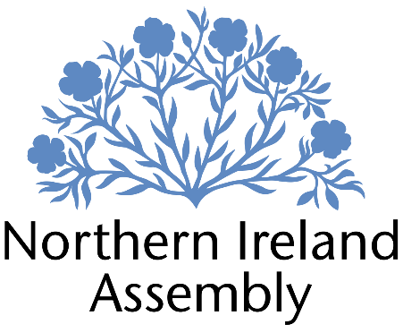

**David Honeyford MLA**

*Alliance Party Member of the Northern Ireland Assembly for Lagan Valley Constituency*

**PART TIME RESEARCH OFFICER**

|  |  |
| --- | --- |
| Report to: | David Honeyford MLA |
| Office Location: | Parliament Buildings, Stormont. |
| Hours: | 8 hours per week. |
| Holidays: | As per determination |
| Salary: | Grade 2 - £33,409 Pro Rata |
| Pension: | A central Assembly-approved pension scheme is provided. If enrolled an amount equivalent to 10% of employees salary will be paid into the pension scheme. |
| Duration: | Permanent  Employment contingent upon member remaining an MLA or until legislation is introduced to change Constituency expense provision. Six-month probation period shall apply. |
| Closing Date | Noon, Tuesday 13th May 2025 |
| Interview dates: | It is anticipated that shortlisted candidates will be interviewed during week beginning 19th May 2025. |

# JOB DESCRIPTION

“Responsibility to assist David Honeyford MLA on range of policy and research support to David Honeyford MLA preparing briefings, questions and speeches, monitoring business, developing Motions, Questions and Private Members Bills”

* Providing rapid, accurate and detailed research on a wide range of policy issues in support of David Honeyford MLA’s work
* Drafting briefing papers, speeches, and questions for David Honeyford MLA
* Assisting in the development of Assembly motions and Private Members Bills
* Monitoring business of the Assembly and Committees, and providing detailed briefing for David Honeyford MLA
* Maintaining up to date knowledge of relevant legislation, policy and wider political and industry developments
* Ensuring efficient data and file management to comply with GDPR and data management.
* Other duties as required in support of the MLA carrying out their Assembly duties.

**PERSON SPECIFICATION**

|  |  |  |
| --- | --- | --- |
|  | **Essential Criteria** | **Desirable Criteria** |
| **Professional / Technical Qualifications** | * Five GCSE’s / O’ Levels or Equivalent at Grade C or above including both English Language and Mathematics * Third level qualification * Excellent written skills (Grammar, punctuation and spelling) * Proficiency in the use of   Microsoft Outlook, Word and Excel packages | * Degree level qualification |
| **Experience / Job Knowledge** | * Minimum of two years’ experience working in a paid or voluntary capacity in undertaking research in a political context * Knowledge of Northern Ireland political scene * Experience of working in a small team. * Previous experience of working with the public. | * Knowledge of the workings of the Northern Ireland Assembly * Minimum of two years’ experience working in a paid or voluntary capacity in speech writing * Experience of dealing with sensitive and confidential information (both verbal and written) in line with the Data Protection Actand GDPR * Ability to update and maintain a database |
| **Personal Qualities /**  **Skills** | * Good punctuality and time management * Excellent verbal communication skills in person and on the phone * Flexible approach to work duties * Understanding of Alliance Party objectives | * Ability to multi task in the context of challenging deadlines. * Experience of organising online events * Proven ability to foster productive professional working relationships. |
| **Circumstances** | * Able to work unsupervised and as lone worker in office or at home when required | * May be required to travel to meetings |

Applicants must demonstrate clearly on their application form how they meet the criteria.