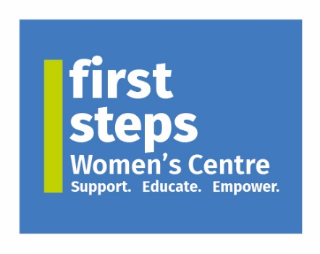

**Job Description**

**Job Title:** Administrative Assistant – Heritage Journeys Project

**Duration:** Period up to March 2027 (subject to funding)

**Responsible to:** Project Coordinator – Heritage Journeys Project

**Job Purpose:** To provide administrative support for the Heritage Journeys: Voices of Migrant Women in Mid Ulster project.

**Location:** Dungannon

**Hours:** 24 hours per week. Work pattern to be discussed

**Rate of pay** £13.29 per hour

**This post is subject to funding**

**Main Aim of Post:**

To provide administrative support for the Heritage Journeys project, made possible by the National Lottery Heritage Fund. By engaging with migrant women living in and around the Dungannon area, the project intends to collect, record and share the stories of these women.

**Duties & Responsibilities**

* To be a point of contact for participants, informing them about the programme.
* To respond to queries from participants to ensure barriers to participation are removed and questions are answered in a timely manner.
* To meet and greet potential participants.
* To assist in organising appropriate venues in which to conduct interviews.
* To assist in organising participant childcare and transport, if required.
* To assist in the marketing of the Heritage Journeys project.
* To assist with publicity events, annual general meetings, conferences, and any other events or meetings relating to First Steps Women’s Centre.
* To attend relevant courses and training events to develop skills and knowledge, and;
* Any other reasonable duties which may be required.

**General Duties**

1. To actively promote and raise the profile of FSWC and the services it provides at every opportunity.
2. Ensure that all Health and Safety requirements are implemented in respect of yourself, Staff & Service Users, in accordance with FSWC policies and Procedures and in line with statutory requirements.
3. To comply with and actively promote all FSWC policies and procedures.

**Please note:** This job description will be subject to review in the light of changing circumstances and may include other duties and responsibilities as may be determined. It is not intended to be rigid or inflexible, but should be regarded as providing guidelines within which the individual works.

First Steps Women’s Centre operates a “No Smoking” Policy and all employees **MUST** comply with this.

We are an Equal Opportunities Employer.

**Personal Specification**

A shortlist of candidates for interview will be prepared solely on the basis of the information contained against each criterion in the table below. It is therefore essential that all candidates demonstrate through each criterion how and to what extent their experience and qualities are relevant to this post.

| **Criteria** | **Essential** | **Desirable** |
| --- | --- | --- |
| **Qualifications** | * Minimum 5 GCSE’s or equivalent including English and Mathematics at grades A*- C * ECDL or demonstrable experience in a range of Microsoft Packages, e.g. Word, Excel, Access etc. |  |
| **Skills & Knowledge:** | * Excellent organisational skills and the ability to prioritise. * Excellent interpersonal, written and verbal communication skills. * The ability to work with a wide range of external and internal customers. * The ability to work both independently and as part of a team. | • Knowledge of the immigration system and how it impacts women and their families.  • Ability to work flexible hours. |
| **Experience:** | * A minimum of 12 months experience working in an administration setting, to include use of social media in a business setting and experience of working with the public in a face to face manner. * Experience of developing and maintaining relationships with external organisations. | * Experience of working within a target driven environment |

**Shortlisting**

Shortlisting of candidates for interview will be prepared on the basis of the information contained in the application form. It is therefore essential that all the applicants demonstrate through their application how and to what extent their experience and qualities are relevant to this post and the extent to which they satisfy each criterion specified.

The appointment is subject to proof of the attainment of any qualifications deemed essential to the post and used as a basis for shortlisting. Where educational or professional qualifications form part of the criteria you will be required, if shortlisted for interview, to produce original certificates, and one photocopy of same, issued by the appropriate authority. Only those certificates relevant to the short-listing criteria should be produced. If educational certificates are not available an original letter and photocopy of same detailing examination results from your school or college will be accepted as an alternative. Failure to provide evidence of the required qualifications prior to taking up the post will result in the offer of employment being withdrawn.

**If successful you will be required to produce documentary evidence that you are legally entitled to live and work in the United Kingdom.** This documentation can be a P45, payslip, National Insurance Card or a birth certificate confirming birth in the United Kingdom or the Republic of Ireland. Failure to produce evidence will result in a non-appointment.

**Satisfactory Access NI checks will also be required if appointed.**