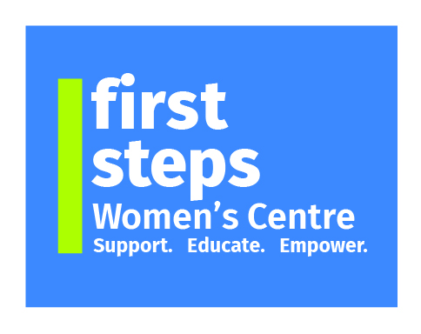

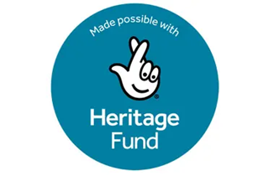

**wishes to recruit for the following vacancy:**

**Project Coordinator – Heritage Journeys project**: **30 hours per week, £19.15/hr**

Period up to March 2027 (subject to funding)

**Main Aim of Post:** To coordinate the Heritage Journeys: Voices of Migrant Women in Mid Ulster project which is made possible by The National Lottery Heritage Fund.

Thanks to National Lottery players, we have been able to secure funding to chronicle the stories of migrant women living in Mid Ulster.

**Essential Criteria:**

* 3rd Level Qualification in an appropriate area plus a minimum of GCSE English & Maths (Grade C or above), or equivalent;
* A minimum of two years’ experience in a similar role within the last five years;
* Experience of developing and maintaining relationships with external organisations;
* Excellent organisational skills and the ability to prioritise;
* Excellent interpersonal, written and verbal communication skills;
* The ability to work with a wide range of external and internal customers, and;
* The ability to work both independently and as part of a team.

First Steps Women’s Centre is an Equal Opportunities Employer

For further details and an application pack please contact:

First Steps Women’s Centre, 21a William Street, Dungannon, BT70 1DX

Tel: (028 8772 7648) Website: www.firststepswomenscentre.org

Email: fswc.recruitment@gmail.com

Charity Number NI101202

**Closing Date for Application**: Wednesday 7th May 2025 at 12 noon

**Interviews to be held week beginning Monday 12th May 2025**