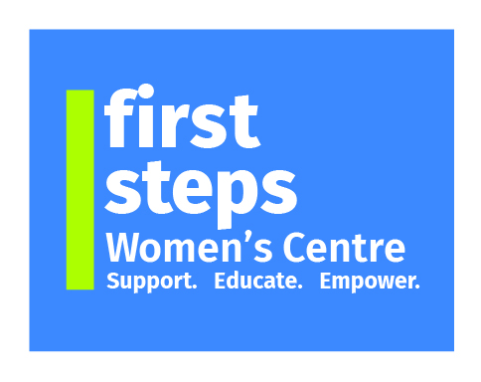

**wishes to recruit for the following vacancy:**

**Childcare Leader**: **30 hours per week, £16.04/hr**

Period up to March 2026 (subject to funding)

**Main Aim of Post:** To oversee and manage the daily operations of the onsite Crèche, ensuring a safe, nurturing, and educational environment for all children.

# ESSENTIAL

* NVQ Level 5 in Childcare Qualification,
* A minimum of 2 years’ experience (within a childcare/school setting) with supervisory responsibilities within the past 5 years,
* GCSE Maths & English or equivalent at Grade C or above,
* Up to date Safeguard Training
* Competent in IT packages including Microsoft Word and Excel.

**DESIRABLE**

* Team Leading / Management qualification,
* First Aid/Paediatric Certificate.
* Music/Arts/Crafts skills.
* Food Hygiene
* Moving and Handling
* Experience of working in the Community Sector.

First Steps Women’s Centre is an Equal Opportunities Employer

For further details and an application pack please contact:

First Steps Women’s Centre, 21a William Street, Dungannon, BT70 1DX

Tel: (028 8772 7648) Website: www.firststepswomenscentre.org

**Email: fswc.recruitment@gmail.com**

Charity Number NI101202

**Closing Date for Application**: **Wednesday 7th May April 2025 at 12 noon**