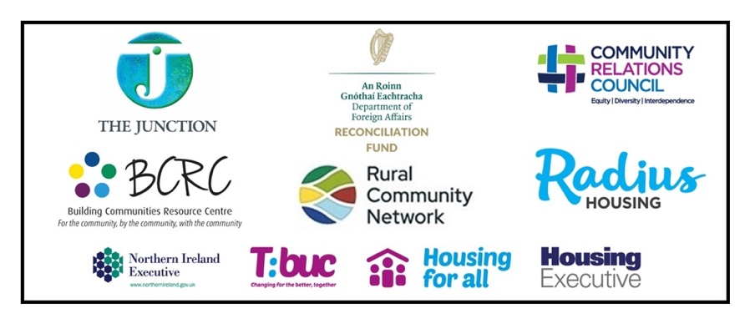
Overcoming the Hidden Menace of Intimidation: An Awareness Raising Toolkit and Empowerment Training Project
*A new Upskilling Opportunity for Community Facilitators/Trainers*

EXPRESSION OF INTEREST

Taking action to address the menace of Intimidation

Train the Trainers
15th and 16th May, BCRC (Ballymoney).

Are you ready to make a real difference in the communities in which you work? Intimidation silences voice, divides neighbourhoods and halts progress,
but together, we can help to change that.
Our Two-Day Anti-Intimidation Training Course is designed to equip community facilitators/leaders like you with the tools, confidence and strategies needed to foster safer, more resilient communities.
Join us to learn practical techniques and build a network of empowered leaders committed to creating spaces where everyone feels safe to speak up.
Let’s transform fear into courage!

Background: The Junction and Partners: BCRC, RCN/Beyond Belfast Practitioners Forum and Radius Housing, with support from a steering/advisory group and Blu Zebra have developed a Toolkit and Training programme entitled Taking action to address the menace of Intimidation. We are now seeking to engage Community Facilitators, Trainers and Community Leaders working with community groups to participate in our first Train the Trainer programme.

This two-day Training programme will be delivered to a select number of Facilitative Leaders /Trainers who are interested in supporting local communities around awareness raising and empowering collective action and who can commit to two days of training to help us build a suite of local trainers in this increasingly important arena. The Training will take place on 15th and 16th May 2025 in BCRC, Ballymoney from 10.00 to 4.00pm and is free of charge. A Training pack and lunch and refreshments will be provided.

The Training Programme will include access to a newly developed Toolkit geared towards raising awareness around key regional initiatives that aim to address intimidation. It aims to engender preventative, positive collective actions within neighbourhoods – as a counter to that which can lead to intimidation.

We are seeking Facilitators/Trainers and who can demonstrate a commitment to cascade out facilitative training sessions in the community. A Phase 2 will involve the development of a cross-community shared learning network addressing Intimidation (which will meet online/in-person a number of times a year *Funding dependant). We wish to engage with Facilitators/Trainers who are able to commit to onward delivery (approx. 4 learning forum meetings over the next 15 months).

Those wishing to take part in the training need to align with four Criteria:

- Existing Experience: Facilitators/Trainers have existing experience of working within neighbourhood contexts, and of working with community groups and leaders
- Integration of Training: Facilitators/Trainers are committed to making use of the Training and rolling it out over the incoming year. Tell us about the community area/group with whom you hope to engage and work over the incoming year. (*We are seeking a number of Trainers/Facilitators who can deliver some Training before the end June 2025, as well as a number who can deliver through 2025/2026).
- Ongoing/ Shared Learning: Facilitators/Trainers are willing to undertake reflection on the training providing feedback on the Toolkit and Training programme; and are interested in a wider shared learning forum over the next 15 months.
- Availability: Facilitators/Trainers are available to participate in two-day training 15th and 16th May, BCRC, Ballymoney

In order that the Training can go on to be an active support for area-based communities wanting to become more informed and active in positive ways to build good neighbourhoods, we are asking that you address the above Four Criteria.

Places are Limited for this Initial Train the Trainer programme.

SUBMIT Expression of interest
Email to: Ruth Gonsalves Moore/Mel Bradley no later than Tuesday 15th April 5pm
info@thejunction-ni.org

For Further Information:
The Junction/Ruth Gonsalves Moore ruth@thejunction-ni.org T: 02871361942
BCRC/Katherine Murphy: manager@theresourcecentre.org 028 2766 5068
Beyond Belfast/RCN/Rachel Power: rachael@ruralcommunitynetwork.org
T 028 8676 6670
Radius Housing/Lisa Mooney: Lisa.Mooney@radiushousing.org 02827665068

This project is supported by the DFA Reconciliation Fund

