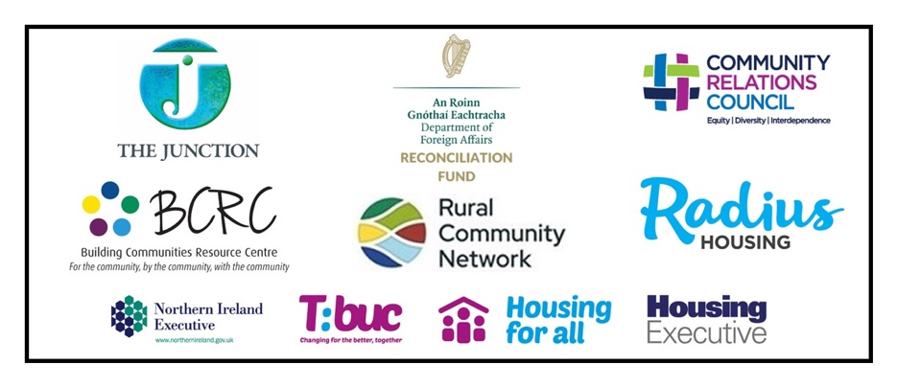
Overcoming the Hidden Menace of Intimidation.
An Awareness Raising Toolkit and Empowerment Training
(referred to in short as the Addressing Intimidation Project)

Expression of interest – Form

Name
Address
Organisation
Position in Organisation
Contact Details (Email/Tel/Mobile)
Existing Experience | Please list your existing experience of working within neighbourhood contexts, and of working with community groups and leaders. (Max 100 words)
Can you commit to making use of the Training and rolling it out over the incoming year-15 months. | Please tell us about the community area/group with whom you hope to engage and work over the incoming year/15 months. (Max 100 words)
Could you deliver Training before the end June 2025 | Yes |  | No
Are you willing to give some feedback on the toolkit and training post the 2 day training course based on some of your own delivery | Yes |  | No
Please describe how you could help create feedback on the training. | Please describe how you could help create feedback on the training e.g. submission of additional case studies; feedback on different techniques used to engage learners etc. (Max 100 words)
Are you willing to be involved in a shared learning forum on this work post the 2-day training course | Yes |  | No
Are you available on the 15th and 16th May | Yes |  | No

SUBMIT EOI TO:
The Junction: Ruth Gonsalves Moore/Mel Bradley
Email: info@thejunction-ni.org

No later that: Tuesday 15th April 5pm

This project is supported by the DFA Reconciliation Fund.

