

Finance & Services Administrator
INFORMATION PACK

November 2024
JOB REF: FSA/24

Admin & Finance Support Worker


About Us
Boys & Girls Clubs (NI) is a leading Regional Voluntary Youth Organisation (RVYO), a registered charity and limited company that supports a membership of 147 local youth organisations.
Who we are
Boys & Girls Clubs (NI) was founded in 1940 as an independent, voluntary association of six local organisations that were dedicated to bringing communities together and enriching the lives of children & young people. Today, we have transformed into a modern membership organisation, providing supporting 147 member organisations. This membership is diverse and includes part-time & full-time youth organisations, community associations, schools, and sports clubs. The foundations and purpose of the charity remains strong and our mission is to support the personal development and social education of children & young people and to promote good relations and community development.
What We Do
Each year our professional youth work team engages directly with 3000 children, young people, volunteers & youth workers. Indirectly, we support a wider network of 48000 stakeholders on an annual basis. We work in partnership with local organisations and provide wraparound support through membership services, compliance and regulation, accredited training, networking opportunities, intervention projects, policy guidance, governance advice and an extensive programme of youth programmes. Our main office is located in Belfast and we operate in both rural and urban areas across Northern Ireland through our professional team of area-based youth workers.
This Post
This is an exciting time for Boys & Girls Clubs with innovative new projects and the expansion and development of our core services.
The main purpose of this post is to maintain and develop the Organisation's information and communication systems in-keeping with policy and management priorities e. g. website, Salesforce CRM system and our Youth News and also to support the Director of Finance and administration team with maintaining budgets to ensure staff have access to accurate information.

Our Services
We serve children, young people, volunteers, and youth workers through a variety of support services all under the core 5 pillars of our service. This includes training for educational enrichment, networking opportunities, policy guidance, youth intervention projects, safeguarding packages, legal compliance/governance support, and an extensive programme of youth activities.

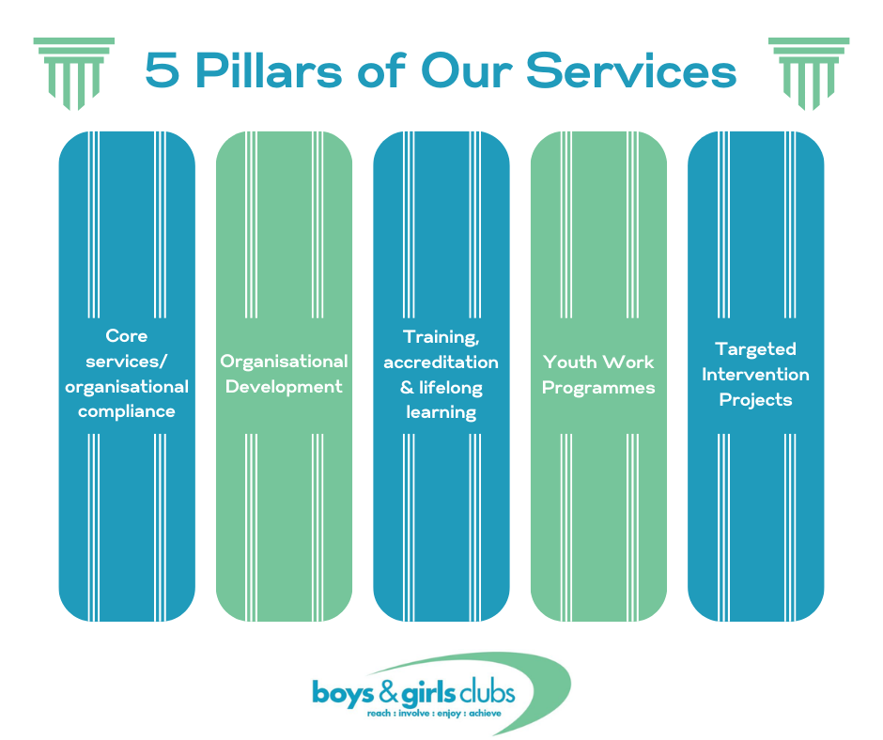

Job Description
Admin & Finance Support Worker
Admin & Finance Support Worker – reports to Director of Finance & Services
Hours: 12 - 28 hours depending on preferences from ideal candidate
Salary: £ 22458 (Pro-Rota) Per Annum . Closing Date: Friday, 14th February 2025.
Main Duties:
- Use, maintain and develop the Organisation's information and communication systems in-keeping with policy and management priorities e. g. website, Salesforce CRM system and our Youth News.
- Support the Director of Finance and administration team with maintaining budgets to ensure staff have access to accurate information.
- Support the senior management team with financial information for complete quarterly and annual returns to sponsors.
- Develop invoices upon request and maintain records of incoming and outgoing finances.
- Support administrative staff with developing budgets for funding and tracking spend across current contracts.
- To oversee milage claims and expenses for all staff.
- Liaise with banks and funders to check double check information and make any enquiries as directed by SMT.
- To oversee procurement processes and ensure compliance with financial policies internally.
- Support the Director of Finance & services to maintain administrative systems such as records for reporting of membership payment details, postage, receipts, and hardcopy filing.
- In conjunction with the Director of Finance & services, to issue annual insurance & affiliation invoices and follow-up receipt of payments and associated record keeping.
- Ensure compliance with all Boys & Girls Clubs (NI) polices reference to the safeguarding, health and safety, equal opportunities, and communication policies.
- As Boys & Girls Clubs is a growing organisation, the detail of your daily tasks will inevitably change over time. Please note that while all efforts are made to include the main responsibilities, you may, from time to time be required to undertake activities of a similar nature that fall within your capabilities as directed by the management.

Personal Specification:
Education & Experience:
A recognised qualification a finance or administration related discipline.
Or
2 years’ paid experience of working in a finance or administrative department.
Experience & Knowledge:
2 years’ experience of maintaining budgetary spend, generating invoices and keeping record of incoming and outgoing spend in an organisation.
2 years’ experience of delivering and reporting against contracted outcomes and working to deadlines.
A good understanding of the financial requirements of sponsors in the community and voluntary sector.
Skills and Abilities:
Knowledge of ICT with proficiency in the use of Microsoft Office packages and digital platforms.
Proven track record of implementing and maintaining monitoring and evaluation processes and producing reports in a timely manner.

PLEASE RETURN CV ALONG WITH COVER LETTER TO post@boysandgirlsclubs.net
Closing Date: Friday, 14th February 2025 at 2.00 pm.

Late applications will not be accepted.

