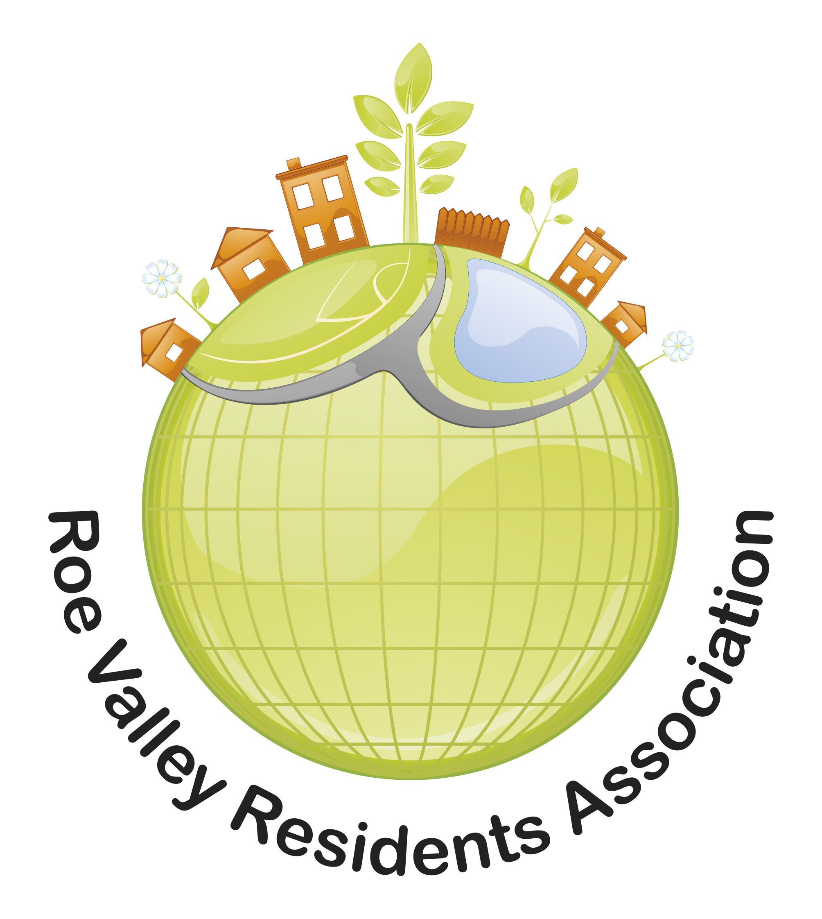

13-14 Keady Way
Limavady
Co Derry
BT49 0AU
Tel: 028777 69996
Email: admin@roevalleyresidentsassociation.org.uk

Youth Worker
Job Description

Job Title: Youth Worker
Key Function: To support the implementation of all aspects of the PEACEPLUS project across Limavady and its partner areas, including the development of a range of youth interventions focused on building good relations, Personal and Social Development, Employability and Citizenship.
Reports to: RVRA Project Coordinator
Responsible to: RVRA General Manager

Job Purpose: The central purpose of this post is to take responsibility for the delivery of all aspects of the PEACEPLUS programme to include a range of targeted youth interventions focused on employability, building good relations, personal and social development and citizenship.

Key Duties:

- To work alongside a team of Youth Workers & Project Co-ordinator to plan an annual programme plan of delivery for the project
- To co-ordinate and oversee the duties of the part time staff and volunteers
- To manage elements of the programme budget for programme delivery
- To design and deliver a range of youth programmes targeting young people
- To design and deliver good relations programmes and initiatives which enhance young people’s active participation in the issues, services and decisions that impact on their lives.
- To design and deliver programmes which provide opportunities for young people to raise their aspirations, confidence, self-esteem and their ability to learn and grow.
- To design and deliver programmes which improve the safety, health & well-being of young people.
- To provide evidenced based youth work intervention programmes, on both a 1 to 1 and group work basis
- To facilitate workshops with participants (young people and adults) on relevant issues.
- To engage with other statutory and voluntary sector organisations to enhance the quality and range of opportunities available to rural young people.
- To represent RVRA and partners on all forums and partnerships in the absence of the Project Co-ordinator which can enhance the opportunities for young people living in the local community.
- To provide appropriate training to build the capacity of young people and other volunteers who have a role in supporting youth work activities.
- To implement procedures for monitoring and evaluation to help articulate the impact of all interventions.
- To support the Project Co-ordinator to provide quarterly monitoring in line with funding requirements.
- To report to the designated line manager with timely reports detailing progress, achievements and outstanding issues.
- To work as part of a wider team of staff and volunteers to support RVRA in achieving a thriving, sustainable and vibrant community.
- To attend all RVRA staff meetings and contribute to a written report detailing progress and outstanding issues at each meeting
- Work to strict deadlines and be available to work outside normal office hours as required.
- Undertake other duties as shall be reasonably required from time to time
JOB DETAILS

Reports to | PROJECT CO-ORDINATOR
Responsible to | RVRA GENERAL MANAGER
Salary | £27,803 (under review)
Hours of Work | Full time (37.5 hours per week), at times this role will require flexible working hours to meet the needs of the organisation, including evenings / weekends.
Holidays | 25 days plus 12 statutory holidays per year.
Pension | In line with the Pensions Act 2008, under auto-enrolment, Roe Valley Residents Association operates a pension scheme to which employers contribute. Full details are available upon appointment.
Probation | You will be required to serve a probationary period of 3 calendar months
Duration of Employment | This is for a 12 month period with the possibility of extension, subject to funding.

YOUTH WORKER
PERSON SPECIFICATION

 | Essential
Attainments/ Education | - Degree holder in Youth Work or related field (a relevant discipline (i.e. Community/Youth, Education or Social Work) or working towards a youth work degree or related field, plus 3 years’ experience working with young people  Or  Minimum Level 4 qualification plus 5 years’ experience working with young people  - Grades A-C GCSE in Maths & English or equivalent
Experience | - 2 years’ experience in working with young people facilitating youth led projects  - Experience of working on good relations programmes  - Experience of recruitment and engagement of young people onto programmes  - Experience of individual needs assessment and co-design/co-delivery of appropriate interventions.
Skills | - Communication – Good communications skills including speaking, report writing and listening skills.  - Team member – the ability to work as a member of a team, providing support to colleagues in an efficient and effective manner  - Proficiency of Microsoft Word, Excel and the Internet  - Well presented & inspires confidence  - Possess good organisational and project management skills  - Self- management, ability to work on own initiative and as part of a team.  - Good organisational skills.  - A commitment to the development of young people in the community.
Knowledge & Values | - Current issues that affect young people living within disadvantaged communities.  - Of working to current standards of best practice in relation to child protection and confidentiality.  - Of existing services, resources, agencies, and organisations that can help further support the development of youth work programmes in the local community.
Circumstances | - Flexible approach to working hours evening and weekend work is a pre-requisite within this post.  - A full driver's licence & access to a form of transport which will enable the post holder to meet the requirements of the post in full.
 | Desirable
- Experience of facilitating and delivering accredited training.
- Experience in delivering a consistent youth work service within a local community.
- Working knowledge of the Limavady Area

