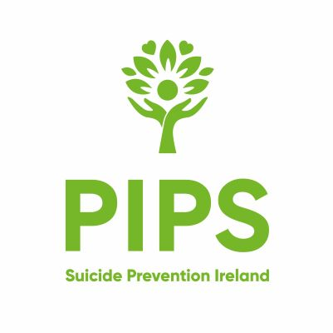
Reference No. | Title of Post  Child & Youth Counsellor | Location of Post  Belfast

PERSONAL DETAILS
Surname: | Previous Names:
First Names: | Address:
Email Address: | Telephone Number:  Mobile No.

Eligibility to Work in the UK
Do you require a permit to work in the UK?

If yes give details

Qualifications
School/Colleges/Universities | Qualification (s)

Employment:
PRESENT OR MOST RECENT POST Please complete the section below starting with your current or most recent employer. Please complete in full and give reasons for any gaps in employment in the Additional Employment Information section.

Employer Name:  Employer Address: | Date Employment commenced:  Date Left (if applicable)  Salary
Previous Positions
Employer Name | Position Held | From | To | Reason for Leaving

Having read the Job Description please outline how you meet the essential and desirable criteria. You should provide all relevant experience giving examples if possible.

Additional Skills and Qualifications or Training:

Are you a member of a Professional Body?
Please state name and level of Membership
Personal Declaration:
Is there any reason why you cannot work in Regulated Activity

Answer:

I declare that to the best of my knowledge the information given is honest and accurate. I understand that any wilful misstatement or mission renders me liable to disqualification or, if appointed, to dismissal.

I understand that the appointment is subject to receipt of satisfactory reference, pre-employment health assessment, the verification of qualifications required for the post (as per the personnel specification) and appropriate Access NI disclosure check when relevant. Having a conviction will not necessarily debar you from working with PIPS Charity. Please be advised that PIPS Charity adheres to the Access NI Code of Practice and has a Policy on the recruitment of ex-offenders, copies of which are available upon request from the HR Department.

Signature:

Date:

Notes:
Only this Completed Application Form will be considered. Continuance Sheets will be accepted. However, we cannot accept CV’s.
Applications must be legible.
It is the responsibility of all applicants to clearly demonstrate by the information which they provide in this application how they meet the essential and desirable criteria.
Where a high volume of applications are received desirable criteria may be relied upon during shortlisting.
Application Forms received after the deadline date and time will not be considered
Please return the Equal Opportunities Monitoring Form with your Application.
Completed forms should be returned to: liz@pipscharity.com

