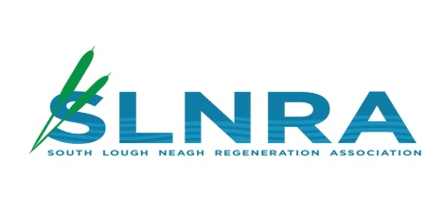

# JOB DESCRIPTION



**Job Title:** SLNRA Administrator and Support

Assistant

**Reports To:** Manager - SLNRA

**Duration:** Fixed term contract October 2024 to 31st December 2025

**Location:** SLNRA Offices

**Salary:** £20,202 per year pro rata (16hrs per

week

**Job Purpose**

South Lough Neagh Regeneration Association (SLNRA) has secured funding from the RANK Foundation to build on the work of SLNRA ‘s community presence in the area and continue to identify means to support communities in the South Lough Neagh area.

The administrator will provide essential and valuable support to our overall administrative functions. SLNRA would like to appoint an experienced Administrator with People and social media skills to support SLNRA in its Vision and future.

**Main purpose of the role:**

To support the Project Manager and SNLRA Management Committee in all areas of administration and input of data, to include but not be limited to the responsibilities:

**Main responsibilities:**

- Supporting the Project Manager and Board(s) through carrying out general admin duties as requested/required e.g., incoming/outgoing correspondence by phone, email, social media, maintain office files, typing of correspondence, minute taking and dissemination of same, filing, photocopying, scanning, and reception cover.

--Contributing to Organisation’s communications, e.g., updating information screens, website and social media.

-Maintaining and updating records, organisational processes and procedures, safety and confidentiality information

- Preparing and formatting letters, documents

-Inputting numeric data to appropriate systems

-Booking meeting rooms / facilities.

- Keeping resources updated, e.g, website, intranet content, telephone lists

-Assisting with administration of the organisation of events

-Checking and updating stationery

-Backing up /Saving all work

-To undertake any other duties as may be reasonably required by SLNRA Manager and SLNRA’s Management Board.

**Personal specification: Essential Criteria**

**Qualifications:**

* Educated to GCSEs Level A-C qualification (including Maths and English) or /and in CLAIT/word processing

**Essential Experience /Skills:**

* 2 years paid experience of administration within an organisation/company
* 2 years administrative skills and computer literacy, including MS Office
* 1 years experience of working in an office environment
* Experience of dealing with internal/external staff
* Ability to work unsupervised and work efficiently to meet set deadlines
* Experience in social media engagement and communication
* Have knowledge of /interest in the South Lough Neagh area
* Able to work on own initiative and lone working
* Excellent communication skills, both oral and written
* Willingness to work unsociable hours and flexibly (occasional)
* Accuracy and attention to detail.
* Ability to work independently and as part of a team
* Self‐motivated, adaptable, enthusiastic and positive approach.
* Have excellent time management.

**Desirable:**

Experience working in the voluntary/community sector