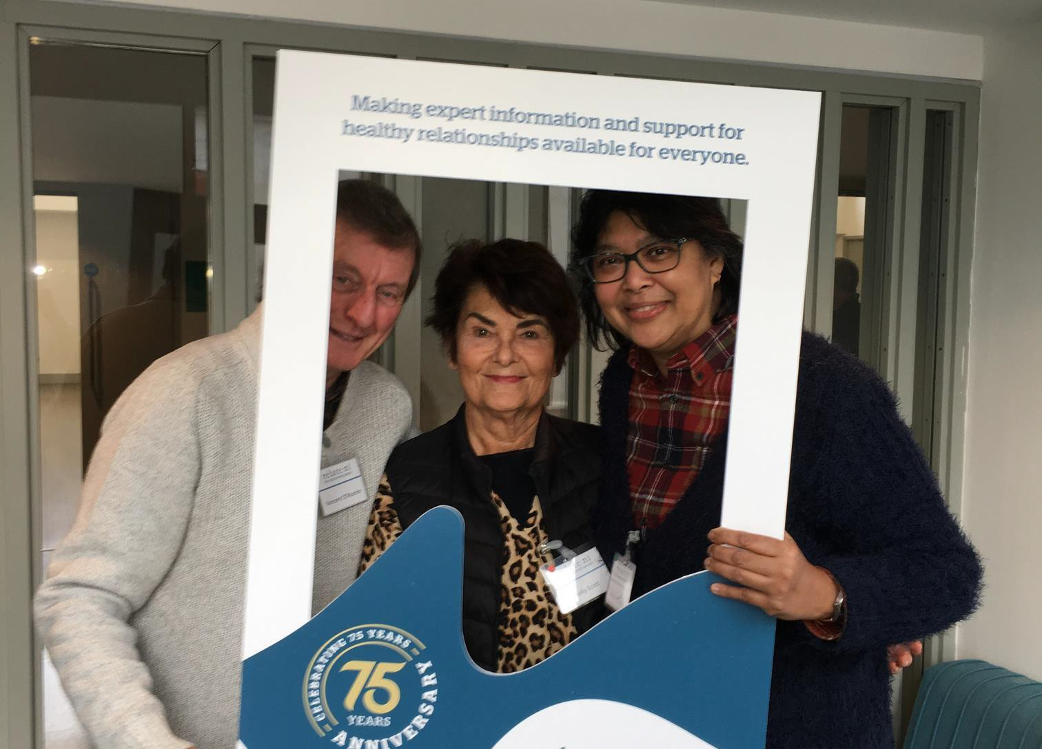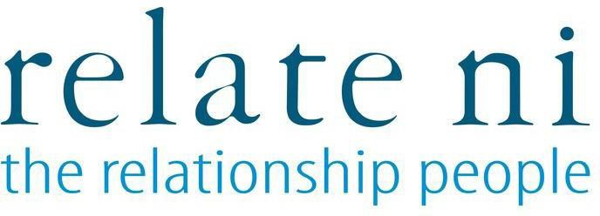



Senior Fundraising Officer

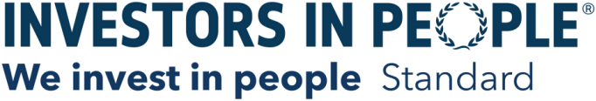

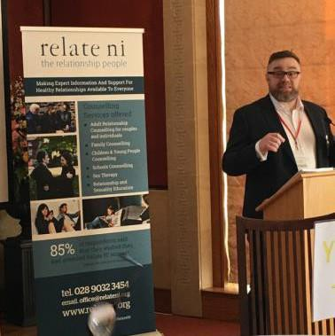

Relate NI is passionate about enabling good quality relationships for our diverse society in Northern Ireland. Through our experience of working with people across Northern Ireland, we’ve come to understand that relationships not only give our lives meaning; they are of vital importance to our wellbeing. In fact, good quality relationships are one of the most important assets we have as a society. Research and evidence now demonstrate why good quality relationships matter. Evidence indicates that good quality relationships are a crucial protective factor which can shield us from the effects of long-term health conditions; aid our recovery and can even prevent illness in the first place.

This is an exciting time to join the team at Relate NI team as we celebrate 75 years of providing high quality support for people and their relationships right across Northern Ireland, and as we look towards the ongoing relationship support needs of people and communities in the years to come.

So please take some time to find out more about Relate NI, the work we do and why you should think about submitting an application to come and join us to make a difference in the lives of people and communities right across Northern Ireland.

We look forward to receiving your application.

# f\BOUT REL/\ TE NI

Relate NI is a charity with a mission to make expert information and support for healthy relationships available for everyone. Our vision is of a future where healthy relationships are at the heart of a thriving society, and our mission is to make expert information and support for healthy relationships available to everyone. We have a number of ways in which we do this:

## - Provision of Therapeutic Services

Our core service and what we are probably best known for is the counselling support we have provided to people across Northern Ireland for more than 75 years. We provide counselling in the community to families, couples, individuals, teenagers and children from our premises in Belfast and Portadown, and through outcentres in Derry-Londonderry, Coleraine and Ballymena. Our counsellors are qualified and have several years' experience in relationship counselling. Relate NI is registered with the British Association of Counselling and Psychotherapy (BACP) and adhere to its professional standards. We also work with community-based organisations in Belfast to provide counselling and other supports to primary school children through the FSCN, Mu MO and STEP programmes and we are also on the Healthy Happy Minds framework for counselling in primary schools across Northern Ireland.

## - Provision of Education and Training Programmes

Relate NI has always been an advocate of Relationship and Sexuality Education and works in partnership with Nexus NI and The Rainbow Project to provide this to young people aged 15 and 16 years through a range of host organisations working with young people across Northern Ireland. The programme is supported by the Public Health Agency. We also deliver a CPCAB Level V Diploma in Relationship Counselling.

## - Delivery of Projects

Here at Relate NI, we are always looking for new ways to provide high quality and accessible relationship support to people. The Sustaining Healthy Relationships project is a new and innovative venture which has been supported through the Dormant Accounts Fund. Through this project we want to transform the way we work with and provide support to people by taking our educational interventions into the heart of communities with a view to preventing and or reducing relationship stress through providing tools and techniques to encourage, nurture and strengthen the foundational relationships that bring us joy and improve our mental and physical wellbeing. We provide education interventions to people involved in a range of youth and community groups through this programme.









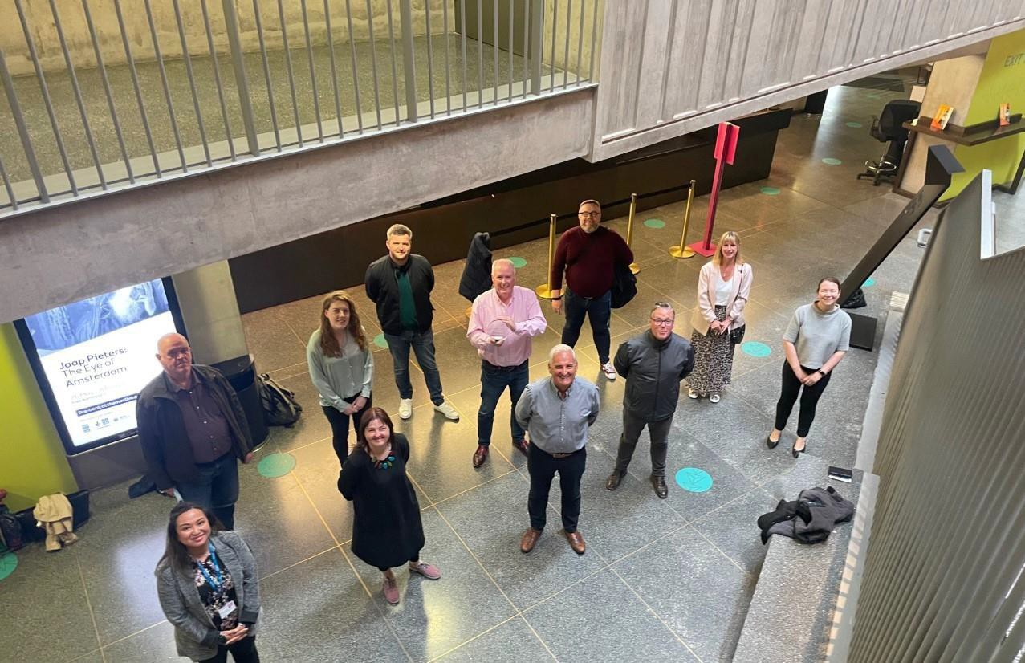*2021 Good Governance Award Winners (Medium Size Organisation)*

HELP US MAKE A DIFFERENCE IN THE LIVES OF PEOPLE ACROSS NORTHERN IRELAND

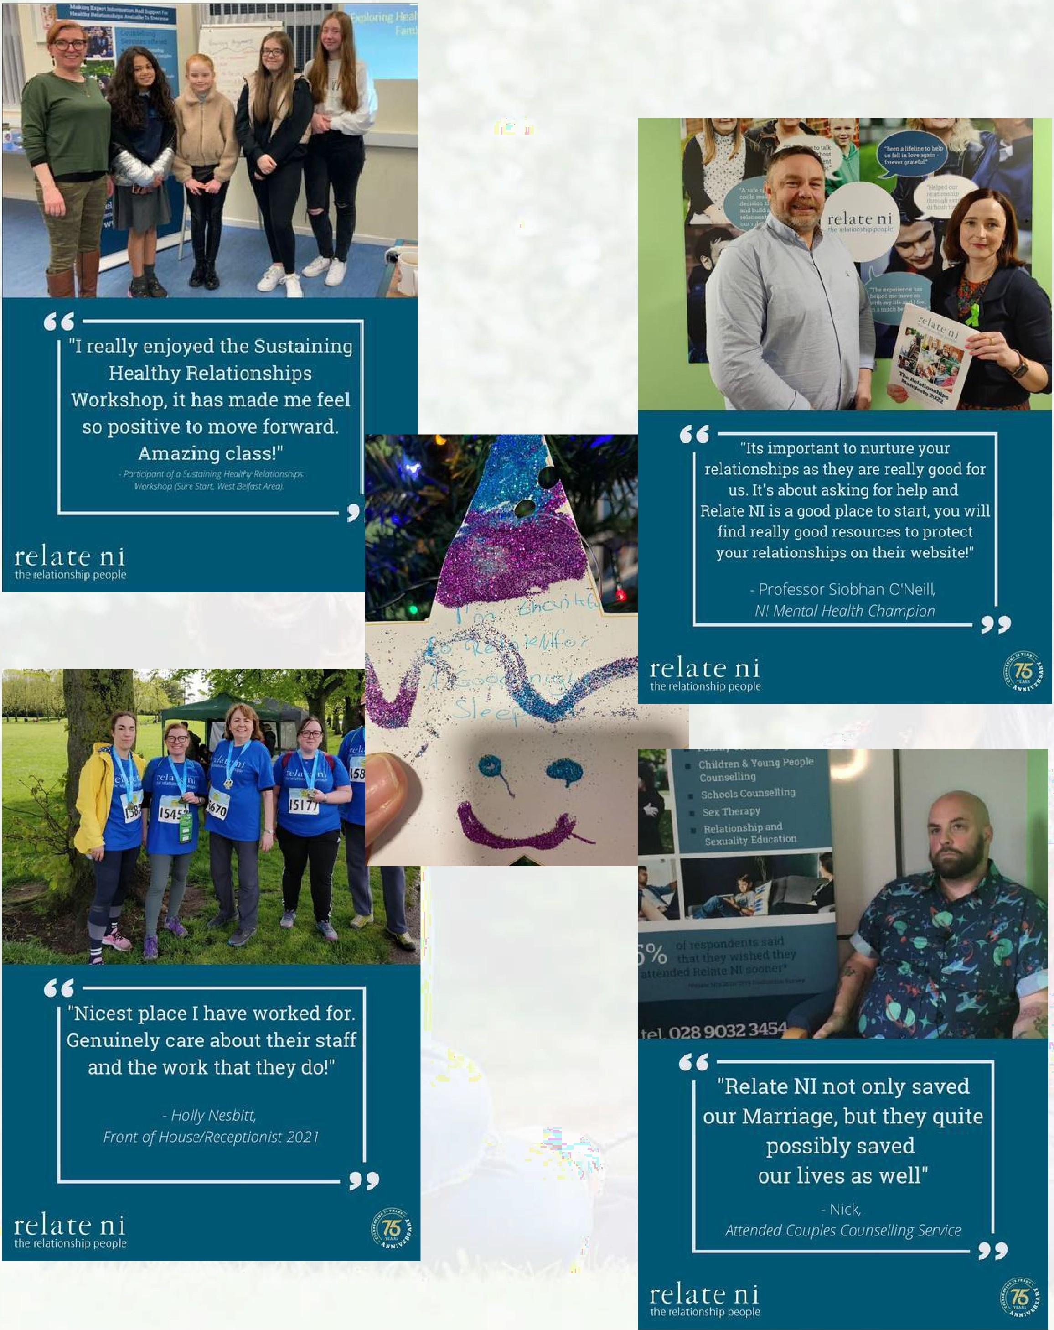

# WORKING. *f* T RELATE NI

Relate NI is an accredited Investor in People and to that end we are keen to support our staff through learning and development and continuous professional development opportunities. We provide all our staff with line management support and our counsellors with clinical supervision, both individual and group. Relate NI also provide all mandatory training at no cost to clinical employees.

Relate NI is accredited to provide CPCAB qualifications including a bespoke Level 5 Diploma in Relationship Counselling and can offer subsidised routes for those working with the organisation interested in completing this.

Following our recent re-accreditation for Investors in People here is what some of our staff said about working with Relate NI:

*"I get a sense of helping people* - *doing something for a purpose" "We are trusted to do what we do, professionally and ethically"*

*"I came to work in Relate NI because I wanted to do something that improves peoples' lives"*

"/ *was made feel very welcome; a valued member of the team"*

*"Takes the time to keep you up to date with what is happening and gives me feedback on how I am doing"*

*"Every year there has been improvement"*

*"We put relationships at the core of what we do, and that includes working with each other"*

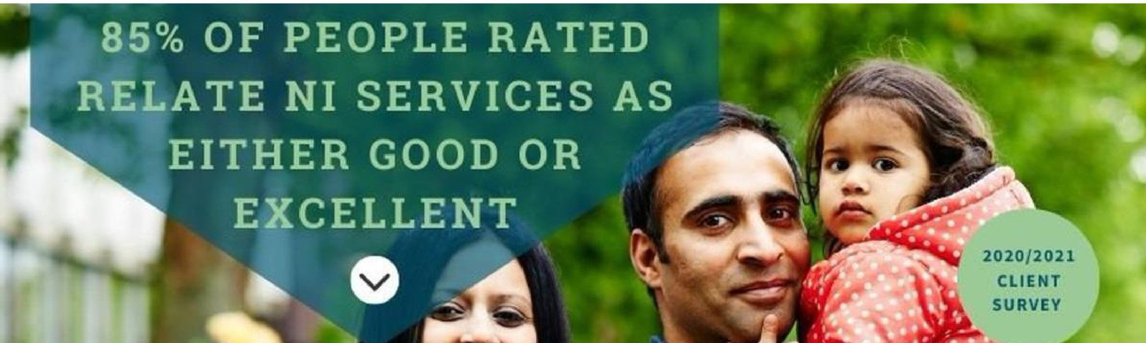









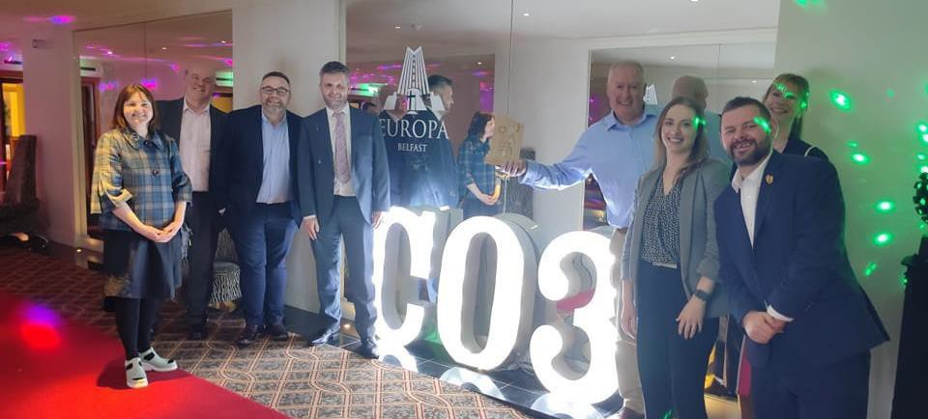*2022 Trustee of the Year Winners (Aidan Bennett, Chair)*



|  |  |
| --- | --- |
| **Job Title** | **Fundraising Officer** |
| **Place of Work** | 3 Glengall Street, Belfast, BT12 5AB |
| **Reports to** | CEO |
| **Salary** | £22,495.20 per annum gross |
| **Working Hours** | 35 working hours per week |
| **Holiday**  **Allowance** | 25 days per year plus 12 statutory days, pro-rata. The Relate NI holiday year  runs from 1 April to 31 March. |
| **Contract** | Subject to Funding |

### Job Purpose



* 



* 



Reporting and Governance

* Evaluate and report the impact of fundraising activity against projected targets and income generation forecasting.
* Ensure all activities are carried out legally and conform best practice in line with Fundraising Regulator, Codes of Fundraising practice and GDPR.
* Undertake such training as deemed necessary for the performance of these duties and participate in identifying training and development needs.
* Undertake any other duties as may reasonably be required as part of the Relate NI team.

### PERSONAL DEVELOPMENT

* To continue to participate in ongoing professional/ personal development opportunities.
* To keep abreast of new research, developments in practice and in the operating environment/ social policy framework.

**PERSON SPECI FICJ\ TION**

EXPERIENCE

* + Proven track record in a fundraising development or other relevant sales/marketing role with at least 3 years experience of developing and delivering income generation initiatives
  + Proven experience of delivering in a target driven environment of income circa £100k+ per annum
  + Proven experience in the development and delivery of fundraising through corporates and/or though events and/or through trusts and foundations at a regional and local level
  + Track record of developing new initiatives with at least three years successful track record in communications, sales and/or fundraising development

SKILLS

* + Proficient in MS Office including Excel
  + Proficient in maintaining record keeping systems required for fundraising activity
  + Strong written and oral communication skills; able to present information in an effective way to different audiences
  + Customer focused (internal and external) in a Communications/Fundraising role
  + Excellent negotiation and influencing skills
  + Effective networking skills and the ability to build relationships with a diverse range of people
  + Problem solving skills
  + Ability plan and prioritise own workload meet deadlines and departmental objectives with minimal supervision, using own initiative as appropriate

OTHER

* + Strong understanding of the work of Relate NI and the importance of healthy relationships for people and communities across Northern Ireland
  + Team player, with the ability to work co-operatively with others as part of a team

DESIRABLE

* + 3rd Level Qualification relevant to the role
  + Speak languages other than English

*Relate NI reserves the right to enhance the criteria for short-listing purposes in the event of a large number of applications being received.*





  [FrancesMcCausland@](mailto:EmmaIrwin@relateni.org)relateni.org



Frances McCausland Head of Business Operations3





