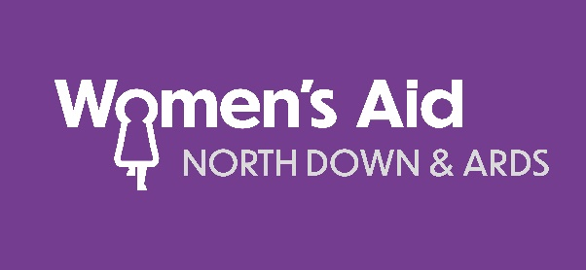

Dear Applicant

We have enclosed an application pack as requested. Details of the closing date and submission are noted on the front page of the application form. Late submissions will not be accepted. Included in the pack is:

- Ethos of North Down & Ards Women’s Aid
- Vision, Core Aims and Values of North Down & Ards Women’s Aid
- Job Description
- Person Profile
- Application Form
- Equal opportunities monitoring form (we require this form to be completed for FEC monitoring purposes)

North Down & Ards Women’s Aid is an Equal Opportunities Employer. We are recruiting females only for this post. Due to the level of contact with vulnerable women and children, the lawful recruitment of females for this post falls within the exemption stated in Article 10 (2b and 4e) of the Sex Discrimination (N.I.) Order 1976 (as amended).

In order to comply with the Safeguarding Vulnerable Groups (Northern Ireland) Order 2007, North Down & Ards Women’s Aid are required to explore the successful candidate’s suitability to work with vulnerable adults and children through ACCESS NI pre-employment screening. These checks will be repeated every three years for workers in post.

The Application Form gives you the opportunity to ‘market’ yourself to us and tell us how your skills, knowledge, qualifications and competence fits the requirements of the job. Please be as comprehensive in your answers as possible. We will use the information you give us to decide whether to invite you for an interview. You should read the questions carefully, and answer the questions fully. You should look at the job description, person specification and other supporting information and tell us how your skills, knowledge, qualifications and competence match our needs.

The Person Profile sets out the experience, skills & abilities, knowledge, qualifications and other competencies you need to carry out the activities given in the role profile. We use it at both the short-listing and interviewing stages of the recruitment and selection process as the criteria you’ll be assessed on. The person specification is made up of two levels.

- Essential Criteria – this is the criteria that you need to meet to perform at a satisfactory level from the first day in the job. If you don’t meet the essential criteria, you won’t be short-listed for interview. It is not sufficient enough to state you meet the criteria – applicants must explain how they meet it.

- Desirable Criteria – the desirable criteria that would allow you to perform the job more effectively.

Canvassing, either directly or indirectly, will be an absolute disqualification.

NDAWA takes its obligations to data protection seriously. The information you provide will only be used for the purpose of this recruitment exercise and your details will be held in a secure environment. Access to your information will be restricted to those involved in the recruitment and selection process. By completing and signing the application form, you are consenting that the information on this form will be collected, stored and processed by North Down & Ards Women’s Aid with the Fair Employment and Treatment (NI) Order 1998 and provisions of the Data Protection Act (1998) and GDPR Regulations (2018). Your application will be stored for up to a 12-month period in line with the above legislation. I further understand the information is being used to:

- Process my application for employment
- Form the basis of a computerised record on the recruitment system for processing and monitoring purposes
- Form the basis of a manual file with other application forms and will be used for processing
- If appointed, form the basis of a manual and computerised employment record.
- Your rights – You have the right to contact us and request to be forgotten or withdraw consent at any stage.

May I take this opportunity to thank you for your interest and we look forward to receiving your application.

Yours faithfully

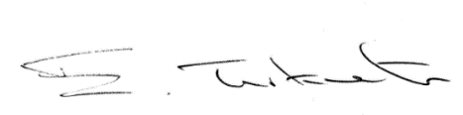

Emalyn Turkington
Chief Executive Officer
North Down & Ards Women’s Aid

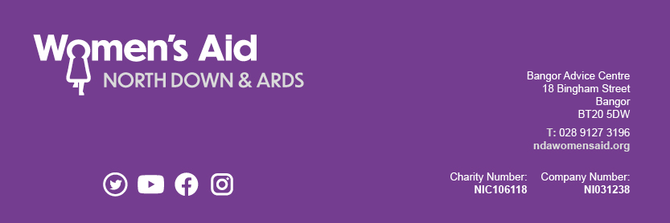

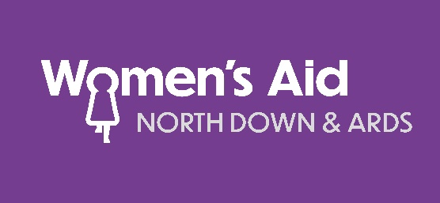

Our Ethos

We are part of a worldwide feminist movement working for a better future in which equality of opportunity and real choice is available to all. Our work is rooted in the principles of non-violence, self-help, best practice and working in partnership. All Women’s Aid services are developed in response to the needs of women and children affected by domestic and sexual violence. By listening and responding to their needs, we have built up a wealth of expertise about violence and abuse.

We believe:
- violence against women is a manifestation of unequal power relationships between women and men at all levels of society;

- violence against women remains a historical and cultural feature of our society;

- the underlying cause of violence against women is the abuse of power and control by perpetrators;

- domestic violence is one form of violence against women;

- domestic violence is a violation of Article 5 of the UN Universal Declaration of Human Rights – that “no one shall be subjected to torture or to cruel, inhuman or degrading treatment or punishment”;

- women are not passive victims of domestic violence – with support, women have the capacity to cope with and survive the violence and abuse they experience;

- children who are experiencing domestic violence benefit from a range of services and support and some may need safeguarding from harm – often, supporting a non-violent parent is the most effective way of promoting a child’s welfare.

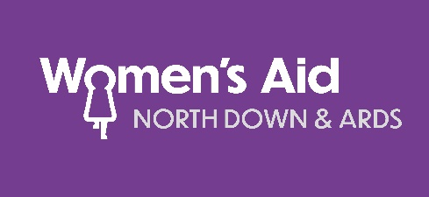

OUR VISION

Our vision is for a time when the voices of women, children and young people living with domestic violence, are heard and understood, where support and information is available locally, where the communities in which we live are safer, healthier and where domestic violence is eliminated.

OUR CORE AIMS
Provide temporary refuge to women and their children suffering emotional, mental, physical or sexual abuse within their home;

Encourage the woman to take control of her own future, whether this involves returning home or beginning an independent life;

Recognise and care for the emotional needs of the children involved;

Offer support and advice to any woman who asks for it, whether or not she is living in a refuge and to offer supportive aftercare to women leaving the refuge;

Educate and inform the public, the media, the courts, social services and other agencies, always mindful of the fact that abused women are a direct result of the general position of our society.

VALUES

High quality services- We have a commitment to provide professional, quality services which reflect the involvement of staff, volunteers and service users. Consultation with service users is a key component of our work. We provide support and direction to staff with a focus to continual improvement of practices and services.

Self-help – Self-help plays a vital role in our work with women and children. Women are supported, as they share their experiences with other service users. They learn from each other as they rediscover their identity and their self-worth. As this discovery develops, self-confidence and self-esteem increase and personal growth and empowerment move women forward. Women empower themselves to make choices with confidence.

Non-judgemental - We are committed to delivering anti-discriminatory services and providing strong recognition of equality and diversity.

Respect - We respect and value the experiences of service users, staff and volunteer members as well as the contribution of all stakeholders and partners.

Self-determination - We work from a non-directive approach. The choices made by women are supported by staff and volunteers. Women are supported and encouraged to develop a belief in themselves.

Women - We are a woman focused organisation and deliver our core work using a woman only staff and volunteer team. We believe it is vital to support women in crisis, both to create a safe environment and also to provide positive, strong role models. We recognise the need to provide positive male role models for children and young people, and to engage the support of men where their expertise will inform and enhance service delivery and planning.

Children and young people - We recognise the direct and indirect impact of domestic violence and abuse on children and young people and will continue to deliver services and develop programmes to meet their needs.

Human rights, equal opportunity and diversity - We are committed to the principles of equal opportunities and to achieving diversity within its capacity as an employer and a provider of services. We will actively challenge discrimination both within our own organisation, where it is identified with partners and in the wider community. We recognise domestic violence and abuse as a contravention of the human rights of people within our society.

Public awareness and education - By raising public awareness around the complex issues arising from domestic violence and abuse, we seek to address the underlying causes through education, prevention and training work.

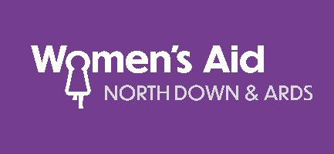

JOB DESCRIPTION

JOB TITLE: Rural Support Worker
RESPONSIBLE TO: Floating Support Team Leader
LOCATION: Bangor Advice Centre, Ards Peninsula (various locations), Bangor and Newtownards
DURATION OF POST: 2 years (with potential for extension)

SUMMARY OF POST:

To provide support services and raise awareness to women living in rural locations in Ards and North Down, who are or who have experienced domestic and/or sexual violence/abuse.

MAIN RESPONSIBILITIES:
  - To provide information, advocacy and support for women experiencing or who have experienced domestic and sexual violence/abuse.
  - To work alongside the refuge team to support women entering the refuge.
  - To provide one-to-one support sessions for women who are living with the impact of domestic and sexual violence/abuse.
  - Provide a range of support services including advocacy and accompaniment with statutory agencies; advice surgeries; personal development work; benefit information and housing support services to assist women in ensuring their safety and maintaining their independence.
  - To ensure an effective risk management plan is implemented when risk is identified.
  - Develop an individually tailored support plan with each woman, containing agreed objectives, time-scales and review periods.
  - Support and empower women to identify personal needs and goals to promote their personal development through the encouragement of participation in all appropriate areas of service provision.
  - Establish and maintain good inter-agency working relationships with statutory agencies, including Social Services, PSNI, NIHE and community and voluntary sector agencies.
  - Offer on-going accompaniment and support as relevant to women regarding courts, solicitors etc.
  - Offer enhanced support to women and children with specific needs e.g. cultural, mental health, alcohol and drugs, learning difficulties; through consultation with managers and other support workers or referring to external agencies
  - Publicise North Down and Ards Women’s Aid services via advice surgeries, information sessions and contacts with other groups and agencies.
  - Raise awareness within the local community of the needs of women and children experiencing domestic and sexual abuse and the work of North Down and Ards Women’s Aid.
  - Refer women to the range of services provided by North Down and Ards Women’s Aid as required.
  - To be fully aware of the child and adult safeguarding and protection procedures in North Down and Ards Women’s Aid and report to your line manager any concerns or issues in this area.
  - Provide any information and reports on the project required by the Line Manager and ensure all statistics and administrative procedures are kept up to date.
- Maintain general upkeep of locations – general housekeeping tasks with a particular regard to cleanliness, tidiness and safety.
- To keep up-to-date with changes in legislation and working practices and ensure North Down and Ards Women’s Aid standards and requirements are met at all times.
- To promote the best interests of women, children and young people at all times.
- To undertake any other appropriate duties that contributes to the achievement and function of this post.

GENERAL DUTIES:
- Refer women to the range of services provided by North Down and Ards Women’s Aid as required.
- Attend staff meetings, training courses, supervision as required.
- Adhere to regional and local Women’s Aid policies and procedures including Data Protection, Safeguarding Children Policy and Adults at Risk Policy and procedural guidelines.
- Be flexible and responsive to project needs be being available to work weekends and bank holidays on a rota basis.
- To participate in the on-call rota (Additional payment and annual leave hours applicable)
- To adhere to the ethos of North Down and Ards Women’s and Code of Conduct, displaying attitudes and behaviours appropriate to the organisation and respect the rights and responsibilities of others.
- To promote the best interests of women, children and young people at all times.
- Encourage and maintain the ‘self-help’ standards of Women’s Aid.
- Respect the confidentiality of all information received as a result of the post holder’s duties.
- To undertake any additional duties relevant to the post as may be specified by Senior Managers/C.E.O./Board of Directors of North Down and Ards Women’s Aid.

TERMS: | 2 years (with potential for extension)
HOURS: | 37 hours per week, Monday – Saturday by rota. This post will involve flexible working to facilitate the needs of the projects
SALARY: | Starting Salary £20,202 per annum, rising to £21,164 per annum after probation period
HOLIDAYS:  PENSION: | 25 days (rising to 30 days per annum with length of service) and public holidays  4% employee/8% employer contribution pension scheme.

The job description is a general outline of the post as it is currently perceived by NDAWA. This job description is not intended to be restrictive or definitive and will be modified to meet the requirements of the evolving needs of the services we provide. The responsibilities of the post will change in line with continuous improvements as NDAWA aims to meet its vision, strategic planning and best response to the needs of clients accessing our services.

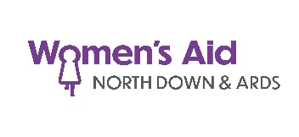

Rural Support Worker

PERSON SPECIFICATION

 | ESSENTIAL | DESIRABLE
Experience | - Recent relevant experience of working in Floating Support or support environment.  - Recent relevant experience of working with statutory agencies/community or voluntary agencies. | - Experience of working with individuals in crisis.
Skills and Abilities | - Effective interpersonal and communication skills.  - Proven networking skills.  - IT skills – experience of record keeping with excel, word and database.  - Proven ability to give practical and emotional support and guidance.  - The ability to prioritise own workload and work on own initiative. | - Group facilitation skills.
Knowledge | - Knowledgeable, passionate and committed to women’s issues particularly in the area of domestic and sexual abuse.  - An understanding of the causes and effects of domestic and sexual abuse including the legislative framework of safeguarding vulnerable adults and children. | - Knowledge of relevant Health and Safety issues and procedures.
Qualifications | - GCSE (or equivalent) standard of education.  - QCF Level 3 Health & Social Care or equivalent (NVQ Level 3 etc) or a recognised counselling qualification. | - Higher qualification/s in relevant field.
Other | - Willingness to work flexible hours as required and attend monthly team meetings and training events.  - To assist in the provision of the 24-hour refuge On-Call cover through our established rota systems.  - Car driver with access to car that allows candidate to fulfil duties of the post. (This criteria will be waived in the case of applicants whose disability prohibits driving but who have access to a form of transport approved by NDAWA, which will permit them to carry out the duties of the post.)  - Able to meet Enhanced Access NI requirements.  - Entitled to work in the UK.

Applicants please note: Shortlisting will be carried out on the basis of the minimum criteria set out above, using the information given on the application form. You should therefore address the requirements when completing the application form, as failure to do so may result in you not being shortlisted.

Due to the level of contact with vulnerable women and children, the lawful recruitment of females for this post falls within the exemption stated in Article 10 (2b and 4e) of the Sex Discrimination (N.I.) Order 1976
NDAWA is an Equal Opportunities Employer

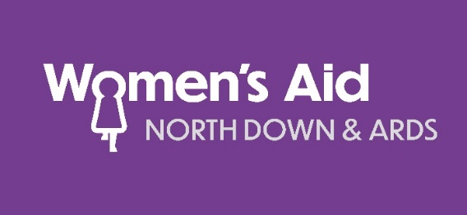

Application for appointment as

Rural Support Worker

This form must be returned no later 12pm on Friday 31st March 2023.
(late submissions will not be accepted)

emailed to: jobs@ndawomensaid.org

Guidance notes for completion of application forms:
- Please complete this form in print only; we do not accept handwritten applications.
- Applicants are advised that the short listing of candidates will be based only on the details given in the application form.
- CV’s must not be included as part of your application and if submitted will not be considered.
- Please note that all sections of the application form must be completed in full. Where sections are not relevant, write “Not applicable” or “None.” Do not leave blank.
- Please ensure that all checkboxes are appropriately marked.
- NDAWA reserves the right to shortlist only those candidates who best fit the criteria.
- Desirable criteria for this post may be used to facilitate the short listing process.
- All sections of the form must be completed and continuation sheets may be used for this purpose if necessary.
- We accept hard copy or emailed applications.

Title | Surname | Forename(s) (Please underline name by which you are known)
Address | Contact telephone number/s | Email address
Are you eligible to work in the UK? Yes ☐ No ☐
Please note that we are only able to employ people who have the right to work in the UK.

Do you hold a full driving licence? Yes ☐ No ☐

Do you have access to a reliable form of transport? Yes ☐ No ☐

Present and previous work experience/voluntary work
Please start with the most recent experience, include any breaks in employment
Employer name and nature of organisation | Post held and brief outline of responsibilities | Dates  (month and year)  From To | Reason for leaving
Salary and benefits of most recent post |  | Notice required
If there are any gaps in your employment, please explain further.

Education & qualifications
Secondary level, further and higher Education

From | To | Type of school/college/university attended |  | Subject | Examinations passed/working towards
 |  |  |  |  | Level | Grade | Date
Membership of professional Institutions/associations

Details of any other training/qualifications gained which support your application. Include any on the job training as well as formal courses.
(use further space if required)

Essential Criteria

Please refer to the Person Specification which sets out the experience, skills & abilities, knowledge, qualifications and other competencies you need to carry out the activities given in the role profile. We use it at both the short-listing and interviewing stages of the recruitment and selection process as the criteria you’ll be assessed on. Essential Criteria – this is the criteria that you need to meet to perform at a satisfactory level from the first day in the job. If you don’t meet the essential criteria, you won’t be short-listed for interview. Please ensure you give work-based evidence and examples - it is not sufficient enough to state you meet the criteria – applicants must explain how they meet it.

(Use further space if required)

Desirable Criteria

Please refer to the Person Specification which sets out the experience, skills & abilities, knowledge, qualifications and other competencies you need to carry out the activities given in the role profile. We use it at both the short-listing and interviewing stages of the recruitment and selection process as the criteria you’ll be assessed on. Desirable Criteria – the desirable criteria that would allow you to perform the job more effectively. Please ensure you give work-based evidence and examples - it is not sufficient enough to state you meet the criteria – applicants must explain how they meet it.

(Use further space if required)

Please supply two professional referees (not relatives) one who should have knowledge of your present and most recent work and be in a Supervisory/Managerial role. References will only be contacted after interview and when a job offer has been made.

Reference No 1 Name:

Occupation:

Organisation:

Address:

Email Address:
Contact No:

Reference No 2 Name:

Occupation:

Organisation:

Address:

Email Address:
Contact No:

Due to the nature of the work environment, positions within NDAWA will require the post-holder to undertake a confidential Enhanced Access NI background check, where the post is a regulated position as defined by the Safeguarding Vulnerable Groups Act 2006 and Safeguarding Vulnerable Groups (NI) Order 2007 and also falls within the definition of ‘excepted’ employment as provided by the Rehabilitation of Offenders (Exceptions) Order (NI) 1979.

Therefore, you are required to answer the following question. Disclosure will not necessarily prevent you from obtaining this position. Do you have any convictions, cautions, reprimands or final warnings that are "unspent" as defined by the Rehabilitation of Offenders Act 1974 (Exceptions) Order 1975 (as amended in 2013)?
Yes ☐ (give details) No ☐

Conflicts of Interest – Please give details of any personal or professional interests that may be relevant to the work, ethos, vision, core aims and values of NDAWA (statements are included in this application pack) and which could lead to a real or perceived conflict of interests if you are successfully appointed to the post.
Yes ☐ (give details) No ☐

Do you have any pre-booked holiday arrangements which NDAWA needs to be aware of in respect of your availability? If yes, please give dates. (NDAWA is under no obligation to take into account holiday arrangements but will endeavour to do so.)
Yes ☐ (give details) No ☐

The Disability Discrimination Act 1995 defines a disability as ‘a physical or mental impairment which has a substantial and long term adverse effect on a person’s ability to carry out normal day to day activities’. Candidates with a disability will be given equal consideration. Do you have any disabilities which may affect your application? If YES, are there any reasonable adjustments, which you feel, should be made by the recruitment process to assist you in your application for the job?
Yes ☐ (give details) No ☐

Please note candidates with a disability will have the opportunity to discuss their employment needs at interview to enable NDAWA to identify if reasonable adjustment/s can or should be made.

Declaration and signature

Data Protection - I understand that the data contained in this application form and the “sensitive personal data” on the attached monitoring form will be retained on file and may be processed by NDAWA for use in connection with this application for employment, or to comply with any requirement of statutory legislation in order for NDAWA to comply with its legal obligations, and I hereby agree to any such processing by NDAWA. NDAWA will ensure that I am safeguarded against the possible misuse of any personal information about me that is kept on file by strictly controlling access and use. Such access and use will be in compliance with the Data Protection and GDPR legislation and will be on a “need to know” basis only. I have read and understood the General Data Protection Regulation privacy statement on the covering letter.

I declare that the information given in this form and in any accompanying documentation is true to the best of my knowledge and belief and give my permission if I am the successful applicant, for enquiries to be made (including online enquiries) to confirm qualifications, experiences and dates of employment, right to work in the UK and for the release by other people or agencies of necessary information to verify the content. I further agree that, should I be successful in this application, I will consent to an application for disclosure of criminal convictions. I understand that my application, any job offer made, and any subsequent employment with NDAWA may be withdrawn in the event that I have given any false or misleading information or have withheld any relevant details or have received unsatisfactory references and Access NI background checks.

Canvassing, either directly or indirectly, will be an absolute disqualification.

NDAWA may use online sources to collect data during the recruitment process if application specifies online work, blogs, websites etc.

Signature ________________________________________ Date _____________________
(A digital signature will be accepted – if shortlisted for interview you will be required to provide written signature at time of interview.)

