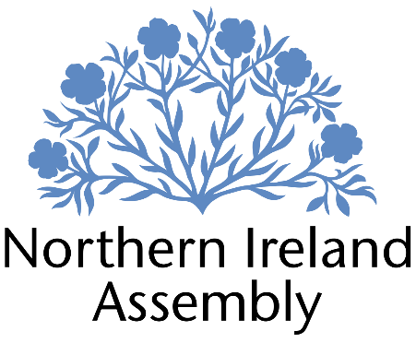
Patrick Brown MLA

Alliance Party Member of the Northern Ireland Assembly for North Down Constituency

CONSTITUENCY OFFICER

Report to: | Patrick Brown MLA
Office Location: | 4 days per week at constituency office in Downpatrick
Hours: | 28 hours per week, Four days per week, Tuesday-Friday
Holidays: | As per determination
Salary: | Grade 1, £12.83ph, £24,679 pro rata (£18,676pa)
Pension: | A central Assembly-approved pension scheme is provided. If enrolled an amount equivalent to 10% of employees salary will be paid into the pension scheme.
Duration: | 3 Month temporary term whilst the member remains an MLA or until legislation is introduced to change Constituency expense provision. No probation period.

Closing Date | Noon, Friday 31st March 2023
Interview dates: | Tuesday 4th April

JOB DESCRIPTION

“A role with the opportunity to make a tangible difference in people’s lives through assisting with complex and meaningful casework as part of Patrick Brown MLA’s South Down constituency service”

Constituency

- To assist in the work of the Constituency Office by delivering effective casework as part of Patrick Brown MLA’s constituency services

- Support the running of Downpatrick constituency office including opening & closing, cleansing, utilities, rent, stocking and other relevant office management tasks

- Provide support and guidance to constituents in need and deal with enquiries sensitively and confidentially

- Receiving and processing constituency enquiries via office walk-ins, phone calls, letter and email

- Log casework, monitor progress and take appropriate action using project management software, ensuring all GDPR rules are adhered to

- Review key themes emerging from casework to identify issues to be progressed either with statutory agencies or by legislative action

- Liaise regularly with other staff members to ensure fair and equitable delegation of casework and related activities

- Liaise regularly with Policy, Communications and Research Manager to develop relevant stories for local press articles based on casework priorities, and assisting in their drafting where necessary
- Building relationships, liaising and meeting with business, community, local government and other key stakeholders in the constituency on behalf of the MLA
- Carrying out research tasks as and when required
- Proactively surverying residents, businesses and other key stakeholders to gather and process casework
- Scheduling, attending and note-taking during meetings
- Other duties as required in support of the MLA carrying out their constituency service.

PERSON SPECIFICATION

 | Essential Criteria | Desirable Criteria
Professional / Technical Qualifications | - Five GCSE’s / O’ Levels or Equivalent at Grade C or above including both English Language and Mathematics  - Excellent written skills (Grammar, punctuation and spelling)  - Proficiency in the use of Microsoft Outlook, Word and Excel packages | - Recognised professional qualification in relevant field such as customer care  - Third level qualification in relevant field  - 7 GCSEs at Grade C or above including Maths and English Language
Experience / Job Knowledge | - Minimum of one years’ experience working in a paid or unpaid capacity in administration in an office environment  - Minimum of one years’ experience in a paid or voluntary capacity in the community/voluntary sector  - Experience of working with a range of stakeholders in order to achieve outcomes  - Previous experience of working with the public  - Experience of dealing with sensitive and confidential information (both verbal and written) in line with the Data Protection Act and GDPR | - Experience of managing an office  - Campaigning experience; political or otherwise  - Experience of managing volunteers  - Experience of managing a budget  - Experience of working in a small team  - Experience of working on complex projects  - Working knowledge of the Benefits and Housing processes in Northern Ireland  - Working knowledge of the advice sector  - Working knowledge of the planning system  - Experience of preparing and submitting funding applications
Personal Qualities /  Skills | - Good punctuality  - Excellent verbal communication skills in person and on the phone  - Flexible, innovative and enthusiastic approach to work duties  - Understanding of Alliance Party objectives  - Commitment to local area and a desire to drive change | - Patience and compassion  - Time management  - Ability to multitask
Circumstances | - Able to work unsupervised and as lone worker in office when required | - May be required to travel to meetings

Applicants must demonstrate clearly on their application form how they meet the criteria.

