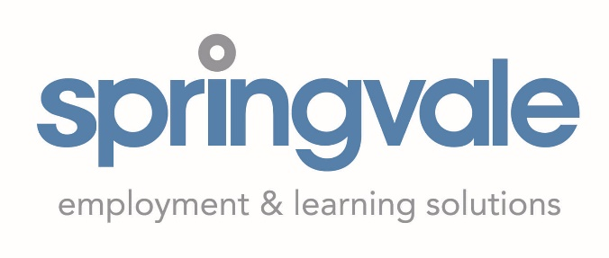

Job Description
title Apprenticeship NI recruiter
responsible to Director of Operations
Location 200 Springfield Road, Belfast
contracted hours 37.5 Hours per week
Salary £30,000 p.a.
Springvale is a leading employment & learning provider, delivering a wide range of training and employment programmes to young people and adults throughout N. Ireland for more than 30 years.
We are currently in an exciting period of growth having won a number of large contracts this year and with a number of new key roles being filled to support this growth we’re delighted to be advertising for an Apprenticeships NI recruiter position.
As an organisation, we are fully committed to further developing our links and relationships with employers across Northern Ireland. This includes building our employer network of Apprenticeship providers in line with our growth strategy.
The successful candidate must have 3 years or more experience within the last 5 years of working with employers in an engagement/relationship/recruitment capacity and ideally be educated to degree level in a business studies or sales related qualification.
main responsibilities
- Creation and roll out of a new recruitment strategy
- Proactively develop relationships with a wide range of employers across NI to build our opportunity base, particularly focusing on apprenticeship opportunities
- Work with employers to identify additional opportunities outside of our core programmes
- Work with existing placement providers to transition learners into permanent employment opportunities eg. onto an apprenticeship programme
- Act as a brand ambassador for Springvale with employers across Northern Ireland and identify opportunities for brand enhancement
- Maintain up to date knowledge of the local labour market and skills gaps, using this knowledge to help identify sector specific support to meet employer needs
- Maintain an accurate and up-to-date employer database and participant information systems

- Ensure accurate and timely completion of all paperwork

- Performing any other duties as required by the line manager and that are commensurate with the grade of the post

This job description indicates only the main duties and responsibilities of the post. It is not intended as an exhaustive list.

The post holder must have a flexible attitude to work and carry out any other duty, from time to time, requested by management.

Person Specification

CRITERIA | ESSENTIAL / DESIRABLE  (E / D)
EXPERIENCE / KNOWLEDGE  Educated to HNC/HND in a Business/Sales subject AND at least 3 years current demonstrable experience in a recruitment/sales role  Educated to Degree level in a Business/Sales related subject  Proven experience of working with both employers and clients  A working understanding of the needs of employers in NI and the barriers that students might face when they gain full time work or a placement  Experience of working within a target driven environment responding to the needs of employers  Experience of communicating effectively with clients and employers resolving issues and building relationships  Valid driving license and access to car to complete duties | E  D  E  E  E  E
SKILLS / ABILITIES  Ability to establish new relationships with employers and  Excellent written communication skills to include the ability to write high quality reports and plans  Ability to create innovative and engaging ideas and put these into practice through a robust employer engagement strategy  Excellent interpersonal, communication and influencing skills with a wide range of audiences  Proficient ability to use MS Office to include word, excel, access, outlook and PowerPoint  Ability to gather and analyse market data  Ability to work effectively and flexibly as part of a team and using initiative.  Excellent time management with excellent organisational skills and a proven track record of meeting deadlines. | E  E  E  E  E  E  E  E

Application Process

Please send a copy of your cv and a cover letter outlining how you meet the criteria by 12 noon on xxxxxxxxx to j.fegan@usdt.co.uk

