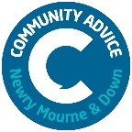

Community Advice Newry, Mourne and Down (formerly Citizens Advice) are recruiting a Tribunal Representative to work as part of our small, dynamic, and effective team to help those in our local community.
(Trainee will be considered and full accredited training provided).

Tribunal Representative.

Salary: £25,409 pro rata. Trainee £20,000 pro rata

One Post: 21 Hours per week

Location Ballymote Centre, Downpatrick

Closing date for applications: Friday 17th February @ 1pm.

Application packs are available from: reception@advicenmd.com or downloaded from communityni.org.

25 days holidays, 11 days statutory holidays, Private Health Insurance, death in benefit insurance, wellness day and much more.

Community Advice aims to be an Equal Opportunities Employer and welcomes applications from all sections of the community.

