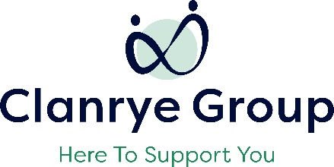
Clanrye Group
Job Description

Job Title | Employability Officer
Reports To | DSS Programme Manager
Programmes | Disability Support Services
Work Location | Various throughout NI
Hours of Work | Based on Need

Summary of Position

- Provide a work placement support service to young people who require assistance whilst participating on the Skills for Life and Work, Training for Success and/or Apprenticeships NI Programme.
- Carry out administrative tasks required and as agreed with line manager.

Key Duties and Responsibilities

- Organise work placements and support participants in the work placement process.
- Prepare participants for interviews/introductory meetings with potential new employers and accompany them to these.
- Prepare participants for their first day on placement to ensure they know what is expected of them and what they can do to make the right start.
- Provide mentoring support to participants as and when required.
- Organise and attend placement visits to monitor the progress of participants and deal effectively with any issues/concerns that arise.
- Carry out administrative duties including engagement notes and department required documentation.
- Assist the DSS Co-ordinator with the monitoring and evidencing of progress against Performance Targets set.
- Provide monthly updates to the DSS Co-ordinator on the participant’s progress.
- Maintain a confidential and effective system for processing and maintaining all internal documentation.

The key job duties listed above give a broad outline of the functions of the role. However, these duties must be approached in a flexible manner. The job holder will be expected to adapt to changing circumstances and undertake other duties as allocated by your Line Manager. The outline of the job duties may change from time to time.

General Duties

- Carry out job duties in compliance with Clanrye Group’s policies and procedures to include equal opportunities and health and safety legislation.
- Adhere to existing work practices, procedures and undertake relevant training and development activities and to respond positively to new and alternative systems.
- Keep up to date with new resources in line with industry demand and currency ensuring participants are trained using the most up to date and current resources.
- Act in compliance with all course examination, assessment and validation requirements.
- Ensure quality of provision at all times.
- Demonstrate commitment to Clanrye Group through the completion of all tasks allocated to you and by attending staff and development opportunities to ensure that professional competency is maintained.

Essential Criteria

- Educated to NVQ Level 2 or equivalent to include Maths and English.
- 1 year experience in a similar role supporting people with learning disabilities within a group environment and / or on 1-1 setting.
- Effective 1:1 mentoring and motivational skills to encourage participants to undertake positive actions towards employment.
- Ability to be flexible and adaptable - hours are flexible.
- Ability to demonstrate administrative skills with good record keeping.
- Proven experience and good knowledge of MS Office to include Word, Excel and Outlook.
- Knowledge of statutory services and relevant legislation especially child protection and safeguarding.
- Understanding of the barriers faced by people with learning disabilities.
- Full current driving license and access to a car.

Desirable Criteria

- Experience of supporting people who require employability support.
- Appropriate educational attainment to meet the needs of the learner.

