Job Description
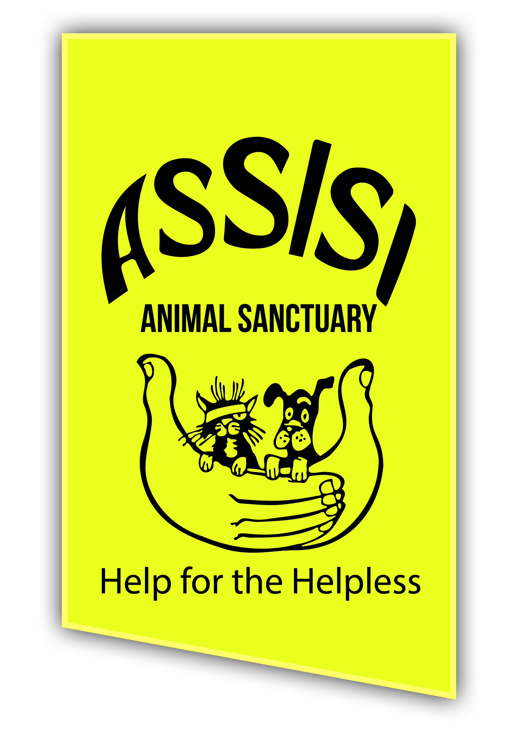

Job Title Animal Welfare Manager

Hours of work: 37.5 hours per week
Monday-Sunday on a rota basis, including bank holidays

Location of Job: Assisi Animal Sanctuary, 1 Old Bangor Road,
Conlig, BT23 7PU

Salary: Scale 5 £31,683 - £34,980

Closing Date: Friday 19 August 2022

Line Management: Reporting to Chair of the Board

Direct Reports: Dog Unit Manager
Cat and Small Animals Unit Manager
Reception and Administration Assistant
Estates Assistant
Animal Behaviourist

Purpose of the role:
The post holder will have primary responsibility for the day-to-day operaions at the Sanctuary. Along with the unit managers, the Animal Welfare Manager will ensure the highest standard of animal care is in place for all our animals. This is a public-facing role, with responsibility for oversight of our Outreach programme, managing relationships with animal welfare within the council, other animal rescues and representing the charity at NICAWG. Excellent communication and people skills are required.

To promote the Mission, Vision, Values and Core Principles of Assisi Animal Sanctuary, taking a positive approach to supporting a workplace that celebrates success and embraces learning opportunities. Be responsible for meeting appropriate standards of performance. To ensure that Assisi is legally compliant in all areas using the retained consultancies as appropriate. Support all managers, staff and volunteers at the Sanctuary as well as visitors and suppliers to remain safe and well whilst associated with Assisi. Ensuring the highest-quality visitor and supporter experience when on-site and being the face of the oprganisation to the public.

The position is a keyholder position, which will involve ad-hoc callouts to premises in the event of emergency.

A dynamic individual with excellent communication skills is required, with a passion for the cause: the role is contributing to Animal Welfare in Northern Ireland and ensuring an excellent service is provided to all stakeholders of the organisation.

Key Responsibilities:

Animal Welfare
- To promote and communicate Assisi Animal Sanctuary’s aims, mission, policies and work clearly and effectively.
- Take overall responsibility for the welfare of all animals at the Sanctuary, supporting the unit managers in meeting the highest standards of care. While unit managers are responsible for the day to day animal welfare delivery, the Animal Welfare Manager has overall responsibility for animal welfare standards at the sanctuary.
- Ensuring that the Assisi name becomes synonymous with good animal welfare for animals in our care
- Reporting on animal welfare to the Board on a monthly basis
- Identifying opportunities to improve animal welfare at the sanctuary and working with staff to effect change, raising any issues with the Board of Trustees
- Responsible for ensuring all staff are fully trained on animal welfare standards
- Ensure that training programmes are delivered by staff and external consultants for those animals in our care who require additional support and that accurate records are kept. Work with external consultants where beneficial to deliver specialist advice for veterinary, clinical and behavioural issues.
- Effectively challenge direct reports and other staff on animal welfare where standards are not met
- Be able to conduct themselves in a calm and professional manner around euthanasia decisions at the Sanctuary, demonstrating emotional resilience and supporting staff and volunteers throughout the decision-making process. Being the final decision maker in cases of euthanasia.
Leadership
- To lead, inspire and motivate staff and volunteers through a visible, enthusiastic and positive presence at the Sanctuary. Tackling issues and challenges head-on and being proactive in seeking resolution to issues as these arise.
- To create a ‘learning environment’ within the organisation and leading by example. Demonstrating a growth mindset and encouraging this in others
- Working with the HR Advisor to develope and maint an environment that attracts and retains the best staff and volunteers
- Line managing the unit managers, estates assistant and reception and administration assistant and supporting and developing them in their roles through regular 1:1s, coaching and mentoring.

Sanctuary Operations
- Overall responsibility for ensuring the effective and efficient daily management of the Sanctuary in respect of visitor welcome, presentation, cleanliness, safety and security.
- Manage main sanctuary/ overheads budget ensuring best value for money is consistently achieved
- Authorisation for carrying out essential works and approving invoice payments
- Project management as required
- Responsibility for ensuring all Sanctuary policies and procedures are effective, accurate, fully documented and regularly updated, and that staff have access to these and are fully trained on them, in line with an agreed governance framework
- Ensure maintenance of the site is upheld to an acceptable standard, through use of a maintenance book, ensuring good housekeeping across all areas of site at all times.
- Responsibility for Health and Safety - ensuring all Security, Health and Safety policies and procedures are adhered to in order to provide a safe and secure environment for staff, customers and company assets, reporting any concerns or incidents to the Board of Trustees.
- Creating a culture of Health and Safety excellence, through demonstrating leadership in this area and ensuring any health and safety issues are resolved and that a culture of reporting issues by staff and volunteers is established. Identifying any opportunities to improve health and safety standards and implementing change to policies and procedures.
- Monitor health and safety risks and hazards in the workplace and carrying out regular Health and Safety risk assessments, mitigating any risks identified in the process. Working with our partners to ensure the highest standards are enforced throughout the sanctuary
- Advise employees on how to minimise or ultimately avoid risks and hazards in the workplace through training, and having responsibility for ensuring all staff complete this training in a timely manner
- Carry out regular audits and inspections to check that policies and procedures are being properly implemented.
- Responding to out-of-hours emergency responses as these arise as notified by our third-party security supplier
- Ensure the safe delivery of all events and open days where these occur at the sanctuary
- Ensure that adequate supplies of all equipment and foods etc are held and regular stocktakes are done to ensure that replacement stock is ordered in a timely manner and within budget.

Community engagement
- Representing the charity to the local community and engaging with stakeholders, raising the profile of the charity and the work that we do
- Managing the delivery of the Outreach programme
- Representing the charity on industry bodies, including NICAWG and ADCH
- Where required, engaging with the media and comms, supported by the Fundraising and Communications Manager
- Working effectively with key stakeholders in the community and demonstrating leadership in animal welfare through relationships with local vets, animal welfare staff within the local council, pounds and other animal rescues and grassroots groups. Ensuring the Assisi name is associated with being a visible, effective and positive presence in the animal welfare ecosystem
- Engaging with charity members and presenting at the annual AGM
- Engaging with the Probation Board and the Fundraising and Communication Manager for corporate volunteers, ensuring they have a good experience when onsite and that the charity benefits from their work
Communication and reporting
- Ensuring effective internal communications are happening throughout the charity with staff and volunteers – whether face to face, email or otherwise
- Managing staff and volunteers’ feedback, ensuring it is responded to in a timely and appropriate manner. Actively listening to the feedback of those who work for and support the charity, and ensuring there are effective channels for this to be raised. Ensuring issues are actioned effectively, flagging to the Board of Trustees where needed, and reported back on regularly to all stakeholders.
- Reporting to the board of trustees on sanctuary operations in an agreed format on a monthly basis, with regular communication outside of board meetings by email / phone
- Ensure that regular Sanctuary team meetings take place on at least a monthly basis to maintain communication and awareness of issues relating to all Sanctuary matters, and that the appropriate follow ups are done and staff have access to minutes

Customer Care
- To take the lead on setting and delivering quality standards for customer care throughout the Sanctuary
- Respond promptly to customer complaints, and record, monitor and report on these as well as compliments, through the agreed procedures.
- Ensure that all staff understand the importance of excellent customer service and that they deliver customer service of the highest standards at all times. Training staff effectively on customer care.
- Ensure the highest standards of customer care are delivered to all Sanctuary visitors and contacts, by presenting a professional and friendly approach both face to face and on the telephone at all times and ensure that any queries are dealt with in a timely and efficient manner.
Additional Requirements
- Liaise with the outsourced IT company for any hardware or software challenges
- Carry out any other duties as may be reasonably directed by the Board of Trustees.
- The normal hours in this role are 37.5 per week, working 5 days out of 7, with some of those days falling on a weekend. The post holder will be expected to be onsite for those hours. There will be times when longer hours will be required, for which time off in lieu may be granted. Overtime is not normally paid.
- The above duties are not exhaustive and this job description will be reviewed periodically.

Person specification
In order to meet the full requirements of the post, applicants must hold the qualifications specified, have experience in and/or be able to demonstrate competence in the following areas:

Essential Criteria
- Five GCSE's at grade C or higher, including English and Maths (or equivalents)
- Qualified to National Diploma Level, NVQ 3 or equivalent in animal care/welfare or three years experience in a similar position
- One years paid or voluntary experience of working in an animal rescue environment at a supervisor level or higher
- Have an excellent level of written and verbal communication skills and be able to discuss the welfare and management requirements of animals within a team environment and with members of the public, charity members, board members and community groups.
- Excellent communication skills - ability to communicate well with customers, volunteers and colleagues. Ability to challenge others effectively.
- Ability to use initiative and take responsibility, prioritise work accordingly through excellent time management, planning and organising skills. Strong follow-through ability, ensuring things get done.
- Proficient in the use of MS Office products with experience and knowledge of Excel, Word & Outlook, as well as use of social media
- Full drivers licence required
- Enthusiastic, self-motivated and committed to working to a high standard
- Passionate and committed to the aims and charitable objectives of Assisi Animal Sanctuary
- Flexible and adaptable approach to work and ability to remain calm and work under pressure

Desirable Criteria
- Animal care/welfare qualifications above that of National Diploma Level or NVQ 3
- Customer Care qualification
- Experience of an animal database (e.g. Anilog)
- ILM qualification

This role profile is not exhaustive and can be amended at any time to suit the changing needs of the Sanctuary

