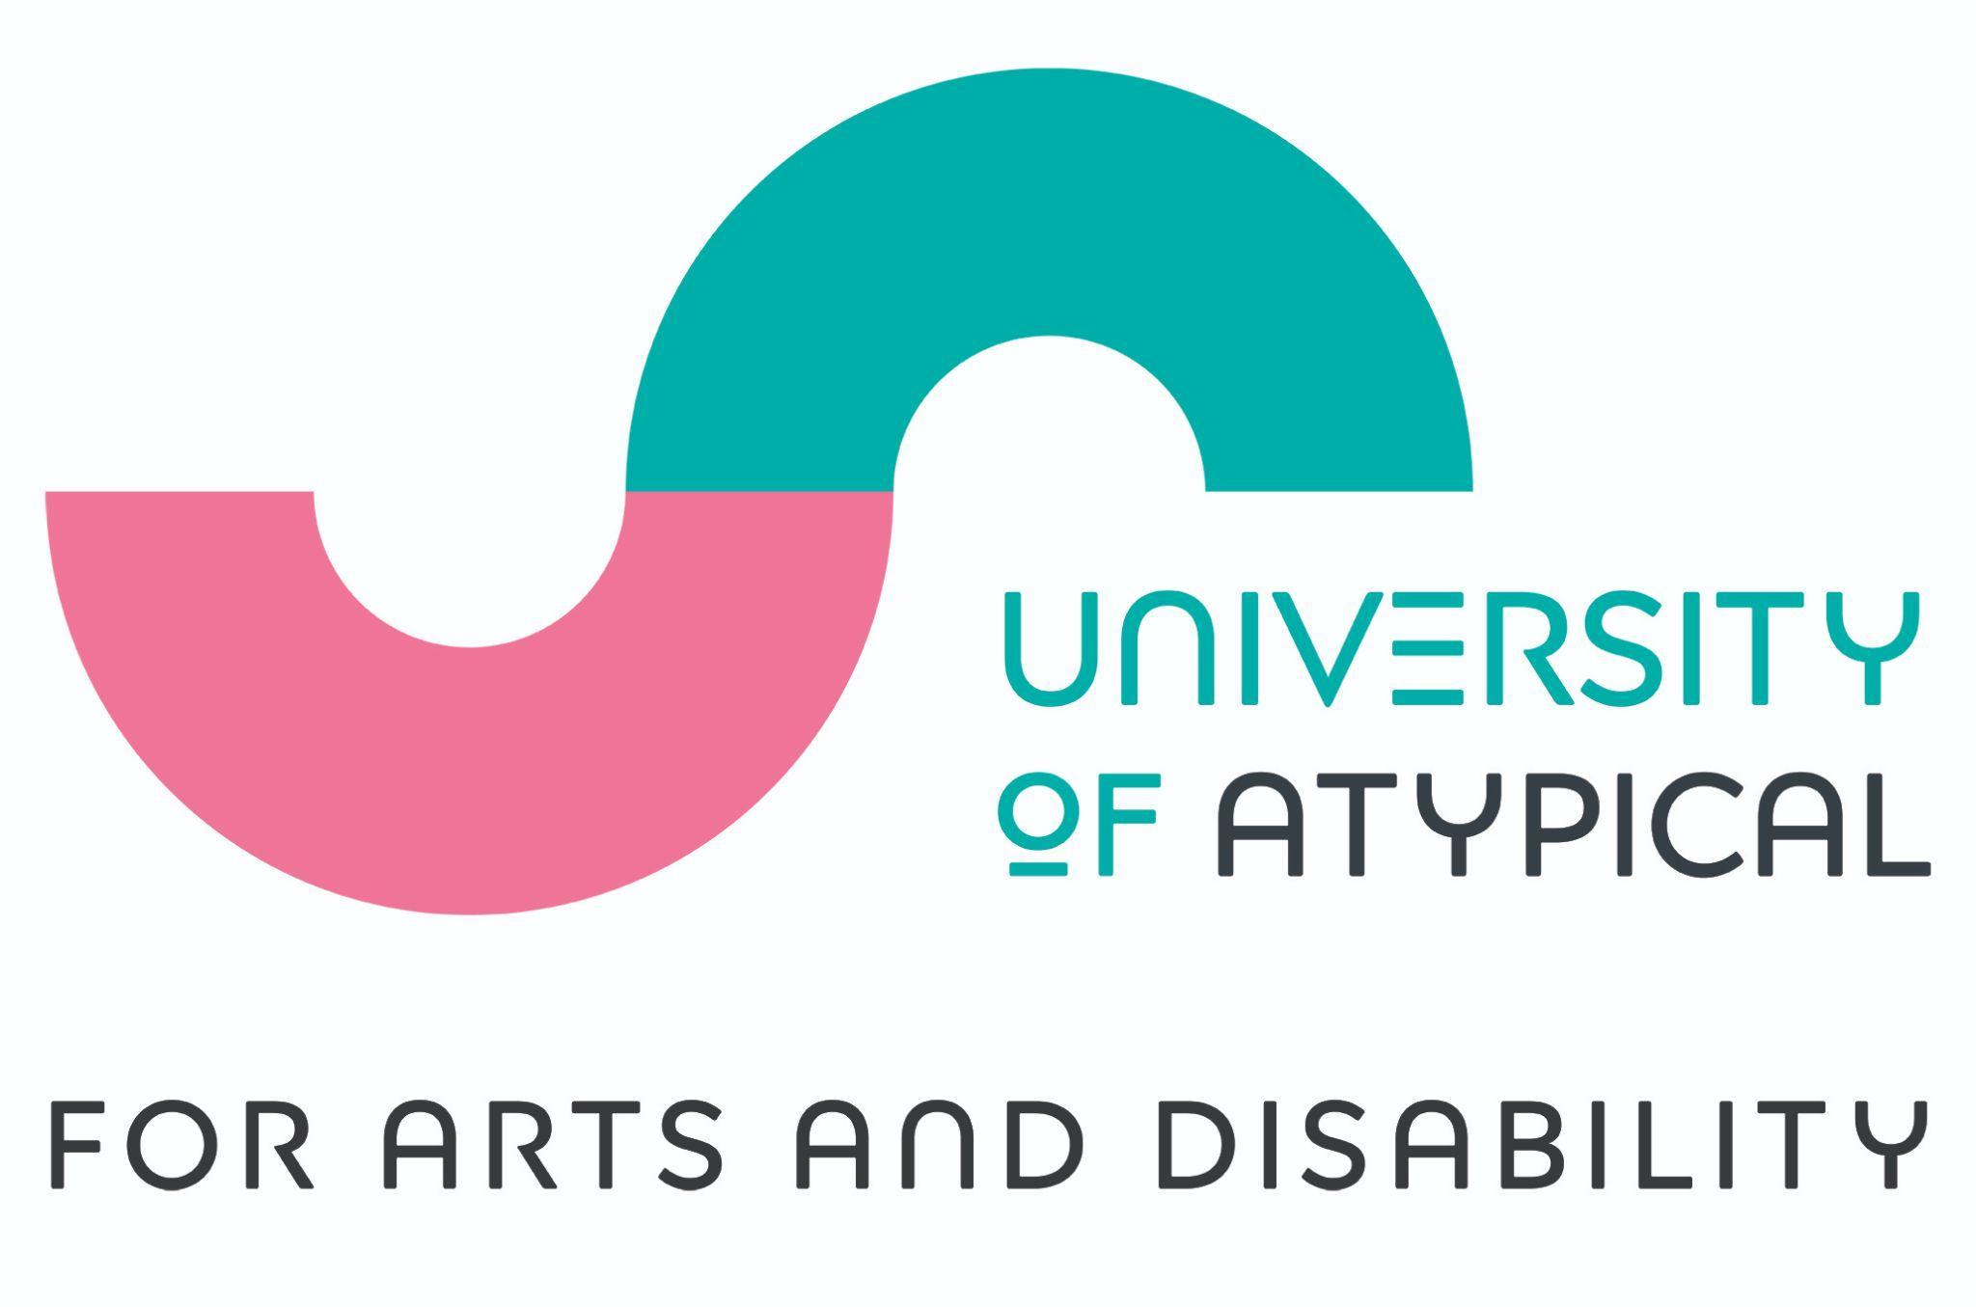

May 2022

Dear Applicant,

Thank you for your interest in the role of Freelance Volunteer Coordinator. We are excited to be offering this new freelance position to manage our volunteer programme with the University of Atypical for Arts and Disability (UofA).

As a disabled-led organisation UofA has a focus in supporting people who identify as d/Deaf, disabled and neurodiverse to work with us and so we welcome those with and without disabilities to apply.

Wishing you all the best of luck and I look forward to receiving your application.

Sincerely

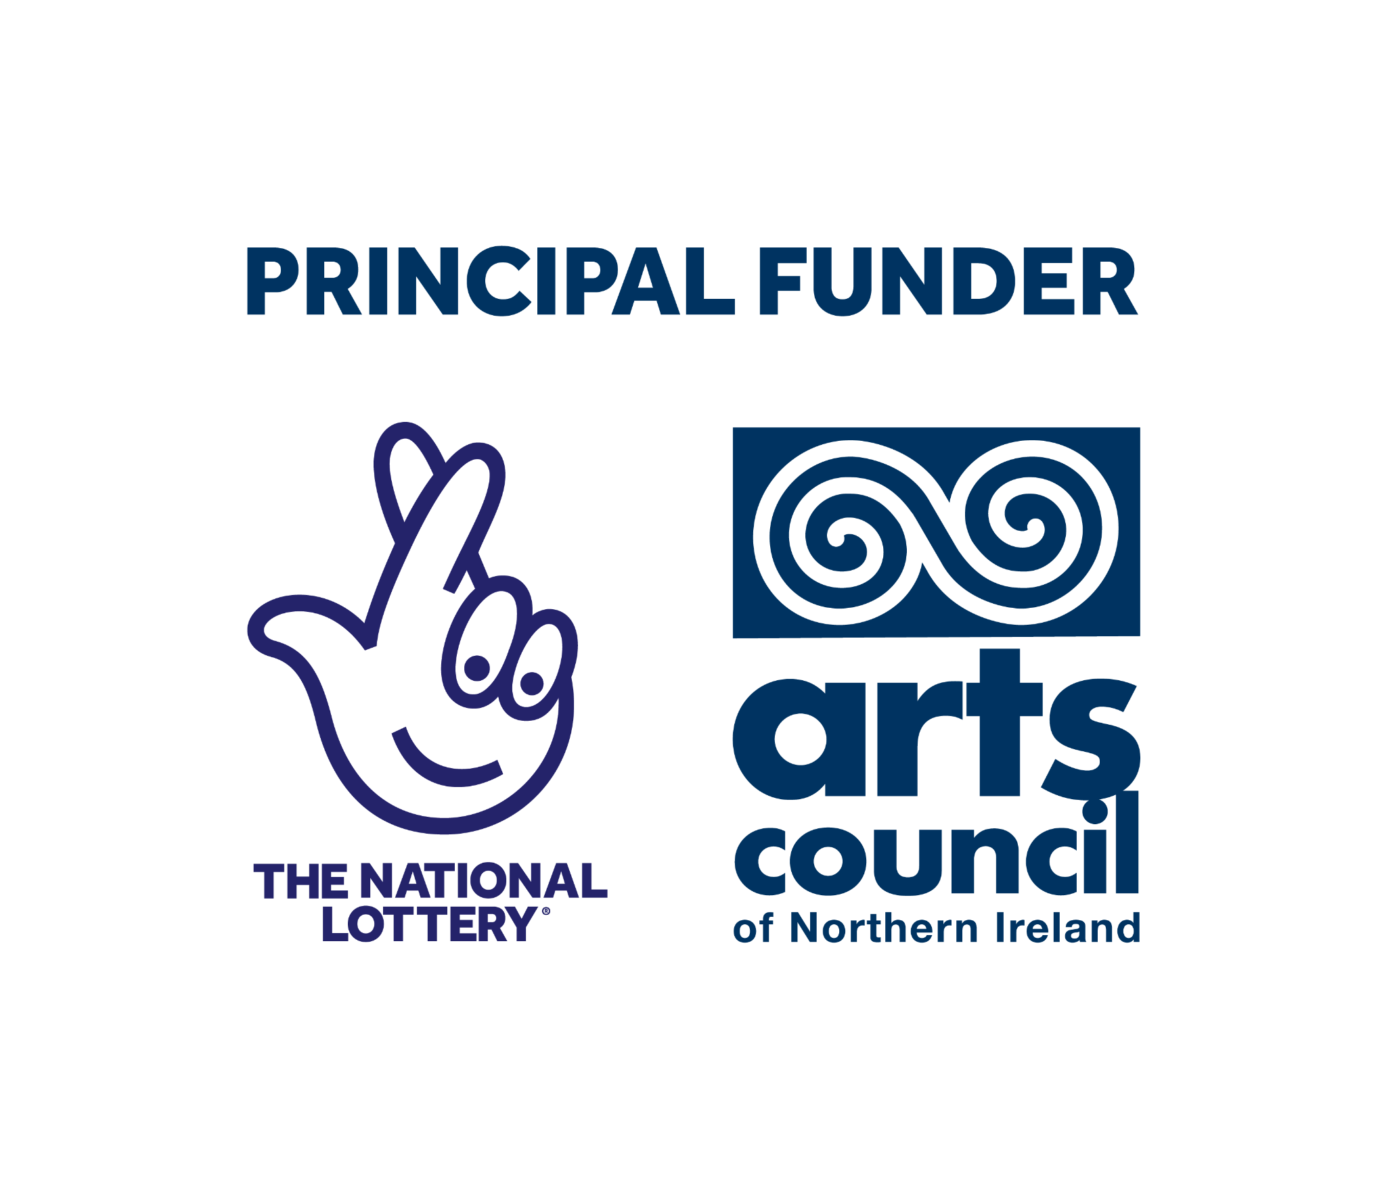
Damien Coyle -CEO of University of Atypical

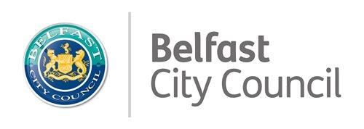

University of Atypical for Arts and Disability
www.universityofatypical.org

Recruitment Pack for the post of
Freelance Volunteer Coordinator
£10/hour x 8 hours a week (plus additional hours as agreed)
Duration of post: August 2022 - April 2023

Apply for this role
- Other formats of the application can be provided including Braille.
- Application deadline: 4.00 pm on Tuesday 14th of June 2022.
- Interviews will take place on a day to be confirmed on the week commencing the 27th June - 1st July 2022.

About Us

The University of Atypical for Arts and Disability (UofA) operates under the legal name Arts and Disability Forum. The organisation was established in 1993 and is the lead disabled-led sectoral arts organisation in Northern Ireland.
UofA takes an empowerment-based approach towards disabled and d/Deaf people’s involvement in the arts as audience members and as practitioners. UofA specialises in developing and promoting the work of d/Deaf and disabled artists and in doing so engages d/Deaf and disabled audiences in a direct and meaningful way.
We aim to increase opportunities for D/deaf, disabled and Neurodiverse people to engage with the arts, working on a pan-disability basis providing participative and networking opportunities, exhibitions, Bounce arts festival, training and other sectoral developments in equality, access and inclusion.
Our Mission:
To enhance the artistic lives and creativity of D/deaf and disabled people in Northern Ireland
Our Vision:
A society where everyone has the opportunity to positively channel their creative energies and talents through the arts
Our Values:
The following values underpin every aspect of UofA’s culture and activities:
- Inclusion - we believe that a healthy and stable society needs to be built by all its people working together. We will be open to those of all abilities and disabilities and celebrate the diversity of the society in which we live. UofA operates under the social model of disability: which says that people are disabled by barriers in society, not by their impairment or difference. We will oppose injustice and anything that excludes or marginalises disabled people and others who are considered to be different.
- Disabled-led - UofA is driven by disabled and D/deaf artists who understand the needs, rights and aspirations of other disabled and D/deaf artists and act as an independent voice
- Parity - everyone has an equal right to be treated with dignity and respect, to learn and develop, to access the arts in all its forms and to have their voices heard
- Human Rights - we believe that everyone has inalienable human rights which should be upheld. In particular, we support the UN’s Convention on the Rights of Persons with Disabilities and will work to promote and defend these rights
- Excellence - everyone has the right to expect that all aspects of UofA’s work are carried out to the highest standard. UofA will also support artists to work towards achieving the highest artistic standards
- Collaborative - we believe the organisation is much more effective when working in partnership with its key stakeholders. We value meaningful collaboration and partnership working

What we do
The UofA has a lead sectoral role in Northern Ireland for
- enhancing the experience D/deaf, disabled and Neurodiverse people have of the arts;
- promoting work produced by disabled d/Deaf and neurodiverse artists;
- elevating public’s experience of art created or presented by D/deaf, Disabled and Neurodiverse artists;
- improving arts organisations’ understanding of access requirements of d/Deaf, Disabled and Neurodiverse people;
- showcasing excellence in art by D/deaf, disabled, Neurodiverse artists.
The UofA delivers a year-round programme including
- Atypical Gallery programme of exhibitions and events
- Partnership work with mainstream arts and Arts & Disability organisations, festivals and creatives.
- The Arts & Disability Equality Charter, supporting arts and cultural venues to commit to increasing access with input from disabled people - Equality and Access Standards Initiative (EASI)
- Sectoral training programme including Disability awareness, Sign Language.
- The annual Individual Disabled Artist (iDA) grant scheme for artists who are disabled, D/deaf or neurodiverse, managed on behalf of the Arts Council of Northern Ireland
- Bounce Arts Festival, showcasing the best performances and exhibitions from NI’s artists alongside the best work by disabled and D/deaf artists working nationally and internationally
- SIGnify Media British Sign Language, Irish Sign Language cultural events broadcasts (broadcast via Facebook).

Key communities UofA works with:
- Professional and emerging artists, across all art form areas who identify as D/deaf, Disabled or Neurodiverse
- Arts sector and community organisation who engage and seek to engage artists and audiences who are D/deaf, Disabled or Neurodiverse
- Professionals in Disability support including translators, audio describers and professional support for people with disabilities.
- people with lived experience of disability, Deaf Community and Neurodiversity.
- Professionals in administrative policy and provision of services for people with Disabilities, d/Deaf Community and Neurodiversities.

About the role you are applying for

Job Description

Role title: Freelance Volunteer Coordinator
Hours of post: The estimated time commitment required for the Volunteer Coordinator at University of Atypical is 8 hours per week. Some weeks may be less, some much more – so there is a need for flexibility and we are happy to work with you to accommodate both our needs..
Fixed term contract: July/August 2022- March 2023 (subject to funding this post may be extended)
Reporting to: Head of Business Administration
Location: Office based location in Belfast with some travel required in Northern Ireland; travel and other costs associated with travel will be covered.
Remuneration: £10 per hour. Expenses associated with your travel and other agreed activity will be reimbursed.

Freelance Volunteer Coordinator

Background to this role:

University of Atypical (UofA) is seeking to recruit a new role of Freelance Volunteer Coordinator

UofA addresses issues of participation, inclusion and accessibility so that all people can participate in the arts and creativity sectors. The communities we advocate for include d/Deaf, disabled and people with neuro-diversities who face barriers to participation. We particularly welcome people who identify as d/Deaf, disabled or neurodiverse to apply.

The organisation has identified the need for a dedicated role to coordinate our volunteers. In 2021 we had approximately 23 volunteers work with us across our Bounce Festival, Office Administration and Gallery events. We are proud that many of our volunteers are d/Deaf, disabled or neurodiverse.

Our volunteers are very important to us and so we want to recruit a coordinator who will support the recruitment of new volunteers and the retention of existing volunteers, and the training and mentoring of our volunteers in order to establish them as a strong and confident group.

We have in place the financial support to enable the coordinator to manage the promotion, training accreditation, expenses and celebration of our volunteers.

Roles and responsibilities:
​​
- Actively promote and advertise volunteering opportunities with their role descriptions
- Using our database system, send information about how to apply to interested individuals
- Arrange and take part in the interview process of volunteers
- Recruit volunteers and ensure they are appropriately matched and trained for a position
- Provide induction for new volunteers
- Undertake training as required in your role as the volunteer coordinator (Safeguarding, Health and Safety, Disability Awareness, etc)
- Arrange training for volunteers (Safeguarding, Health and Safety, Disability Awareness, etc); liaise with training providers
- Ensure access and inclusion requirements for volunteers are met.
- Plan ahead allocating roles and tasks to volunteers and ensuring that all volunteer placements are covered.
- Check in with volunteers regularly to ensure they are happy with their role and completing tasks assigned
- Remind volunteers of deadlines approaching and motivate them to meet them where appropriate
- Maintain the records of volunteers’ hours and note when they are unable to come in to the office
- Manage a budget associated with this post in line with funder requirements.
- Maintain expenses records for volunteers reimbursement in line with finance and volunteer policy.
- Collate baseline and end of term evaluation data from volunteers; create a report on the findings
- Arrange Celebration event for volunteers to acknowledging their achievements and thanking them for all they've done
- Attend organisational team meetings and provide updates.
- Maintain our volunteer database and any other administrative duties.
- Adhere to organisational Volunteer policy, Safeguarding policy, Health and Safety policy, GDPR and other policies relevant to this role.
​
​

Essential criteria

Experience and knowledge
​
- Has lived and direct experience of disability, the d/Deaf community or neurodiversity.
- Has knowledge of the disability arts sector.
- Has experience of volunteering and managing volunteers or other teams of people.
- Has experience of working as part of a team.

Skills
- Can communicate effectively and has excellent interpersonal skills.
- Has the ability to work well in a team.
- Is proactive in keeping informed of all University of Atypical activities
- Has leadership skills including the ability to plan ahead, to problem solve, to offer solutions to difficulties, to encourage a positive team environment, to keep good records and manage budgets.
- Is a good timekeeper and keeps to schedules and deadlines
- Has administrative experience of using basic databases including Windows based software packages.
- Is able and confident in using the internet and social media platforms.

Personal attributes

- Has interpersonal qualities such as is a good listener, has patience, positive attitude, proactive and encouraging and empathetic.
- Is committed to the role on a weekly basis and for particular key areas of the University of Atypical calendar - Bounce Festival, Gallery openings etc.
- Communicates clearly and regularly with the University of Atypical manager and reports regularly against achievements and difficulties.
- Willingness to travel as required for the role.
- Willingness to work flexible hours to accommodate some weekends and evenings; this will be arranged in advance with you.
- Willingness to complete an Access NI clearance (covered by UofA).

​

​
​

Your workplace:
Situated in the University of Atypical office with a small dynamic, inclusive team, Royal Avenue Belfast. We operate a hybrid working model where employees will work in the office however can work from home for agreed times. The office is a ground floor office with a fully accessible toilet. The office address is:

University of Atypical,
Ground Floor,
Cathedral Quarter Workspaces,
109-113 Royal Avenue, Belfast BT1 1FF

Remuneration:
The annual salary for this role £10 per hour. Additional hours may be agreed. Reimbursement of travel associated with work events will be reimbursed. Travel to work costs are not covered.

How to apply:
- The online application form and the monitoring form are available to download from our website www.universityofatypical.org or by contacting us by email to request a copy.
- Alternative formats of the application and monitoring form are available:
- Braille
- Large text

- Complete the application form and monitoring form
- Submit the application form and monitoring form by email or by post on or before the closing date and time
- email submissions should be sent to administration@universityofatypical.org; please put ‘Freelance Volunteer Coordinator post’ in the subject line.
- Postal applications are also accepted; please address your envelope:
Freelance Volunteer Coordinator post, University of Atypical, Ground Floor, Cathedral Quarter Workspaces, 109-113 Royal Avenue, Belfast BT1 1FF

Closing Date for applications:
- 4.00 pm on Tuesday 14th of June 2022.
- No responsibility can be taken by UofA for applications not received by the closing date and time.
Interview
- Successfully shortlisted candidates will be invited to an interview
- Interviews will take place on a day to be confirmed on the week commencing the 27th June - 1st July 2022.
- If invited for an interview you will be asked to attend the interview venue up to hour before your interview where you will be provided with the questions that you will be asked in the interview and have an opportunity to read and think about your answers..
- The interview will normally last around 45 minutes to 1 hour
- You will meet up to three people at the interview.
- We will set the interview room out as an informal round-table space.
- In line with the informal style we hope to create, please dress as you feel comfortable; formal clothing is not required
- If you have any questions or access requirements, please contact us on administration@universityofatypical.org.
Equal Opportunities Employer
- University of Atypical is an Equal Opportunities Employer. All eligible applicants will be considered for employment without discrimination due to race, religion, sex, sexual orientation, gender identity, national origin, age or disability status.

