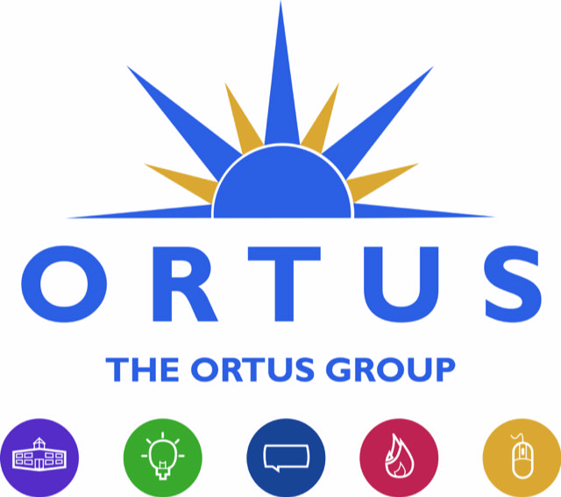

**Applicant Information**

**Ortus – Business Advisor BA/22**

The application pack documents for this role are:

1. Job Description and Personnel Specification
2. Application Form
3. Monitoring Form

* Please complete the application form in full along with the monitoring form.
* The deadline for completed applications is Tuesday 31st May 2022
* Please return your completed application and forms by email to laura@flexlanguageservices.com
* Please note Ortus may decide to interview only those applicants who appear, from the information submitted, to be most suitable in terms of relevant experience and ability. The desirable criteria may be used for short listing if required.
* If you have any queries regarding the recruitment process please call 02890727878 or email laura@flexlanguageservice.com

Thank you for your interest in Ortus,

*The Recruitment Team*