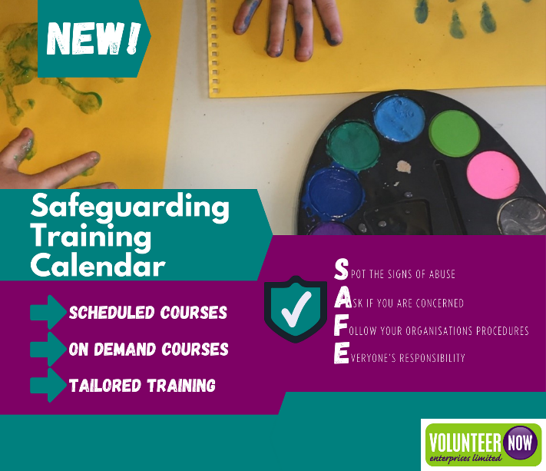
Safeguarding Training Calendar for 2022-23!

Have you signed up yet? We provide a wide range of Keeping Safe courses at different levels including:

- On demand induction courses which cover key basic information about safeguarding
- Introductory level courses which inform staff and volunteers about the legal and policy context of safeguarding, categories of abuse and possible indicators, procedures for reporting concerns and code of behaviour when working with children and/or adults
- More in depth courses which look at how staff and volunteers can safely plan and manage activities for children and/or adults
- Higher level courses for staff and volunteers who have specific safeguarding responsibilities e.g. Designated Officers, Adult Safeguarding Champions and Appointed Persons
- Courses on safe recruitment and selection of staff and volunteers (including eligibility for police record checking) and effective management of staff and volunteers working with vulnerable groups.

View our On Demand Courses here - https://www.volunteernow.co.uk/training/on-demand-courses/

You can view our new training calendar and book your places, here https://www.volunteernow.co.uk/training/courses-scheduled/.

If you are looking for something tailored for your group or organisation, please get in touch via https://www.volunteernow.co.uk/training/tailored-training/

Further dates will be added in the coming weeks, so keep an eye on our website and social media channels!

Website: https://www.volunteernow.co.uk/
Instagram: https://www.instagram.com/volunteernowenterprises/
Twitter: https://twitter.com/VNEnterprise
Facebook: https://www.facebook.com/VolunteerNow/

