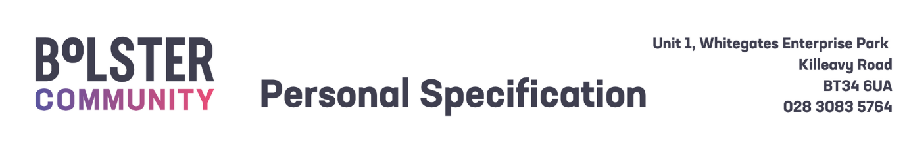
  - Personal Specification – Creche Worker (Bank)
 | - Essential Criteria | - Desirable Criteria
- 1. Circumstances | - Ability to work flexibly in order to meet the needs of the role, including evening and weekend hours when necessary.  - Experience of supporting families in their own homes.
- 2. Qualifications | - QCF/NVQ Level 2 or equivalent/higher qualification in Education, Childcare, Social Care or Health related subject.
- 3. Skills and Expertise | - Excellent communication skills including written, verbal and digital - with an ability to interact with a wide range of people.  - Good planning organisational and record keeping skills.  - Ability to work independently (organising time effectively) and as part of a team. | - Experience of working in a Sure Start Project.  - Experience of contributing to group work and/or delivery of evidence-based programmes for parents and children.
  - Shortlisting will be based on the evidence that you supply on your application form to satisfactorily demonstrate how, and to what extent, you meet the above criteria. The Shortlisting Panel will not make assumptions as to your circumstances, qualifications, and experience.
  - Competencies – Candidates who are shortlisted for interview will be required to demonstrate how, and to what extent, they meet some or all of the competencies listed below during their interview.
1. Effective Communication
Keeps people well informed and communicates messages clearly and concisely. Listens carefully, evaluates other opinions and is able to communicate successfully. Engages in the exchange of ideas, information and feedback within their role.

- Clarity of Purpose
Delivers results on time, within constraints and in line with organisational strategy, policy and procedure. Strives to exceed the expectations and requirements of clients, internal and external customers; acts with customers in mind and values the importance of providing high-quality customer service.

- Ongoing Commitment to Development
Demonstrates required job knowledge and understanding to successfully and competently fulfil or exceed the requirements of their post. Challenges self to continually develop and improve performance to maximise their potential and job knowledge by proactively contributing to the culture of innovation, excellence and teamwork.

- Team and Partnership Working
Demonstrates collaboration within and across teams. Develops and encourages effective partnerships and a positive team atmosphere, both internally and externally, to improve the efficiency and effectiveness of service delivery based on shared outcomes.

- Wellbeing for all
Actively involved in maintaining their own wellbeing. Contributes to the conditions to develop and promote health and wellbeing for staff. Promotes a safe and supportive working environment for staff.

