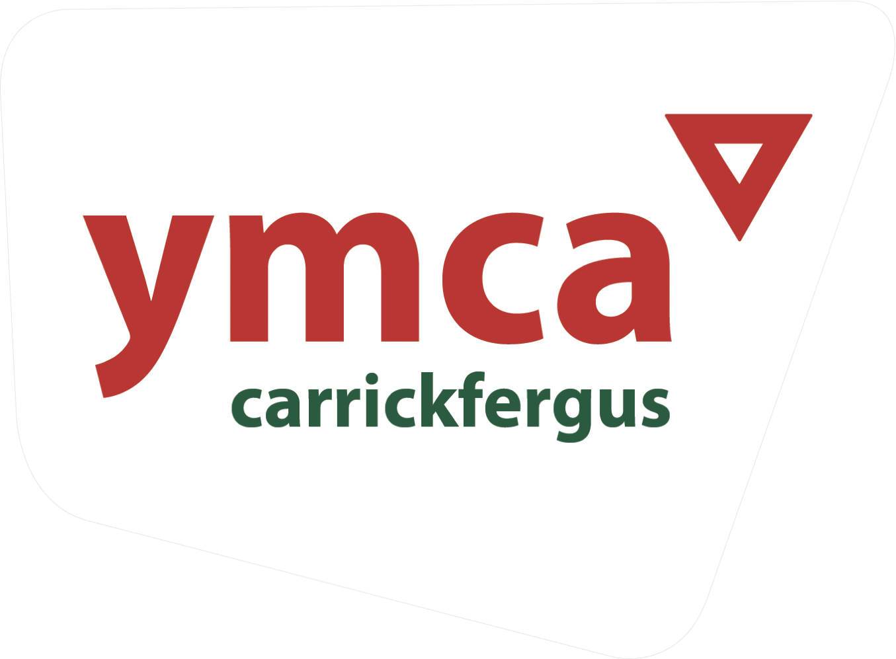
JOB DESCRIPTION

JOB TITLE​: Drug & Alcohol Project Worker
JOB DURATION​: September 2022

RESPONSIBLE TO​: Programme Coordinator – Outreach

SALARY: £23,947 Scale Point: G4
HOLIDAY ENTITLEMENT​: 30 days

JOB PURPOSE​:
To develop and deliver drug and alcohol services with young people across Carrickfergus and Ballymena ensuring sharing of existing resources, partnership working in the development of new resources and delivery of training.

KEY TASKS​:
Working with young people:
- Utilise key delivery methods: outreach, small group work, support and training
- Recruit and engage young people into the drug and alcohol programme
- Establish contact with, listen to, befriend, advise, support and advocate for young people
- Build appropriate relationships with young people in order to provide accurate information to aid decision making
- Work with young people in the assessment of needs and assist them to link in with an appropriate service
- Deliver project work and activities in consultation with young people and in line with project action plan
- Provide opportunities for young people to celebrate their achievements
- Keep young people safe in line with YMCA policies
- Use Upshot and Outcomes Star to measure participation with young people

Working as part of a team​:
- Work flexibly as part of the Outreach team, alongside other YMCA staff and key partners as appropriate
- Develop and deliver an action plan for face to face delivery of drug and alcohol services across Carrick and Ballymena in consultation with the Outreach Programme Coordinator
- To develop a local drug and alcohol network for information, support and sharing good practice
- Participate in the Mid & East Antrim drug and alcohol steering group
- Work with the YMCA drug and alcohol working group to share practice

Administration:
- Ensure all administration relating to the Drug & Alcohol programme is maintained to a suitable standard, specifically:
- Ensure the effective collection, monitoring & evaluation of data for reporting
- Safeguarding sensitive data
- Ensure the implementation of Carrickfergus YMCA policies through programme activities i.e. equal opportunities, safeguarding, health and safety, etc.

OTHER FUNCTIONS OF THE POST:

Maintain and support programmes to meet quality standards

Work with the Programme Coordinator to:
- Deal appropriately with suggestions, child protection concerns and complaints
- Develop own skills and knowledge within the job
- Ensure effective use of resources and make recommendations for expenditure

SCOPE & LIMITS OF AUTHORITY

Carrickfergus YMCA provides a range of youth services within the Mid and East Antrim area, working closely with external agencies in the voluntary and public sectors.

The Drug & Alcohol Project Worker is managed by the Programme Coordinator – Outreach.

The post-holder works in consultation with the Programme Coordinator in the implementation of initiatives and the delivery of programmes that contact young people within the community and encourage their participation in Carrickfergus YMCA services.

The Programme Coordinator is the team leader of the Outreach team with responsibility for staffing, programmes, health & safety, premises management and any discipline issues however this post will work in support of this role and will be part of a supportive and experienced staff team.

PERSONAL CONDUCT

There is considerable direct contact with young people, parents, supporters, health professionals, churches, teaching staff and the public in this role, therefore the successful candidate will be required to represent the organisation in a professional manner.

WORKING HOURS

This post will be full time with the expectation of working 35 hours per week.
The YMCA responds to the needs of young people and as a result some evening & weekend work will be required, there will be the expectation of working a minimum of 3 evenings per week. Time off in lieu (TOIL) will be negotiated with the Programme Coordinator.

DISCLOSURE OF CRIMINAL BACKGROUND

This post will involve ‘regulated activity’ under the Safeguarding Vulnerable Groups (NI) Order 2007, therefore the post holder will be subject to an ACCESS NI check.
PERSON SPECIFICATION

Qualifications
Essential
- Recognised youth work qualification (e.g. OCN level 2 & 3) OR a relevant degree, e.g. youth work, social work or teaching (relevance of qualification to be outlined on submitted application)
Desirable
- Training in ASIST or Mental Health First Aid
- Recent drug and alcohol training

Experience
Essential
- At least 2 years part-time or voluntary experience of working with young people in a relevant context
- Experience in facilitating developmental work with young people and the ability to create, implement and evaluate these activities
Desirable
- Experience of working with vulnerable young people aged 11-25 in an outreach or mentoring setting

Knowledge
Essential
- Knowledge of good youth work practice
- Knowledge and understanding of the challenges of informal education within an outreach setting
- Knowledge, understanding and application of risk assessment, Health & Safety and
safeguarding

Abilities and Skills
- Demonstrate innovation, initiative and creativity
- Excellent interpersonal skills
- Ability to develop and maintain appropriate relationships with young people
- Group facilitation skills
- Planning and organisational skills
- Computer literate
- Full driving license and access to a car or access to suitable transport which enables the postholder to carry out the requirements of the job

Disposition
- Team player
- The YMCA works to a model of Christian Social Action and the post holder must be in agreement with the Ethos, Aims and Purposes of the YMCA
- Resilience and able to deal with the pressures of working with young people and
communities
- Commitment to working within an equal opportunity framework

