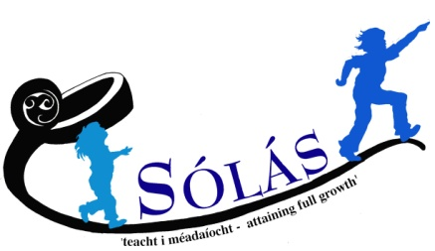
Volunteer Registration Form

Sólás is a Special Needs Charity which supports the educational and social development needs of children and young people with additional needs and autism in the greater Belfast area and across Northern Ireland. Please use CAPITAL LETTERS if completing by hand.

ABOUT YOU
Title | First Name | Surname
Address  Postcode |  | Tel No  Mobile  Email
D.O.B.
N.I. Number
Emergency Contact Name and Number

Are you currently working?
If yes please detail days / times
Are you currently a student?
If yes please detail days / times
How long are you available to volunteer for? |  | ____ months
What date are you available to commence volunteering?

REFERENCES
Please give the names and contact details of 2 people who have known you for more than 2 years (not relatives) and are willing to act as referees. At least one referee should have knowledge of your experience working with children/young people in a paid/voluntary position
Name | 1st REFEREE | 2nd REFEREE
Address

Email
Tel Number
Relationship to you

VOLUNTEERING OPTIONS

Please refer to ‘Sólás Volunteering Opportunities Sheet’ enclosed with this form and tick which initiative(s) you are interested in

PLEASE NOTE: Sólás is committed to providing a reliable and consistent service to our service-users. Therefore, we ask that you only apply to volunteer if you can commit a full session (approx. 3 hours) for a minimum of one term (September - January or January - June) rather than individual days.

 | Monday | Tuesday | Wednesday | Thursday | Friday | Saturday
After-School
1.45pm – 4.15pm
After-School
2.45pm 5.45pm
Youth Club
6pm – 8pm
Saturday
9.45am – 12.15pm
Saturday
1.15pm-4.15pm
Early Years
9am – 11.30am
Early Years
12noon – 2.30pm
Sunflowers
9:30am - 12:30pm

EXPERIENCE, SKILLS AND MOTIVATION

Please detail any previous volunteering, work experience and skills relevant to the volunteering role for which you are applying

Please tell us about your particular interest in volunteering with Sólás and what you hope to get out of this experience

ADDITIONAL INFORMATION

Please tell us about any allergies or health problems which you feel we should be aware of

Under the Disability Discrimination Act 1995, a disability is defined as “a physical or mental impairment which has a substantial and long-term adverse effect on your ability to carry out normal day to day activities”. Having read this definition do you consider yourself to have a disability?
Yes / No

This role will require an AccessNI check to be completed. The AccessNI Code of Practice applies to all registered bodies under ANI, including Sólás. Please disclose if there is any reason why you cannot work in regulated activity.

Having a criminal record will not necessarily prohibit you from volunteering with Sólás. This will depend on the nature of the position, together with the circumstances and background of your offences or other information contained on a Disclosure Certificate or provided directly to us by the police. Sólás policy on recruitment of ex-offenders will be made available to you on request.

Having read this statement is there any reason known to you why you cannot work in regulated activity?
Yes / No

Please give brief details of any previous convictions, where applicable

How did you hear about volunteering with Sólás? Please mark with X

Word of Mouth | Advert | Leaflets | Website | Internet | Other  (please detail)

Signature
Date

Please return your completed form to
beata@solasbt7.com
alternatively, you can post to:
FAO Volunteer admin, Sólás 284A Ormeau Road, Belfast BT7 2GB

For Office Use Only

Application Rec’d Date
Forwarded to
Interview Date
References | - Requested  - Requested |  |  | - Rec’d  - Rec’d
Access NI | Completed |  |  | Cleared
Vetting | Completed |  |  | Certificate issued
Volunteer Placement(s) Agreed
Expected Start date

