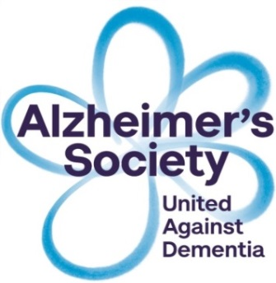 

**Dates for August 2021**

**Tuesday 10th,17th, 24th, 31st 1.00pm-2.30pm (4 topics)**

**Wednesday 11th, 18th, 25th and 1st September 10.30am-12.00pm (4 topics)**

**Half day options – 2 sessions covered each half day**

**Thursday 19th & 26th 9.30am-1.00pm**

**Dates for CrISP 2 July**

**• Understanding change as dementia progresses •Living with change as more help is needed •Living well as dementia progresses. (3 sessions)**

**Wednesday 11th, 18th, 25th 6.30pm-8pm**

**Due to Coronavirus, Alzheimer’s Society has adapted the sessions by Zoom on the following dates. They will fall on the following dates if you would like to attend a programme, please contact Catherine on by phone on 07889648793 or by email at** [**crispbelfast@alzheimers.org.uk**](mailto:crispbelfast@alzheimers.org.uk)**.**

Alzheimer’s Society operates in England, Wales and Northern Ireland, registered charity no. 296645

**Do you support someone**

**living with dementia?**

**Please join our free Carers Information Support Programme (CrISP)**

for people who provide unpaid care and support for someone living with dementia. Topics are Understanding of Dementia, Providing Support and Care, Legal and financial matters and coping day to day.

If these dates do not suit future programmes are planned.

If you would like to be added to the mailing list contact the office.

**East Belfast Network Centre**

**Tuesday 28th November – 12th December**

**10am-2.00pm**

**Agape Centre, Lisburn Road**

**Monday 27th November – 11th December**

**10am-2.00pm**

**Do you care for**

**someone with dementia?**

**Come along to our**

**FREE Training for Informal Caregivers Programme**