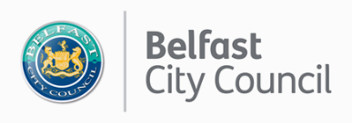
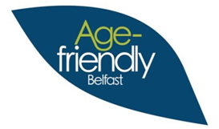
Age-friendly Belfast Older Volunteer Awards -
Nomination form
(Please complete below form in block capitals, in black ink or typed)

- Who are you nominating?
Name of volunteer or team
Contact address
Postcode

- Who is making the nomination?
Name
Name of nominating organisation
(if relevant)
Contact address
Post code
Phone number
Email address

- Select category
Remember, you can only nominate in one category

Older volunteer of the year
An individual volunteer who you feel has made a real impact on or difference to your group or organisation’s work over the last year, October 2018 to September 2019.

Marie Mathews participation award
Someone who embodies the true spirit of volunteering. This may be someone who volunteers across a number of roles or groups, or whose length of service deserves to be recognised.

Contribution to life in the City
A volunteer whose contribution has made an impact on life in Belfast. This can be through their involvement with the arts and culture, health & well-being, environmental projects, community development, befriending or any other charitable activity with a benefit to the community or the individuals within it.

Good neighbour
Someone, not necessarily connected with a group or organisation, who makes a practical difference to others in the neighbourhood or area, improving the quality of people’s lives. Someone who gets the title ‘unsung hero’ because of the things they do, big or small to make life better for people beyond their own immediate family.

Group or team
This celebrates 2 or more volunteers who are involved in the same project, programme or service within an organisation. Through working together this team or group has made a positive on your group or organisation, service users or other volunteers or staff.

- Tell us how this volunteer or team meets the Award category.
Please explain:
- How are they a good example of volunteering?
- What makes them stand out as a volunteer or team?
- How long have they been a volunteer
- What difference does their volunteering make?
- What would happen if they stopped volunteering? (Maximum 650 words – please feel free to add an additional sheet if necessary)

Print name

Date

Completed forms should be returned by Friday 18 October 2019 to

Tracy Mawhinney
Belfast City Council
The Cecil Ward Building
4-10 Linenhall Street
Belfast
BT2 8BP OR volunteering@belfastcity.gov.uk

Please tell us how you heard about the Age-friendly Older Volunteer Awards?

Newspaper
So Social Media

R Radio

Poster/leaflet

Other, please tell us _____________________________________

Privacy Notice
To find out how we manage your personal data, please visit www.belfastcity.gov.uk/privacy.

