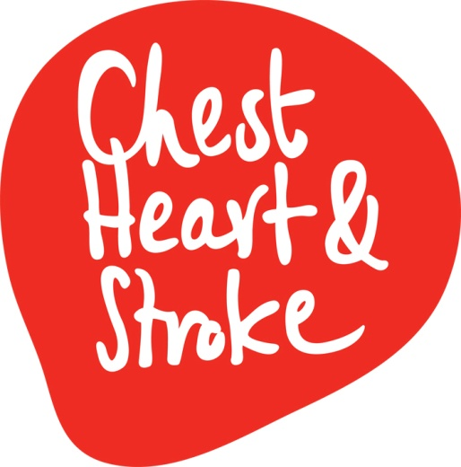
Workplace Health Promotion Manager – Maternity Cover
Information for Applicants

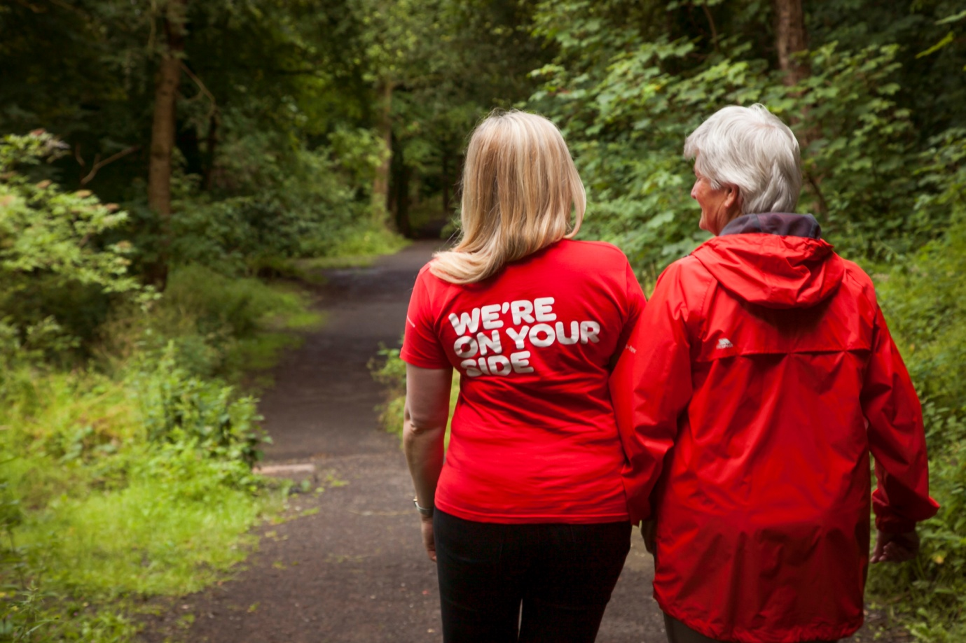

________________________________
Contents
_________________________________
Welcome from our CEO
Background Information
The Role
Person Specification
What we do for you
How to apply

Welcome from our CEO
Dear Applicant,
Thank you for your interest in the post of Workplace Health Promotion Manager (Maternity Cover) with NICHS.
I believe that in order to make the difference that we do, it is essential to recruit a team of high performing, dedicated staff. In this application pack you can find out more about what it takes to become a key part of the NICHS team.
As a voluntary sector organisation, one of the most important investments we make is in our people.
By embracing the world recognised Investors in People Standard, we have made a commitment to strive towards the very best in people management excellence and to make NICHS a great place to work.
Living to a set of values that are consistent with the philosophies of NICHS has been fundamentally important in supporting and inspiring our people. These values articulate those things that we genuinely believe in - caring, integrity, inclusion, innovation, partnership.
For many, this values-driven culture is a key element of what makes NICHS a special place to work. People demonstrate how they experience the values personally and strive to act as role models, applying them on a daily basis in their relationships both with service users and colleagues; treating people with dignity and respect; supporting people to be involved in their communities; taking responsibility for actions; and being honest, open and accountable. In short, achieving our charitable aims to the highest possible standard.
Our collaborative working style has brought together staff from across departments, and built a strong sense of team identity. We are lucky to have attracted and retained a resilient and talented work force, and have many long serving members of staff, some who have been with us for more than 30 years: clear evidence that NICHS is a special place to work, with a climate of positivity, characterised by optimism, mutual supportiveness and good humour.
I would like to thank you for your interest in joining the NICHS team.
Yours faithfully,
Declan Cunnane
Chief Executive
Background Information
The work we do is vital for everyone in Northern Ireland.
Today in Northern Ireland 10 people will suffer a heart attack. 11 people will have a stroke. And 1 in every 8 deaths will result from respiratory failure. In addition to this almost 200,000 people are living with long term chest, heart, or stroke conditions.
Northern Ireland Chest Heart & Stroke is a local charity which helps people living with these conditions and their families. Each year we need to raise over £3m to fund our range of programmes, community services and research in the hospitals and universities of Northern Ireland.
Our vision for Northern Ireland is one where everyone can live life to the full, free from chest, heart and stroke illnesses. To achieve this, our work is focused in these areas: Care Services, Prevention, Health Promotion, Research, Lobbying and Policy Work. All our work is within Northern Ireland. When people donate to NICHS, they know their entire gift will be used for local benefit. Please visit our website to find out more about what we do, and the difference that we make https://nichs.org.uk/about-us/who-we-are/.
The Role
Job Title: Workplace Health Promotion Manager
Responsible to: Director of Public Health
Pay scale: £28, 221 per annum (NJC Pt 31)
Hours of duty: 35 hours per week
Contract: Temporary Maternity Leave Cover 12 Months
Location: NI Chest Heart and Stroke HQ, Dublin Road Office (required to travel to other parts of NI)

Job summary

This is a crucial role within the Charity that supports our mission to lead the fight against chest heart and stroke conditions in Northern Ireland. This role is responsible for ensuring effective and efficient delivery of vital health promotion and early detection services and health checks that saves and improves lives, primarily targeting workplaces and local communities. The post-holder will lead and manage a team, service level agreements with funders, budget and proactively produce business and market plans in partnership with others in order to grow and target the service in line with our priorities. This role is also responsible for ensuring the smooth delivery of high quality-services providing a responsive customer service, managing staff diaries and schedules, producing proposals or reports and carrying out all administrative tasks associated with this service. This post will contribute to the development and delivery of our overall prevention priorities, inspiring people to make manageable healthy lifestyle changes.

Main responsibilities

Service Delivery
- To provide high quality, professional and effective health promotion services
- To provide effective leadership and management to the workplace health promotion team and our associates on the health promotion panel
- To develop, implement, review and co-ordinate Well NI programmes and NICHS Well Checks on an on-going basis & produce bespoke packages in line with customer and organisational needs
- In conjunction with the Public Health Director, develop annual business and operational plans in line with strategic priorities to ensure the service achieves impact and income that covers the cost of the service, as appropriate
- To ensure correct management & administrative processes, systems and policies are in place to manage effectively the delivery of a range of high quality services
- To be responsible for effective diary management for at least six staff, manage clients’ bookings, producing bespoke and costed proposals and reports for clients and manage supplier contracts and relationships
- To ensure all equipment is checked, calibrated and in good working order with all HP staff and HP panel members trained accordingly & updated yearly
- To ensure Workplace Health Promotion Team and Health Promotion Panel receive appropriate clinical and other training to support the delivery of a high quality service.
- To be responsible for health and safety compliance for staff and services and ensuring all clinical waste is disposed correctly
- To ensure all NICHS Staff policies and procedures are implemented and adhered to
- To produce health promotion and marketing material working with our communications team to promote health promotion messages, Well NI services and the impact
- To assist in developing content for new digital and social media platforms to promote health promotion messages, Well NI services and ensure website copy is up to date
- To provide reports to funder and manager in an efficient manner and to a high standard.
- To represent NICHS on external working groups and conferences as required
- To provide Well NI services as and when required
2. Service development
- To help grow the Well NI service year on year to reach more people in line with NICHS Impact Framework and Strategic Plan
- To continually review process maps and pathways relating to Well NI services to ensure they are up to date, based on NICE guidelines and best practice
- To lead on marketing of Well NI programmes to members of the public and the public and voluntary sector
- To support Corporate Fundraising who leads marketing of Well NI to the private corporate sector
- To develop, implement and evaluate all Well NI programmes including but not limited to; Well Checks, Well Mind, Well you and Well Team
- To develop service descriptions, presentations and operating procedures
- To lead and manage a team of six staff and the Health Promotion Panel in compliance with HR policy and procedures
- To identify opportunities to develop partnerships, collaboration and joint initiatives with the Health & Social Care Trusts, public & voluntary sector, the public and community groups.
- To assist in the generation of grant and funding applications and tendering process
- To work closely with internal teams to develop and deliver joint projects, services or campaigns

3. General
- To manage and assess risk within the areas of responsibility, ensuring adequate measures are in place
- To prepare and present reports to the Director and for other audiences
- To manage budgets and information in line with NICHS policies and procedures
- To keep abreast of your service area and advise the Director
- To contribute to the delivery of NICHS’s Engagement Strategy working to raise awareness of healthy lifestyle and prevention through a range of platforms and keeping copy on digital platforms up to date and interesting for your service area
- To support fundraising and other colleagues by working in an integrated way to achieve common goals
- To deputise for the Director and other Health Promotion staff at internal and external events
- To support publicity and media activity, as required
- To contribute to the ongoing promotion of NICHS positive profile and image, particularly in relation to Health Promotion
- To undertake any other duties as requested by the Director or the Chief Executive which falls within the scope of the post

The successful candidate may be expected to work outside normal office hours and at weekends when required. Travel throughout Northern Ireland will be expected and occasional travel within the British Isles may be necessary.

The job description is not an exhaustive list of all tasks associated to this role and it may be subject to change in line with changing priorities.

Person Specification
Criteria | Essential or Desirable
A third level qualification in Health Promotion or a relevant discipline or professional qualification.  Or  A minimum of 3 years experience in managing a health promotion service or related health | Essential
A minimum of 2 years’ experience of leading and managing teams / people | Essential
A minimum of 2 years’ experience in developing and delivering services against targets and achieving results | Essential
Proven experience of effective project management and coordination | Essential
Excellent oral and written communication and presentation skills | Essential
Ability to establish and maintain effective working relationships with internal and external colleagues | Essential
Excellent organisational, priorisation and negotiation skills with an ability to work under pressure and with limited supervision (self-starter) | Essential
Proven experience in the use of Microsoft Office Packages | Essential
Experience of working in the voluntary and community sector | Desirable
Experience or qualification in business development and marketing | Desirable
Postgraduate qualification in health promotion, related field or nursing qualification | Desirable

Applicants please note: short listing will be carried out on the basis of the minimum criteria set out above, using the information given on the application form. You should therefore address the requirements when completing the application form, as failure to do so may result in you not being short listed.

NICHS reserves the right to upgrade criteria should the volume of applications so warrant
What we do for you – Our reward statement
How to apply
PLEASE READ THE FOLLOWING INFORMATION CAREFULLY
- Your application pack contains information about NICHS, the job vacancy and the person required. You should read these carefully.

- You must complete the application form fully and accurately. If there is insufficient space for your answer, continue on a separate sheet. If typing your application form, the boxes will expand as you type.

- It is your responsibility to ensure that sufficient information is given on the application form to enable the shortlisting panel to assess your suitability for this post.

- PLEASE SHOW CLEARLY IN SECTION 4 OF YOUR APPLICATION HOW YOU MEET THE ESSENTIAL AND DESIRABLE CRITERIA OUTLINED IN THE PERSON SPECIFICATION ENCLOSED.

THE SHORTLISTING PANEL WILL REFER TO THIS SECTION ONLY WHEN DECIDING WHETHER YOU HAVE PROVIDED SUFFICIENT EVIDENCE TO DEMONSTRATE THAT YOU MEET THE CRITERIA.

Please do not assume that because you have mentioned something in an earlier section of the form, that the panel will accept this as evidence that you meet the criteria. You must clearly describe in Section 4 the example you are relying on to demonstrate your skills and experience. Your application form will not be shortlisted if you do not describe the specific actions you took for each example you cite.

- Mission, Vision and Values of NICHS
Employees of NICHS must support its Mission, which is to prevent chest, heart and stroke illnesses in Northern Ireland and care for those affected by them. All staff must be committed to the Vision of the charity, which is a Northern Ireland free from chest, heart and stroke illnesses.

NICHS expects all staff to ‘live’ by 5 values, which underpin every aspect of our culture and activities:

- Caring  - Integrity  - Inclusion | Focusing on individual needs and showing respect and empathy for others  Transparency and operating to the highest standards in everything we do  Treating all individuals and communities fairly and promoting equality
- Innovation | Continually striving to identify new and improved ways of working & delivering our services
- Partnership | Working with others to deliver our mission

- Applications, CV’s and attached sheets:

- Applications will only be accepted on the official application form (enclosed)

- Attached CV’s will not be considered, either in lieu of the application form or in conjunction with it.

- Attached sheets will only be considered where they are continuation sheets of a section of the application form where insufficient room was available to include all the necessary details.

- It is the responsibility of the applicant to ensure an email or signed hard copy of the complete forms, together with the completed Equal Opportunities Monitoring Questionnaire, (please put in a separate envelope marked Monitoring Officer) is returned by:

Monday 22 October 2018 at 12 noon

- Application forms received after this time and date will not be accepted.

- Under section 8 of the Asylum and Immigration Act 1996, all successful applicants must provide Documentary evidence of their identity for verification and photocopying.

Completed applications should be returned no later than 12 noon on Mon 22 October 2018
to:

Louis Trainor
HR Support Officer
NI Chest Heart and Stroke
21 Dublin Road
Belfast
BT2 7HB

Or recruitment@nichs.org.uk.

Terms and conditions of employment
Job Title: Workplace Health Promotion Manager
Responsible to: Director of Public Health
Pay scale: £28, 221 per annum (NJC Pt 31)
Hours of duty: 35 hours per week
Contract: Temporary Maternity Leave Cover 12 Months
Location: NI Chest Heart and Stroke HQ, Dublin Road Office (required to travel to other parts of NI)

Annual Leave: The post-holder will be entitled to 25 days annual leave. This is exclusive of bank and public holidays. The annual leave year runs from 1 April to 31 March.
Car Mileage: The post-holder will be reimbursed for any business mileage under the Car Mileage Scheme.
References: All offers of employment are subject to two satisfactory written references.
All applicants will be required to produce:

Evidence of relevant academic and professional qualifications
Evidence of relevant vehicle documentation
Successful applicants must evidence their right to work in the UK (under the Asylum and Immigration Act). This will be evidenced in the first instance by a passport or other forms of identification that will be outlined if no passport is available.

This job description is not intended to be restrictive or definitive.
It is important to note that the responsibilities if the post may change to meet the requirements of the evolving services that the charity provides.
NICHS is an Equal Opportunities Employer

