AVOCA PLAYGROUP

POST OF: PLAYGROUP LEADER

JOB DESCRIPTION

Responsible to:

The Committee, to whom the Playgroup Leader is ultimately responsible, will set down the overall policies of the Playgroup in-line with appropriate legislative and operational requirements as well as those within the ethos of the Group. On a daily basis the Playgroup Leader will be responsible to the Centre Manager

Role:

The Leader is responsible for the day to day running of a Pre-School Playgroup and for ensuring that there is a safe, caring and welcoming environment for the children and their families.

Duties:

- Implement the standards and policies required by the regulating agency including but not exclusively child protection/safeguarding/reporting and recording appropriately in-line with the Children’s Order (NI) 1996 and current good practice.

- The provision of a curriculum of play and activities which follow the guidelines set out in Curriculum Guidance for Pre-school Education 2006 – which provides a broad, balanced and stimulating range of age appropriate activities for each child.

- In consultation with staff, the Playgroup Leader is responsible for ensuring appropriate individual and group observations are carried out and used to inform future planning needs of the group. Regular evaluations of each aspect – observations and planning should be used to ensure quality of provision. The Centre Manager and Management Committee will support the Playgroup Leader regarding time management to achieve this and any preparatory time necessary to meet this objective.

- Ensure the Playgroup Leader maintains awareness of current good practice within early years care and education and keeps updated in order to maintain and improve the quality of the provision.

- Be responsible for the support and supervision of staff, trainees and volunteers on a day to day basis, and consult with the Centre Manager in relation to training for both paid and unpaid staff.

- Assess each individual child’s needs within the group and plan to meet those needs. The Playgroup Leader will listen to, encourage, enable and stimulate all the children as appropriate.

- Support all children thorough development of Speech, Language and Communication skills, through play-based learning. Direct and support the playgroup team in implementing these activities. Gather data to demonstrate progress to share with our funders.

- Have knowledge of GDPR and how to implement these policies in a pre-school playgroup.

- Attend relevant meetings and training courses. Course fees will be considered by the Management Committee for approved training.

- The Playgroup Leader should bring to the attention of the Centre Manager, or a member of the Management Committee if appropriate, any matter of concern regarding the children, parents or staff.

- Adhere to the Centre’s Policy and Procedures, with particular emphasis on childcare related policies.

- Undertake other appropriate tasks as requested by the Centre Manager.

- As part of the Playgroup Leader’s role, it will be expected that parents who use the Playgroup will be encouraged to fully participate in the learning educational programmes available in the centre.

Other General duties include the following:

- Maintaining good standards of hygiene.

- Maintaining first aid supplies.

- Ensuring equipment is properly maintained and safe to use.

- Keep accurate records including a daily register of attendance, accident book, plans of the Playgroup’s activities and notes on the welfare of the children.

- Give reports to Centre Manager in relation to the work of the Playgroup.

- Work with the Centre Manager to maintain waiting lists and co-ordinate admission of children when vacancies occur in keeping with Playgroup Policies.

- Work with the Centre Manager in funding applications.

- Organise and take part in special events, outings and visits.

- Provide a caring stimulating environment for children.

- Attend to any other duties relevant to the post.

AVOCA PLAYGROUP

POST OF: PLAYGROUP LEADER

PERSONAL SPECIFICATION

ESSENTIAL SKILLS & EXPERIENCES

- Childcare Qualification NVQ Level 5 or equivalent.
- A minimum of three years working with 2½ to 4 year olds.
- Sensitivity to the needs of children and understanding of non gender specific play.
- Understanding of parental needs and issues.
- Ability to work effectively and harmoniously as part of a team.
- Initiative and leadership ability.

DESIRABLE SKILLS & EXPERIENCES

- Experience of supervising paid staff or unpaid workers.
- Experience of arts & crafts, story-telling and music.
- Experience of reporting to a Line Manager.
- Experience of sourcing funding.
- Knowledge of the local area.
- Child protection policies and procedures.
- First Aid.

TERMS AND CONDITIONS

The post is funded through Department For Communities, until March 2019, anything beyond this date is subject to future funding.

There is an initial three-month probation period, during or at the end of which the employment may be terminated if work performance is deemed to be unsatisfactory.

SALARY

Salary is £14,241 per annum

HOURS

30 Hours per week (morning and afternoon sessions)

HOLIDAYS

25 days’ annual leave, plus statutory days.

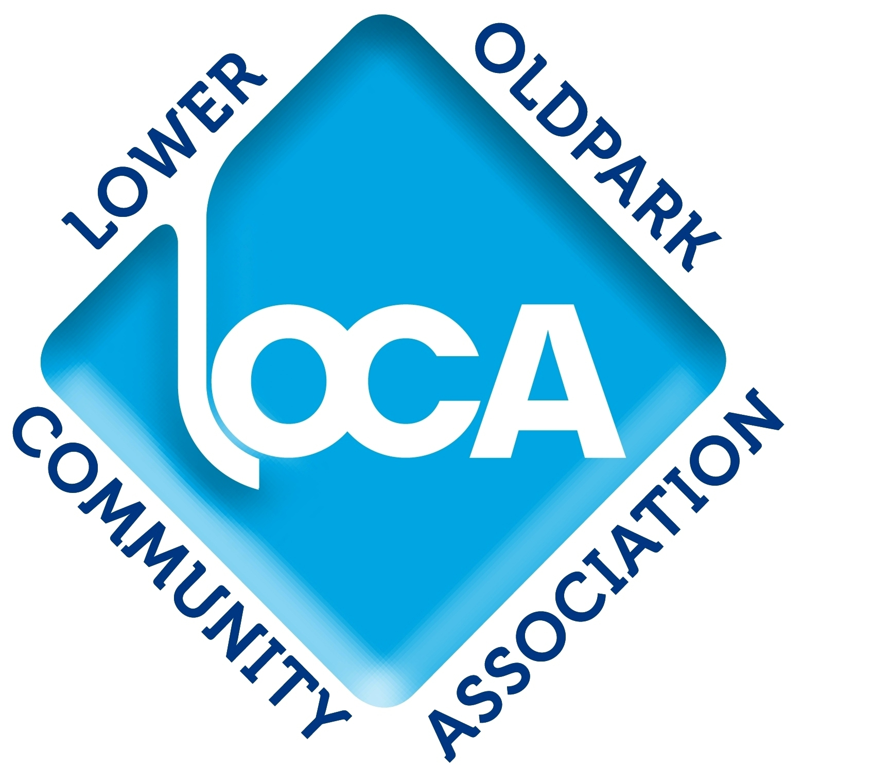

APPLICATION FORM
Vine Centre Limited is a company limited by guarantee registered in Northern Ireland No NI32293 Charity No. XR13743

Please complete this form in black ink (CV’s are not required and will not be considered). All information supplied will be treated as confidential.

Position Applied for: _______________________________________________________

Surname: ________________________________ Forenames: ____________________

Address: _______________________________________________________________

_________________________________________Tel No: ________________________

Date of Birth: ______________________________Marital Status: __________________

Please complete Educational Qualifications below:

Year | Exam | Subject | Grade

Please give details below of any other qualifications held or for which you are currently studying:

Professional Body | Qualification | Year

Please give details below of all positions held since completing full-time education. Start with your present or most recent employment and work back:

Dates |  | Name & Address of Employer | Position Held | Salary per annum | Reason for leaving
From | To

Please give details below of short courses and/or in-service training attended within the last 5 years:

Title and nature of Course | Organised by | Date

How soon would you be able to take up an appointment? _______________________

How many days have you taken as sick leave during the past 2 years? _____________

Are you registered disabled? Yes/No Number _______________________

Have you been convicted of a criminal offence, including offences which are not yet 'spent' under the Rehabilitation of Offences Act 1974? Yes/No

Is there any court action pending against you? Yes/No

REFERENCES

Please give the names and addresses of two persons who have agreed to act as referees and indicate the capacity in which they have known you. The referees must have known you for least two years. At least one referee should have detailed knowledge of you in the working environment. Neither referee should be related to you. References will only be sought in respect of a successful candidate and an offer of employment will be conditional on the receipt of satisfactory references and ACCESS NI check.

Please provide name, address, phone number, e-mail address and the capacity in which the referee knows you.

1. | 2.

I certify that the above information is complete and correct to the best of my knowledge and can be treated as part of any subsequent contract of employment.

Signature: ___________________________ Date: _____________________________

LOCA is committed to Equal Opportunity in employment based solely on selecting the best person for the job without regard to sex, marital status, religious beliefs, political opinion or disability.

Essential Skills & Experiences
(In each box give an example(s) of your skills and experiences)

No. 1 - Childcare Qualification NVQ Level III or equivalent.

No. 2 - A minimum of three years working with 2½ to 4 year olds.

No. 3 - Sensitivity to the needs of children and understanding of non gender specific play.

No. 4 - Understanding of parental needs and issues.

No. 5 - Ability to work effectively and harmoniously as part of a team.

No. 6 - Initiative and leadership ability.

Desirable Criteria
(In each box give an example(s) of your skills and experiences)

No. 1 - Experience of supervising paid staff or unpaid workers.

No. 2 - Experience of arts & crafts, story-telling and music.

No. 3 - Experience of reporting to a line manager

No. 4 - Knowledge of the local area.

No. 5 - Child protection policies and procedures

No. 6 – First Aid

Please return the application form only (not the Job Description or Personal Specification) to:

The Administrator
Lower Oldpark Community Association
9-23 Avoca Street
Belfast
BT14 6EN

Tel. No. 028 9035 1334
E-Mail: locacentre@hotmail.co.uk

The deadline for the return of completed application forms is
1.00pm on Monday 3rd September 2018.

Interviews will take place on 10th & 11th September 2018

