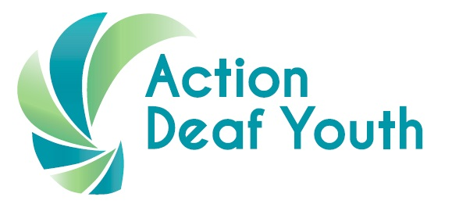

Job Ref: HQ/2018/003

Title: Play Ranger x 10 posts

Employer: Action Deaf Youth

Based at: 385 Holywood Road, Belfast, BT4 2LS

Hours: Approx. 3 hours per week (sessional, term time only)

Employment status: Fixed term until 30th June 2019 with possibility of extension

Salary: £15 per hour

Responsible to: Active Play Coordinator

Job purpose: To work alongside the Lead Play Practitioner in one or more of our group play programmes. You will support and enhance deaf children’s development and act as a positive and inspiring role model for the children and their parents/carers.

You will be able to work with a specific age group depending on your interests and experience (0-2 years, 2-4 years, 4-8 years).

These posts are funded by the Big Lottery Fund

Main duties and responsibilities

Child-led play

- Work alongside the Lead Play Practitioner in group play sessions to support and enhance deaf children’s development through a wide range of fun and enjoyable play experiences

- Develop good relationships with the children and interact with them sensitively

- Act as a positive role model for the children, helping to build their self-esteem and enhance their communication skills

- Provide excellent standards of care at all times by supervising the children appropriately

- Work with the Lead Play Practitioner to reflect on the session and clear away resources at the end

Working with parents/carers of deaf children

- Create a warm, welcoming and supportive space for parents/carers of deaf children, where they are free to discuss issues

- Share your own personal experiences of deafness with the children’s parents/carers, helping them to feel positive about their journey with their child

Safeguarding and hygiene

- Promote and safeguard the welfare of the children who attend our play programmes and ensure all safeguarding and child protection procedures are followed

- Ensure good standards of hygiene and cleanliness are maintained at all times

Training

- Be available and willing to complete all required training – please refer to attached training dates for 2018/early 2019

Person Specification

Post | Play Ranger
Location | Belfast & throughout Northern Ireland
 | Essential | Desirable
Experience | - Experience of working with children (paid, voluntary or personal experience)  - Willing and available to be involved in all required training to develop knowledge, understanding and skills
Personal Qualities | - Warm, playful personality  - Reliable  - Good communication skills  - Empathy with deaf children  - Open attitude  - Can share personal experiences of deafness with parents/carers
Competencies | - Work well in a team  - Able to learn new skills and use these in the play sessions
Other | - Interested in play and how this is important for children’s development

How to apply

- Complete application form. You must show how you meet each aspect of the Person Specification – you can do this in writing on the application form or through BSL video clip.

- Email completed application form (and BSL video clip if you have done this) to michael.johnston@actiondeafyouth.org

- Closing date to apply: Monday 6th August 2018 at 9am

- Interview date: sometime between 20th – 24th August 2018 (to be confirmed)
TRAINING DATES

DATE | TIME | WHERE? | WHAT?
Saturday 1st September 2018  AND  Sunday 2nd September 2018 | 9.30am – 4.30pm | Action Deaf Youth | Introduction to Play & Playwork
To be confirmed  Friday 7th September 2018 evening  OR  Saturday 8th September 2018 morning | 3 hours | Action Deaf Youth | Child Protection (Safeguarding)
Friday 23rd November 2018  AND  Friday 7th December 2018 | 6pm – 9pm | Action Deaf Youth | Paediatric First Aid  (First Aid for children)
Saturday 5th January 2019  AND  Sunday 6th January 2019 | 9.30am – 4.30pm | Action Deaf Youth | Creative Communication with Children

