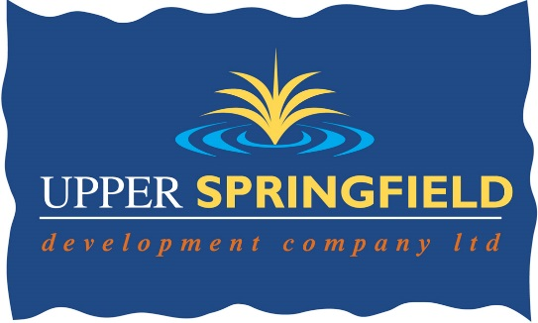

**Guidance for Making your Application**

The application form is designed to ensure that applicants provide the necessary information to determine how they meet the competition requirements and the essential/desirable criteria.

* The space available on the application form is the same for all applicants and must not be altered.
* The Upper Springfield Development Trust will not accept CV’s, letters, or any other supplementary material in place of or in addition to, completed application forms.
* Applicants must complete the application form in black ink or typescript.
* Applicants must not reformat their application form.
* Information in support of your application will not be accepted after the closing date for receipt of applications.
* Relevant or equivalent qualifications – if you believe your qualification is equivalent to the one required, the onus is on you to provide the panel with details of modules studied, etc. so the panel can make a well-informed decision.
* It is essential that all applicants demonstrate on their application form how and to what extent their experience and skills are relevant to this post and the extent to which they satisfy each of the essential and desirable criterion specified. If you do not provide sufficient detail, including the appropriate dates needed to meet the criteria, the selection panel will reject your application.
* The examples you provide should be concise and relevant to the criteria. This is very important as these may be discussed at interview and you may need to be prepared to talk about them in detail if you are invited to interview. It is your unique role that the panel are interested in, not that of your team or division.
* The Upper Springfield Development Trust will not make assumptions from the title of the applicants post or the nature of the organisation, as to the skills and experience gained.

**Application Form Submission**

* Completed applications can be submitted by:
  + Email to j.fegan@usdt.co.uk, by post or delivered by hand to the Office Manager, USDT, 689 Springfield Road, Belfast, BT12 7FP
* We will not accept incomplete application forms; application forms received after the closing deadline or reformatted application forms.
* Please only return the application form, monitoring form and Disclosure of Criminal Convictions Form.
* Applicants using Royal Mail should note that 1st class mail does not guarantee next day delivery. It is the responsibility of the applicant to ensure that sufficient postage has been paid to return the form to the Upper Springfield Development Trust to meet the required deadlines.
* The Upper Springfield Development Trust will not accept application forms where there has been a shortfall in postage.
* In line with GDPR regulations, when your application is being assessed by the panel, all personal details on page one will be withheld and your application will be given a unique reference number.
* Should you have any queries please contact the Office Manager on 028 90236677 or email at j.fegan@usdt.co.uk

**Interview Guidance for Applicants**

At interview, the selection panel will assess candidates against the competencies, qualifications and experience for the post.

If this is your first experience of a competence-based interview, bear in mind that it does not require you to:

* Talk through previous jobs from start to finish
* Provide generalised information as to your background and experience.
* Provide information that is not specifically relevant to the competence the question is designed to test.

A competence based interview does however require you to:

* Focus exclusively, in your responses, on your ability to fulfil the competences required for the effective performance in the role.
* Provide specific examples of your experience in relation to the required competence areas.

**Disability Requirements**

Please notify the Upper Springfield Development Trust by contacting the Office Manager if you require any reasonable adjustments, due to disability, to enable you to attend any part of the assessment process.

In accordance with the Disability Discrimination Act, a person is disabled if they have, or have had, “a physical or mental impairment which has, or has had a substantial and long-term adverse effect on their ability to carry out normal day-to-day activities”.

If you are successful in the selection process and are being considered for appointment, you may be required to outline any adjustments you consider necessary in order for you to take up appointment.

**Equal Opportunities Monitoring Form**

**Please complete the monitoring form and return in a separate envelope marked ‘Monitoring Officer’.**

The information is used for monitoring purposes only. All applications for employment are considered strictly on the basis of merit.

The Upper Springfield Development Trust complies with relevant Equal Opportunities legislation and policies.

**Requirements**

Prior to appointment with the Upper Springfield Development Trust the following will be required:

* Proof of qualifications
* Proof of eligibility to work in the UK
* Personal ID
* ACCESS NI check depending on role.

The Upper Springfield Development Trust complies with Access NI Code of Practice, which can be downloaded from <https://www.nidirect.gov.uk/sites/default/files/publications/accessni-code-of-practice.pdf>