

Are you experienced in letting property?

We are currently seeking an enthusiastic and experienced person to join our private rented sector access scheme in the Derry/Londonderry area. This is an exciting opportunity to manage housing and related services; involving regular contact with tenants, looking after rental income, dealing with repairs, properties and Landlords.

About the Job

HOUSING OFFICER, (PROPERTY LETTING), SMARTMOVE NI, DERRY/LONDONDERRY
(ref: HOSM/R23/01)

Salary: £19,314 per annum (Basic rate), plus additional uncapped bonus earnings, 37.5 Hours per week

We work with specific clients, such people that are homeless, minority groups or people with disabilities.

Minimum Criteria (a Full Job Description and Personal Specification is available with an application pack)

- Third level education
- One year proven track record of working within a housing/Property/support related service.
- A current driving licence with access to a car. (Can be waived in the case of applicant whose disability prohibits driving, but who is able to organise suitable alternative arrangements).
- IT Skills

Interested candidates should e-mail for an application pack, quoting the appropriate job reference number to: karlaokane@first-housing.com

Application Forms can also be downloaded from www.first-housing.com

Please Note: All recruitment correspondence for this position will be done through e-mail. Please provide a suitable e-mail address for correspondence and e-mail completed applications to karlaokane@first-housing.com

If you do not have an e-mail address, please contact Karla on 02871 266115

It should be noted that the criteria for this post may be enhanced to facilitate short listing.

Closing date: Friday, 6th July 2018 @ 12 noon

First Housing operates a child protection and vulnerable adults policy, Access NI checks will be carried out before an appointment can be confirmed.

We are an Equal Opportunities Employer

FIRST HOUSING AID & SUPPORT SERVICES
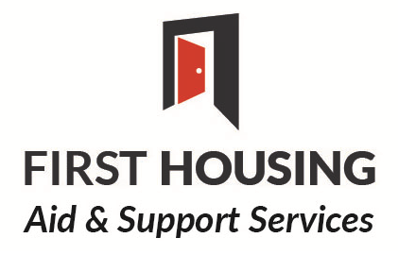
(Registered Charity No: XR19886)


