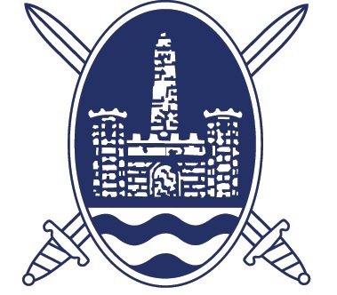
County Antrim & District Football Association
JOB DESCRIPTION: ASSOCIATION SECRETARY
The purpose of the role is to administer all aspects (excluding discipline) of the running of the County Antrim & District Football Association (CAFA)

Detailed description of the role:
- To be available for all meetings of the Association and to organise and minute same.
- To organise, in association with the Irish FA, fixture and draw dates and to fully administer all competitions under the jurisdiction of CAFA (i.e. Senior Shield, Steel & Sons Cup, Junior Shield and Women’s Cup).
- To be available pre and early season each year to administer cup competition entries and to arrange draws as required. All draws to be notified as per the CAFA Rule Book (http://www.countyantrimfa.org/databasedocs/doc_1371697125.pdf )
- To make arrangements for the semi-finals and finals of each competition and to be present at and administer such games. (Applicants will wish to pay special attention that the Steel & Sons Cup is played on the morning of Christmas Day).
- To register, maintain and update all Club affiliations (Senior, Intermediate and Junior) on the CAFA’s IT Systems.
- To ensure the allocation of referees to Junior Leagues, to advise the Irish FA and leagues of referee appointments and to liaise with the North East Ulster Referees Association (NEURA) in all matters related to refereeing within the Association.
- To supervise all disciplinary matters relating to clubs, players and officials at Junior/Women’s Level and discharge the duties of the Disciplinary Secretary/Co-ordinator in their absence.
- To ensure appropriate care and attention to sponsors and to maximise publicity for the competition draws and to be in attendance at draws where publicity is required.
- To liaise with the Irish Football Association in all matters relevant to CAFA
- To liaise with CAFA’s solicitor in all matters relevant to CAFA.
- To bear responsibility for an approved financial float.
- To ensure provision of trophies, medals, awards and mementoes and to organise and record same.
- To implement amendments to the rules and handbook and to produce an updated rule book annually.
- To oversee and contribute to the development and maintenance of the CAFA website and social media presence
- To organise, in conjunction with the Honorary Treasurer the Annual Dinner and Presentation of Awards
- To make arrangements for, notify members and circulate all relevant documents for the Annual General Meeting (AGM) or any Extraordinary General Meetings
- To present a written report for the AGM
- To ensure timely issue of membership cards to CAFA Council and CAFA Life Members
- To be available to carry out other duties as directed by the CAFA President

REQUIREMENT OF THE POST HOLDER:

ESSENTIAL
- Good verbal and written communication skills
- A sound knowledge of Association Football within Northern Ireland
- Able to dedicate sufficient time to adequately perform the various duties which vary from high demand in specific months to low demand in others
- Problem solving and decision making skills
- Ability to deal with a wide range of stakeholders with different views
- Ability to organise in an unsupervised environment
- Be computer literate and skilled in the MS Office Suite
- Ability to work from home with internet access

MUST NOT
- Applicants MUST NOT hold any elected, remunerated or appointed position within Association Football.

In the event that an applicant occupies such a role, they must confirm that they will resign from it if successful at interview.

