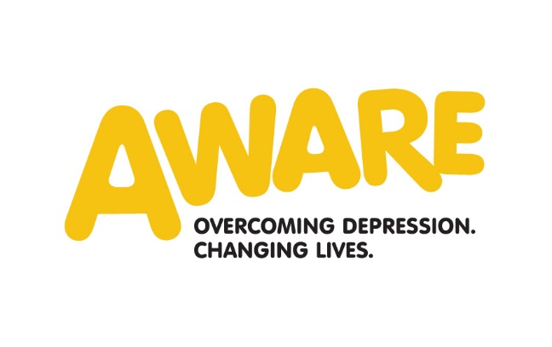

AWARE is looking for a highly motivated and enthusiastic individual to join our Fundraising team. We need to do more for the one in four people affected by depression.
Community and Events Fundraising Officer - (Full-time Permanent Contract – 36 hours pw – Salary Scale: NJC 6)

- To organise and deliver profitable AWARE events
- To recruit key fundraising volunteers and establish a volunteer database with at least 50 volunteers
    - Work with schools, colleges and universities where AWARE has a close relationship to generate fundraising income through creative fundraising activities and promote the importance of mental wellbeing.
    - Provide volunteers with support to establish a fundraising committee in Belfast and in other key areas as agreed by Director of Fundraising and Communications.
    - To work with other key staff to develop links with community organisations in key towns across the region and with our support group facilitators to develop local knowledge, presence and profile within communities

The successful candidate will demonstrate experience of:
- Experience of securing significant funds through community and events fundraising techniques
- Experience in using a range of computer packages including MS Office, particularly Word, PowerPoint and Excel
- Experience in the successful recruitment, support and retention of volunteers specifically for fundraising activity
- Experience in establishing fundraising committees
- Experience of working on own initiative in developing fundraising activities, motivating people to work with us and working with sectoral interests in the area
- Demonstrable experience in managing fundraising events and challenge events.

For more information and an application form see www.aware-ni.org now. Alternatively ring Patricia on 028 71 260602 to request an application pack. We do not accept CVs

The closing date for applications is Friday 28th April 4pm

Aware is an equal opportunities employer.

